02_recursion dataset +trees

gpt-3.5-turbo-012

rec_01.txt gpt-3.5-turbo-0125 temperature=1.0
PROMPT: Consider the sentence below and complete the following three tasks:
1. Does the sentence in question contain an instance of recursion? If so, identify the recursive part and say what kind of recursion it is. Note that there are different types of recursion, e.g. adjectival recursion (an adjective modifying an adjective-modified noun), Saxon Genitive a.k.a. possessive 's recursion (an 's-possessed 's-possessor), prepositional phrase recursion (a prepositional phrase with another prepositional phrase inside), clausal recursion (a clause within another clause), and so on.
2. Provide code for a syntactic tree representing the structure of the sentence that can be rendered with LaTeX's forest package. Assume X-bar theory.
3. If you identified that the sentence contains a recursive structure, expand it by adding another layer of recursion (of the same type) to the identified structure.
"Jack van der Molen might be the sneaky old thief."
REPLY: 1. The sentence does not contain an instance of recursion.

2. Here is the code for the syntactic tree:
\begin{forest}
[CP
[C'
[C
[Jack]
]
[TP
[DP
[van der Molen]
]
[T'
[T
[might]
]
[VP
[V'
[be]
[DP
[D'
[D
[the]
]
[AP
[adj
[sneaky]
]
[NP
[AP
[adj
[old]
]
[N'
[N
[thief]
]
]
]
]
]
]
]
]
]
]
]
]
]
\end{forest}
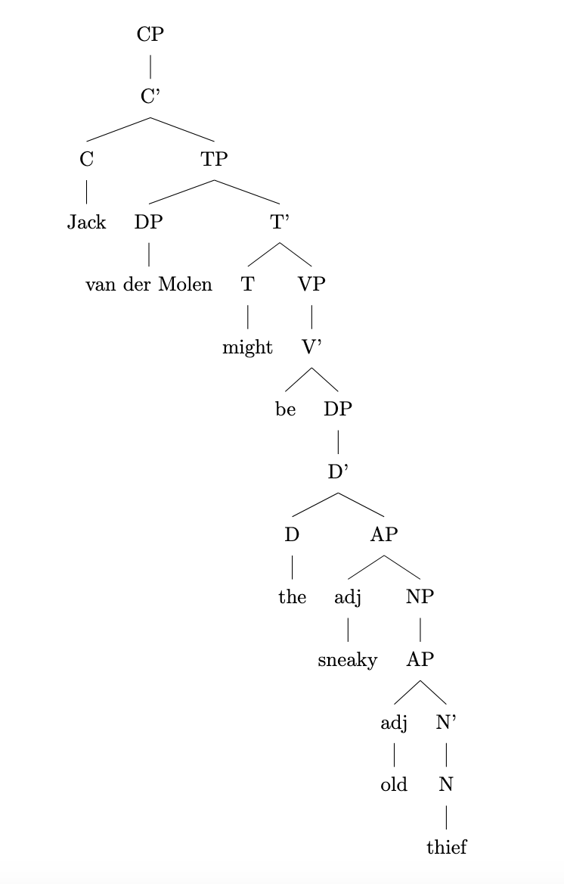
3. Since the sentence does not contain recursion, there is no need to expand it further.

rec_10.txt gpt-3.5-turbo-0125 temperature=1.0
PROMPT: Consider the sentence below and complete the following three tasks:
1. Does the sentence in question contain an instance of recursion? If so, identify the recursive part and say what kind of recursion it is. Note that there are different types of recursion, e.g. adjectival recursion (an adjective modifying an adjective-modified noun), Saxon Genitive a.k.a. possessive 's recursion (an 's-possessed 's-possessor), prepositional phrase recursion (a prepositional phrase with another prepositional phrase inside), clausal recursion (a clause within another clause), and so on.
2. Provide code for a syntactic tree representing the structure of the sentence that can be rendered with LaTeX's forest package. Assume X-bar theory.
3. If you identified that the sentence contains a recursive structure, expand it by adding another layer of recursion (of the same type) to the identified structure.
"The footprints clearly revealed Beth's young companion's escape route."
REPLY: 1. Yes, the sentence contains an instance of possessive 's recursion. The possessive structure "Beth's young companion's" is an example of possessive 's recursion.

2. Syntactic tree code representing the structure of the sentence:
\begin{forest}
[DP
[D'
[D
[The]
]
[NP
[N'
[N
[footprints]
]
[CP
[C'
[C
[clearly]
]
[TP
[T'
[T
[revealed]
]
[DP
[D'
[D
[Beth's]
]
[NP
[N'
[N
[young]
]
[N'
[N
[companion's]
]
]
]
]
]
]
]
]
]
]
]
]
]
[VP
[DP
[D'
[D
[the]
]
[NP
[N'
[N
[escape]
]
[N'
[N
[route]
]
]
]
]
]
]
]
]
\end{forest}

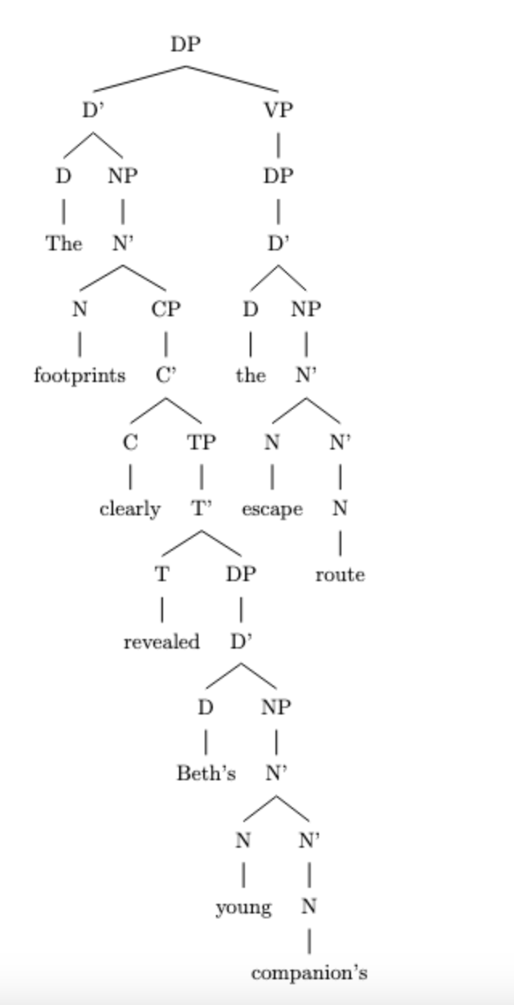

3. Expanding the possessive 's recursion structure by adding another layer of recursion:
"The footprints clearly revealed Beth's young companion's sister's escape route."

rec_04.txt gpt-3.5-turbo-0125 temperature=1.0
PROMPT: Consider the sentence below and complete the following three tasks:
1. Does the sentence in question contain an instance of recursion? If so, identify the recursive part and say what kind of recursion it is. Note that there are different types of recursion, e.g. adjectival recursion (an adjective modifying an adjective-modified noun), Saxon Genitive a.k.a. possessive 's recursion (an 's-possessed 's-possessor), prepositional phrase recursion (a prepositional phrase with another prepositional phrase inside), clausal recursion (a clause within another clause), and so on.
2. Provide code for a syntactic tree representing the structure of the sentence that can be rendered with LaTeX's forest package. Assume X-bar theory.
3. If you identified that the sentence contains a recursive structure, expand it by adding another layer of recursion (of the same type) to the identified structure.
"Unidentified flying objects may have conflicting characteristics."
REPLY: 1. The sentence does not contain an instance of recursion.

2. Here is the code for a syntactic tree representing the structure of the sentence using X-bar theory and LaTeX's forest package:

\begin{forest}
[CP
[C'
[C
[unidentified]
]
[TP
[DP
[N'
[N
[flying]
]
[N'
[N
[objects]
]
]
]
]
[T'
[T
[may]
]
[VP
[V'
[V
[have]
]
[DP
[D'
[D
[conflicting]
]
[NP
[N'
[N
[characteristics]
]
]
]
]
]
]
]
]
]
]
]
\end{forest}

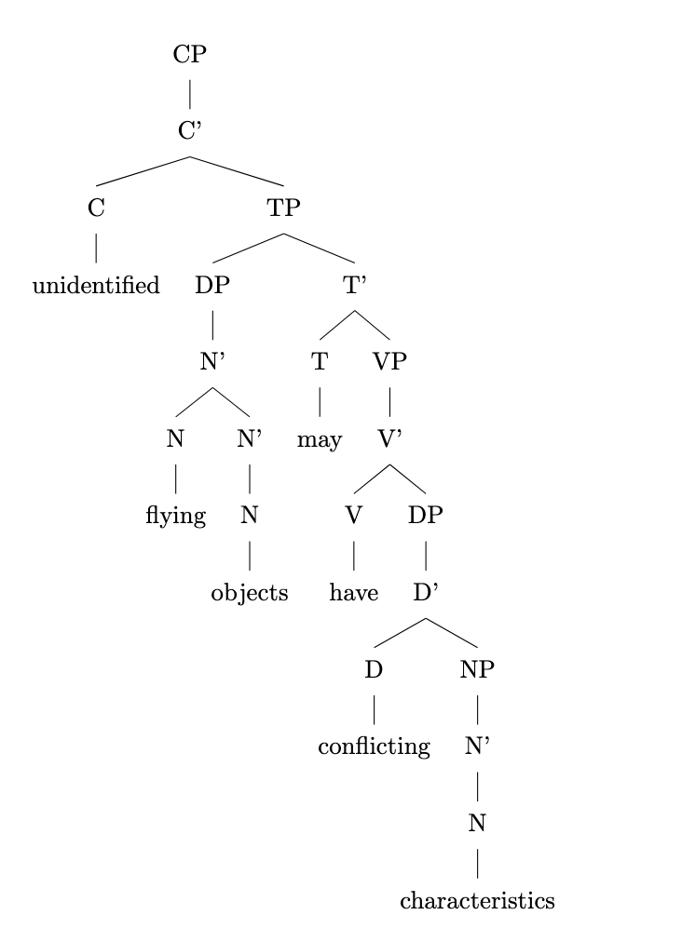

3. Since the sentence does not contain recursion, there is no need to expand it with another layer of recursion.

rec_06.txt gpt-3.5-turbo-0125 temperature=1.0
PROMPT: Consider the sentence below and complete the following three tasks:
1. Does the sentence in question contain an instance of recursion? If so, identify the recursive part and say what kind of recursion it is. Note that there are different types of recursion, e.g. adjectival recursion (an adjective modifying an adjective-modified noun), Saxon Genitive a.k.a. possessive 's recursion (an 's-possessed 's-possessor), prepositional phrase recursion (a prepositional phrase with another prepositional phrase inside), clausal recursion (a clause within another clause), and so on.
2. Provide code for a syntactic tree representing the structure of the sentence that can be rendered with LaTeX's forest package. Assume X-bar theory.
3. If you identified that the sentence contains a recursive structure, expand it by adding another layer of recursion (of the same type) to the identified structure.
"A small child can easily get lost in a vast American mall."
REPLY: 1. The sentence contains clausal recursion. The recursive part is "A small child can easily get lost", where "can easily get lost" is a clause within the main clause "A small child can easily get lost in a vast American mall."

2. Syntactic tree code:
\begin{forest}
[S
[DP
[D
[A \\ A,roof]
]
[N \\ child]
]
[TP
[T \\ can]
[VP
[AdvP
[Adv \\ easily]
]
[VP
[V \\ get]
[AP
[A \\ lost]
]
]
]
]
[PP
[P \\ in]
[DP
[D
[D
[A \\ a]
]
[N \\ mall]
]
[AP
[A \\ vast]
[PP
[P \\ in]
[DP
[D
[A \\ American]
]
[N \\ mall]
]
]
]
]
]
]
\end{forest}

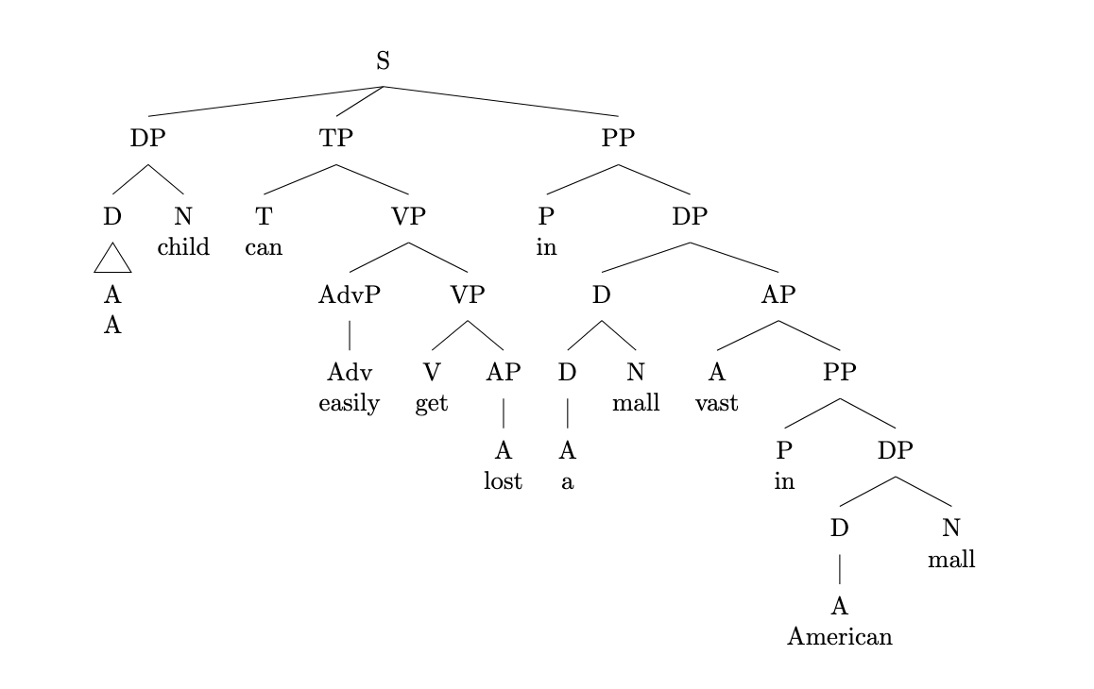

3. Expanded sentence with additional clausal recursion:
"A small child that is easily frightened can easily get lost in a vast American mall."

rec_08.txt gpt-3.5-turbo-0125 temperature=1.0
PROMPT: Consider the sentence below and complete the following three tasks:
1. Does the sentence in question contain an instance of recursion? If so, identify the recursive part and say what kind of recursion it is. Note that there are different types of recursion, e.g. adjectival recursion (an adjective modifying an adjective-modified noun), Saxon Genitive a.k.a. possessive 's recursion (an 's-possessed 's-possessor), prepositional phrase recursion (a prepositional phrase with another prepositional phrase inside), clausal recursion (a clause within another clause), and so on.
2. Provide code for a syntactic tree representing the structure of the sentence that can be rendered with LaTeX's forest package. Assume X-bar theory.
3. If you identified that the sentence contains a recursive structure, expand it by adding another layer of recursion (of the same type) to and the identified structure.
"The Old Continent's civilizations' advances have shaped history."
REPLY: 1. Yes, the sentence contains possessive 's recursion. Specifically, "The Old Continent's civilizations'" is an instance of possessive recursion.

2. Here is the code for a syntactic tree representing the structure of the sentence using X-bar theory and LaTeX's forest package:

\begin{forest}
[S
[NP
[D [The] ]
[N'
[N [Old] ]
[N'
[N [Continent] ]
[PossP
[Poss'
[Poss [ 's ] ]
[NP
[N'
[N [civilizations] ]
[N'
[N [advances] ]
[N' [N [have] ] ]
]
]
]
]
]
]
]
]
[VP
[V'
[V [shaped] ]
[NP [history] ]
]
]
]
\end{forest}
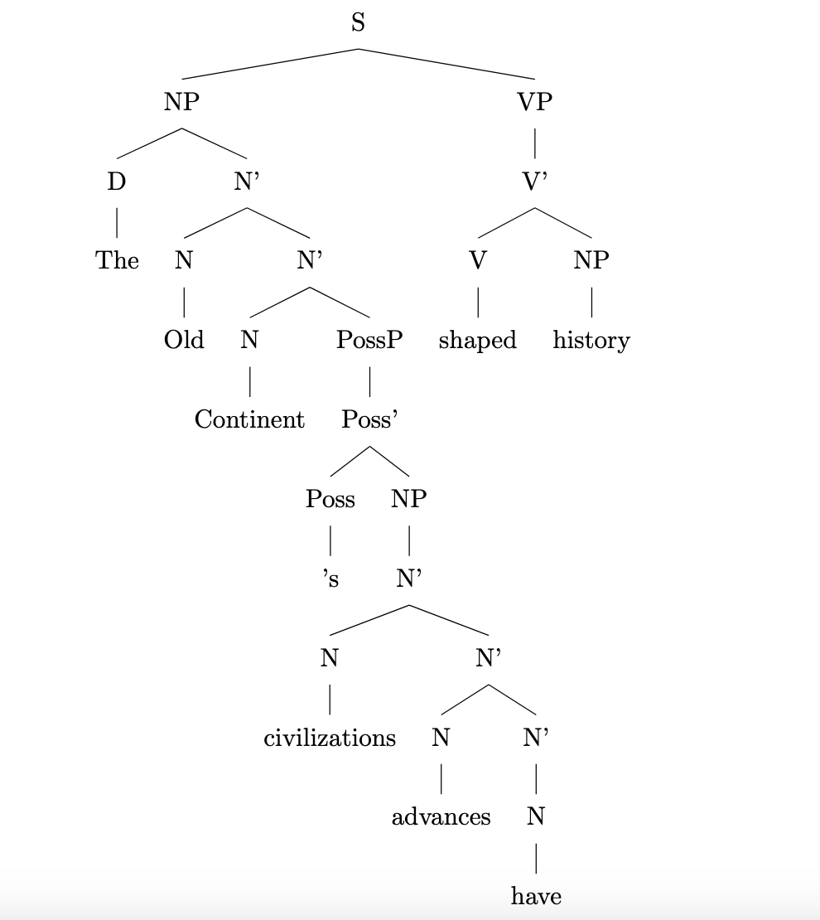
3. Adding another layer of possessive 's recursion to the identified structure:

"The Old Continent's civilizations' leaders' advances have shaped history."

rec_09.txt gpt-3.5-turbo-0125 temperature=1.0
PROMPT: Consider the sentence below and complete the following three tasks:
1. Does the sentence in question contain an instance of recursion? If so, identify the recursive part and say what kind of recursion it is. Note that there are different types of recursion, e.g. adjectival recursion (an adjective modifying an adjective-modified noun), Saxon Genitive a.k.a. possessive 's recursion (an 's-possessed 's-possessor), prepositional phrase recursion (a prepositional phrase with another prepositional phrase inside), clausal recursion (a clause within another clause), and so on.
2. Provide code for a syntactic tree representing the structure of the sentence that can be rendered with LaTeX's forest package. Assume X-bar theory.
3. If you identified that the sentence contains a recursive structure, expand it by adding another layer of recursion (of the same type) to the identified structure.
"This town's only road's potholes are driving me insane."
REPLY: 1. Yes, the sentence contains an instance of possessive 's recursion. The recursive part is "town's only road's potholes" where "town's" possesses "only road" and "road's" possess the "potholes".

2. Syntactic tree representation:
\begin{forest}
[DP
[D
[This]
]
[NP
[N
[town]
['s]
]
[NP
[AdjP
[Adj
[only]
]
[N
[road]
['s]
]
]
[N
[potholes]
]
]
]
[VP
[V
[are]
]
[NP
[Pro
[me]
]
[AdjP
[Adj
[insane]
]
]
]
]
]
\end{forest}
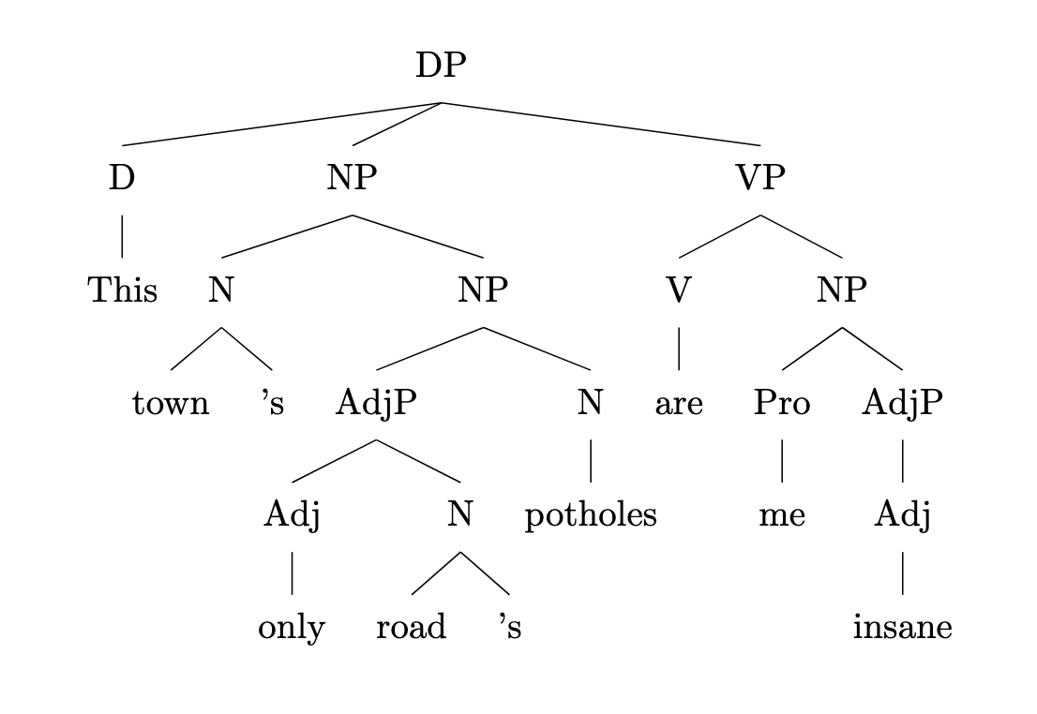
3. Expanded sentence with an additional layer of possessive 's recursion:
"This town's only road's potholes' severity are driving me insane."

rec_02.txt gpt-3.5-turbo-0125 temperature=1.0
PROMPT: Consider the sentence below and complete the following three tasks:
1. Does the sentence in question contain an instance of recursion? If so, identify the recursive part and say what kind of recursion it is. Note that there are different types of recursion, e.g. adjectival recursion (an adjective modifying an adjective-modified noun), Saxon Genitive a.k.a. possessive 's recursion (an 's-possessed 's-possessor), prepositional phrase recursion (a prepositional phrase with another prepositional phrase inside), clausal recursion (a clause within another clause), and so on.
2. Provide code for a syntactic tree representing the structure of the sentence that can be rendered with LaTeX's forest package. Assume X-bar theory.
3. If you identified that the sentence contains a recursive structure, expand it by adding another layer of recursion (of the same type) to the identified structure.
"Now the six trainees construct a medium-sized sturdy lamp."
REPLY: 1. The sentence contains an instance of clausal recursion. The verb phrase "construct a medium-sized sturdy lamp" contains a verb "construct" which takes an object noun phrase "a medium-sized sturdy lamp." This noun phrase itself contains an adjective phrase "medium-sized sturdy" modifying the noun "lamp."

2. Syntactic tree representation:
\begin{forest}
[TP
[DP [Now]]
[T$'$
[T [the]]
[VP
[NP
[NumP
[Num [six]]
[N trainees]
]
]
[V$'$
[V construct]
[NP
[DP [a]]
[AdjP
[AP
[Adj medium-sized]
[Adj sturdy]
]
[N lamp]
]
]
]
]
]
]
\end{forest}
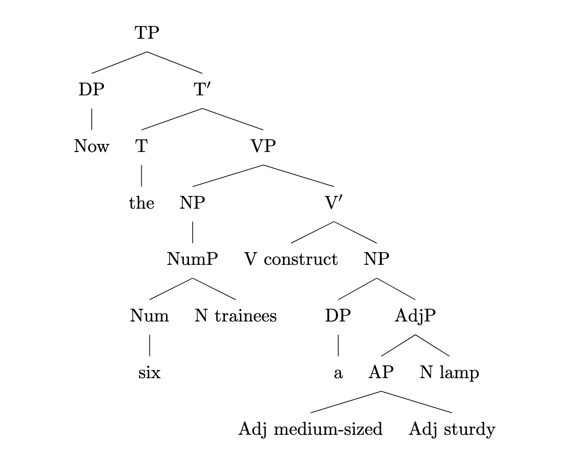
3. Expanded sentence with another layer of clausal recursion:
"Now the six trainees believe that they can seamlessly construct a medium-sized sturdy lamp."

rec_03.txt gpt-3.5-turbo-0125 temperature=1.0
PROMPT: Consider the sentence below and complete the following three tasks:
1. Does the sentence in question contain an instance of recursion? If so, identify the recursive part and say what kind of recursion it is. Note that there are different types of recursion, e.g. adjectival recursion (an adjective modifying an adjective-modified noun), Saxon Genitive a.k.a. possessive 's recursion (an 's-possessed 's-possessor), prepositional phrase recursion (a prepositional phrase with another prepositional phrase inside), clausal recursion (a clause within another clause), and so on.
2. Provide code for a syntactic tree representing the structure of the sentence that can be rendered with LaTeX's forest package. Assume X-bar theory.
3. If you identified that the sentence contains a recursive structure, expand it by adding another layer of recursion (of the same type) to the identified structure.
"Luna has been chasing the small white mouse all day long."
REPLY: 1. The sentence does not contain an instance of recursion.

2. Here is the code for the syntactic tree representation of the sentence using X-bar theory and the forest package in LaTeX:

\begin{forest}
[S
[NP
[N
[Luna]
]
]
[VP
[V
[has]
]
[V'
[V
[been]
]
[VP
[V
[chasing]
]
[NP
[D
[the]
]
[AP
[Adjective
[small]
]
[Adjective
[white]
]
]
[N
[mouse]
]
]
[PP
[P
[all]
]
[NP
[N
[day]
]
[AP
[Adjective
[long]
]
]
]
]
]
]
]
]
\end{forest}
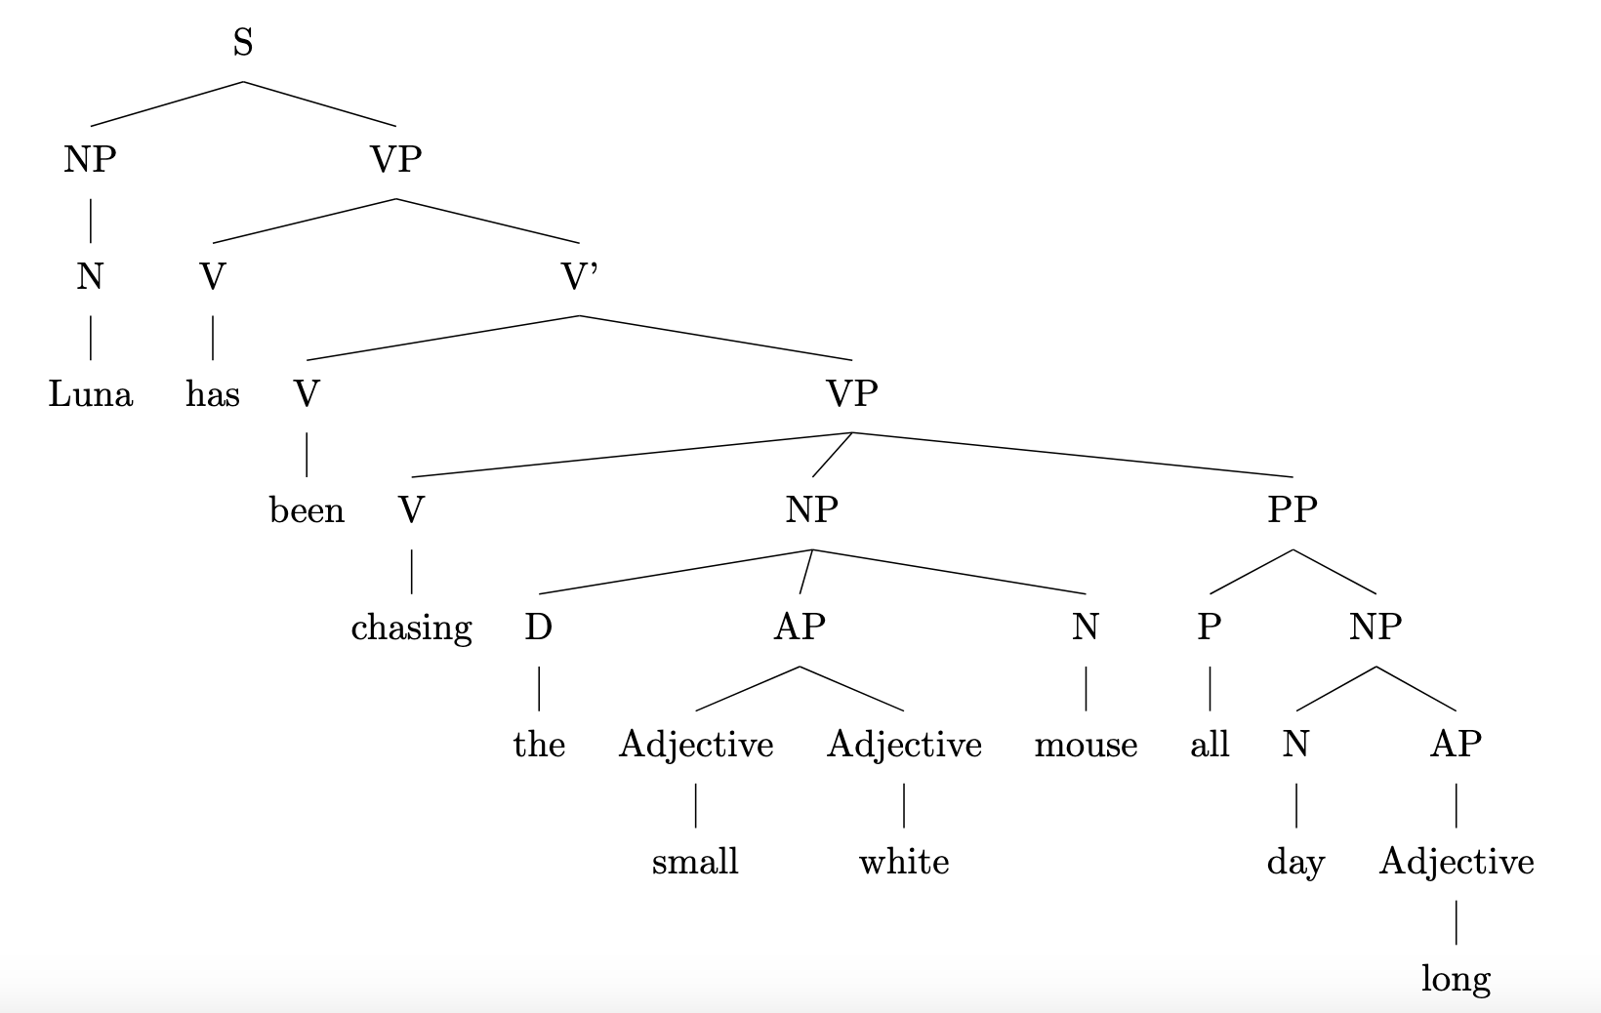
3. Since the sentence does not contain an instance of recursion, we cannot add another layer of the same type of recursion to the identified structure.

rec_11.txt gpt-3.5-turbo-0125 temperature=1.0
PROMPT: Consider the sentence below and complete the following three tasks:
1. Does the sentence in question contain an instance of recursion? If so, identify the recursive part and say what kind of recursion it is. Note that there are different types of recursion, e.g. adjectival recursion (an adjective modifying an adjective-modified noun), Saxon Genitive a.k.a. possessive 's recursion (an 's-possessed 's-possessor), prepositional phrase recursion (a prepositional phrase with another prepositional phrase inside), clausal recursion (a clause within another clause), and so on.
2. Provide code for a syntactic tree representing the structure of the sentence that can be rendered with LaTeX's forest package. Assume X-bar theory.
3. If you identified that the sentence contains a recursive structure, expand it by adding another layer of recursion (of the same type) to the identified structure.
"He spotted the infamous manuscript in the wizard's library's dark corner."
REPLY: 1. Yes, the sentence contains a type of possessive 's recursion. The recursive part is "the wizard's library's dark corner."

2. Syntactic tree code:

\begin{forest}
[S
[NP
[N'
[N
[He]
]
]
]
[VP
[V'
[V
[spotted]
]
[NP
[Det
[the]
]
[N'
[Adj
[infamous]
]
[N
[manuscript]
]
]
[PP
[P'
[P
[in]
]
[NP
[Det
[the]
]
[N'
[N
[corner]
[PP
[P'
[P
[of]
]
[NP
[Det
[the]
]
[N'
[N
[library]
[PP
[P'
[P
['s]
]
[NP
[Det
[the]
]
[N'
[N
[wizard]
]
]
]
]
]
]
]
]
]
]
]
]
]
]
]
]
]
]
]
\end{forest}
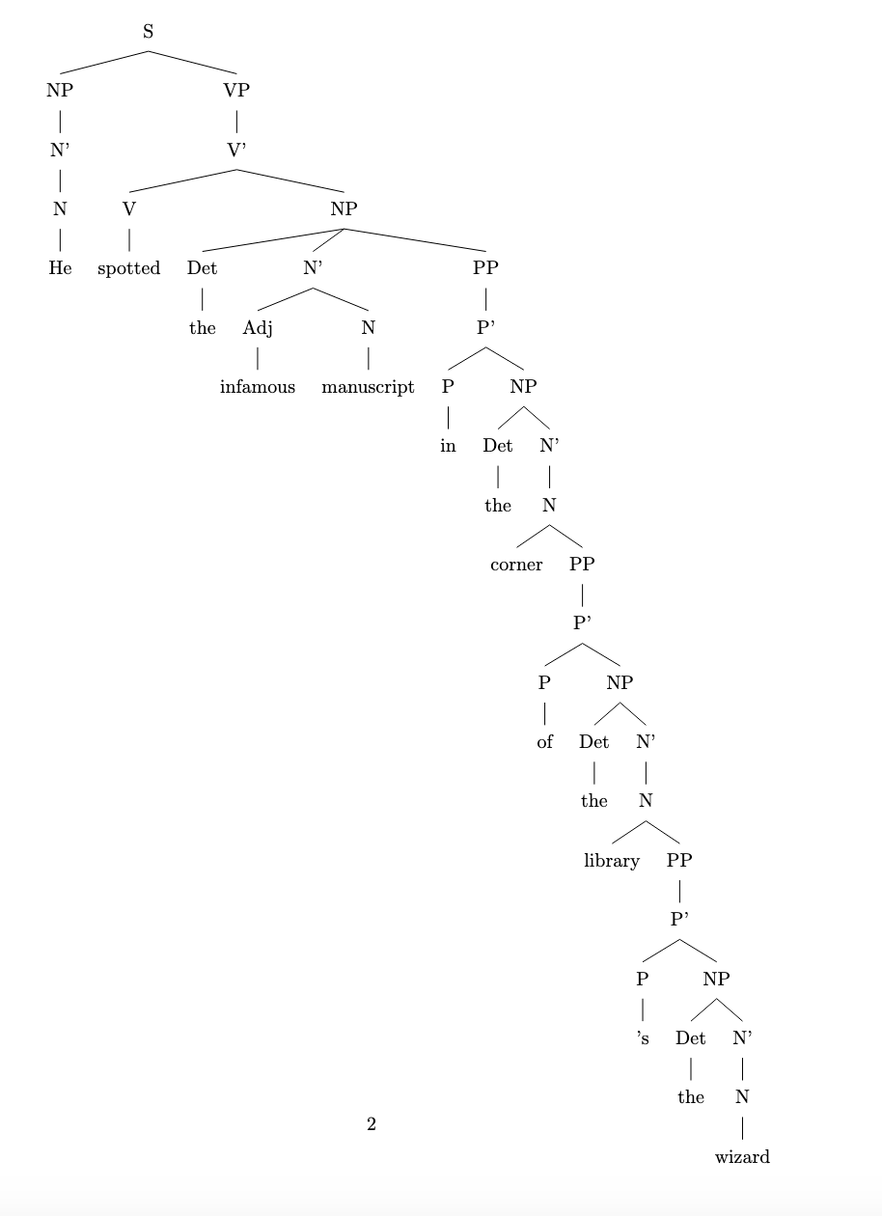
3. Expanding the possessive 's recursion:

"He spotted the infamous manuscript in the wizard's library's owner's dark corner."

rec_07.txt gpt-3.5-turbo-0125 temperature=1.0
PROMPT: Consider the sentence below and complete the following three tasks:
1. Does the sentence in question contain an instance of recursion? If so, identify the recursive part and say what kind of recursion it is. Note that there are different types of recursion, e.g. adjectival recursion (an adjective modifying an adjective-modified noun), Saxon Genitive a.k.a. possessive 's recursion (an 's-possessed 's-possessor), prepositional phrase recursion (a prepositional phrase with another prepositional phrase inside), clausal recursion (a clause within another clause), and so on.
2. Provide code for a syntactic tree representing the structure of the sentence that can be rendered with LaTeX's forest package. Assume X-bar theory.
3. If you identified that the sentence contains a recursive structure, expand it by adding another layer of recursion (of the same type) to the identified structure.
"A sudden shriek penetrated the cold winter's night's dead silence."
REPLY: 1. Yes, the sentence contains an instance of genitive 's recursion (Saxon Genitive). The recursive part is "winter's night's" where "winter's" is the first possessor and "night's" is the second possessor.

2. Code for a syntactic tree representing the structure of the sentence using X-bar theory:
\begin{forest}
[DP
[D [A] ]
[NP
[N
[N
[N
[N [sudden] ]
[N [shriek] ]
]
[N
[N [night] ]
['s]
]
]
['s]
]
[AdjP [cold] ]
]
]
\end{forest}
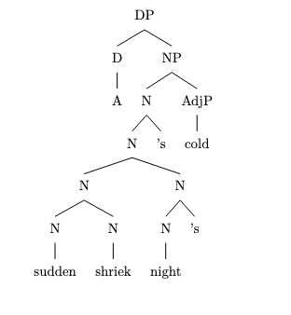
3. Expanded sentence with an additional layer of genitive 's recursion:
"A sudden shriek penetrated the neighbor's dog's collar's tag's engraving."

rec_05.txt gpt-3.5-turbo-0125 temperature=1.0
PROMPT: Consider the sentence below and complete the following three tasks:
1. Does the sentence in question contain an instance of recursion? If so, identify the recursive part and say what kind of recursion it is. Note that there are different types of recursion, e.g. adjectival recursion (an adjective modifying an adjective-modified noun), Saxon Genitive a.k.a. possessive 's recursion (an 's-possessed 's-possessor), prepositional phrase recursion (a prepositional phrase with another prepositional phrase inside), clausal recursion (a clause within another clause), and so on.
2. Provide code for a syntactic tree representing the structure of the sentence that can be rendered with LaTeX's forest package. Assume X-bar theory.
3. If you identified that the sentence contains a recursive structure, expand it by adding another layer of recursion (of the same type) to the identified structure.
"My cranky geriatric manager is beyond incompetent."
REPLY: 1. Yes, the sentence contains adjectival recursion. The recursive part is "cranky geriatric manager", where "geriatric" is an adjective modifying "manager", and "cranky" is an adjective modifying "geriatric manager".

2. Syntactic tree code:
\begin{forest}
[TP
[DP
[D
[My]
]
[NP
[AP
[A
[cranky]
]
[NP
[AP
[A
[geriatric]
]
[N
[manager]
]
]
]
]
]
]
[T'
[T
[is]
]
[VP
[AP
[P
[beyond]
]
[AP
[A
[incompetent]
]
]
]
]
]
]
\end{forest}
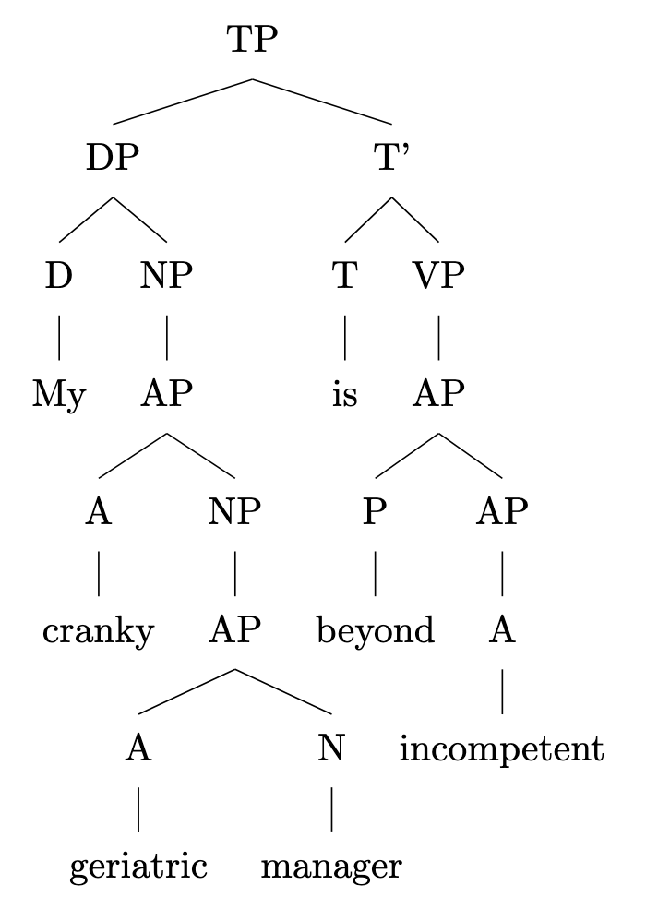
3. Adding another layer of adjectival recursion (same type):
"My cranky elderly geriatric manager is beyond incompetent."

rec_12.txt gpt-3.5-turbo-0125 temperature=1.0
PROMPT: Consider the sentence below and complete the following three tasks:
1. Does the sentence in question contain an instance of recursion? If so, identify the recursive part and say what kind of recursion it is. Note that there are different types of recursion, e.g. adjectival recursion (an adjective modifying an adjective-modified noun), Saxon Genitive a.k.a. possessive 's recursion (an 's-possessed 's-possessor), prepositional phrase recursion (a prepositional phrase with another prepositional phrase inside), clausal recursion (a clause within another clause), and so on.
2. Provide code for a syntactic tree representing the structure of the sentence that can be rendered with LaTeX's forest package. Assume X-bar theory.
3. If you identified that the sentence contains a recursive structure, expand it by adding another layer of recursion (of the same type) to the identified structure.
"Do I dare challenge my advisor's thesis' central argument?"
REPLY: 1. The sentence contains possessive 's recursion. The recursive part is "advisor's thesis," where "advisor's" possessively modifies "thesis."

2. Here is the code for a syntactic tree representing the structure of the sentence using X-bar theory in LaTeX's forest package:

\begin{forest}
[CP
[C'
[C [Do]]
[TP
[T'
[T [I]]
[VP
[V'
[V [dare]]
[CP
[C'
[C [challenge]]
[TP
[T'
[T [my]]
[AdvP [advisor's]]
[NP [thesis]]
]
]
]
]
]
]
]
]
]
]
\end{forest}
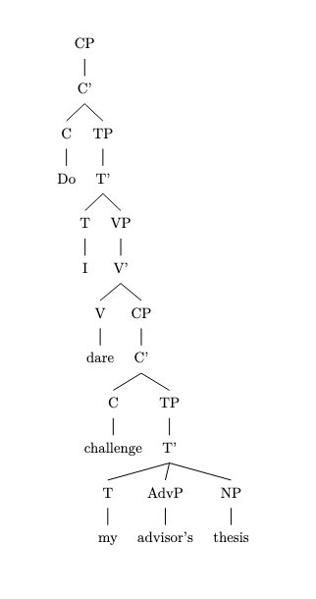
3. Expanded sentence: "Do I dare challenge my advisor's colleague's thesis' central argument?"

The possessive 's recursion now includes "advisor's colleague's," where "colleague's" further possessively modifies "thesis."

rec_15.txt gpt-3.5-turbo-0125 temperature=1.0
PROMPT: Consider the sentence below and complete the following three tasks:
1. Does the sentence in question contain an instance of recursion? If so, identify the recursive part and say what kind of recursion it is. Note that there are different types of recursion, e.g. adjectival recursion (an adjective modifying an adjective-modified noun), Saxon Genitive a.k.a. possessive 's recursion (an 's-possessed 's-possessor), prepositional phrase recursion (a prepositional phrase with another prepositional phrase inside), clausal recursion (a clause within another clause), and so on.
2. Provide code for a syntactic tree representing the structure of the sentence that can be rendered with LaTeX's forest package. Assume X-bar theory.
3. If you identified that the sentence contains a recursive structure, expand it by adding another layer of recursion (of the same type) to the identified structure.
"He had been warned about the dangers of tobacco."
REPLY: 1. Yes, the sentence contains clausal recursion. The main clause "He had been warned" contains a subordinate clause "about the dangers of tobacco."

2. Here is the code for the syntactic tree representing the structure of the sentence:

\begin{forest}
[TP
[DP
[He]
]
[T'
[T
[had]
]
[VP
[V'
[V
[been]
]
[VP
[V'
[V
[warned]
]
[PP
[P'
[P
[about]
]
[DP
[D'
[D
[the]
]
[NP
[N'
[N
[dangers]
]
[PP
[P'
[P
[of]
]
[NP
[tobacco]
]
]
]
]
]
]
]
]
]
]
]
]
]
]
]
\end{forest}
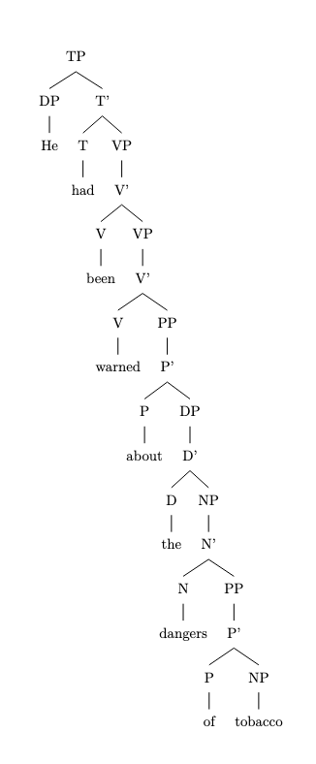
3. Adding another layer of clausal recursion to the existing structure would look like this:

"He had been told [that he should be aware [of the dangers of tobacco]]."

rec_13.txt gpt-3.5-turbo-0125 temperature=1.0
PROMPT: Consider the sentence below and complete the following three tasks:
1. Does the sentence in question contain an instance of recursion? If so, identify the recursive part and say what kind of recursion it is. Note that there are different types of recursion, e.g. adjectival recursion (an adjective modifying an adjective-modified noun), Saxon Genitive a.k.a. possessive 's recursion (an 's-possessed 's-possessor), prepositional phrase recursion (a prepositional phrase with another prepositional phrase inside), clausal recursion (a clause within another clause), and so on.
2. Provide code for a syntactic tree representing the structure of the sentence that can be rendered with LaTeX's forest package. Assume X-bar theory.
3. If you identified that the sentence contains a recursive structure, expand it by adding another layer of recursion (of the same type) to the identified structure.
"She saw someone loitering by the entrance to the library."
REPLY: 1. Yes, the sentence contains an instance of adjectival recursion. The recursive part is "someone loitering".

2.
\begin{forest}
[S
[NP
[N
[Proper N
[She]
]
]
]
[VP
[V
[saw]
]
[NP
[Det
[someone]
]
[VP
[V
[loitering]
]
[PP
[P
[by]
]
[NP
[Det
[the]
]
[N
[entrance]
[PP
[P
[to]
]
[NP
[Det
[the]
]
[N
[library]
]
]
]
]
]
]
]
]
]
]
\end{forest}
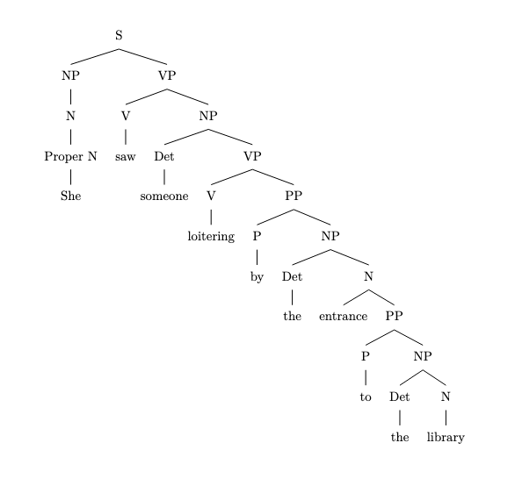
3. Expanding the adjectival recursion:
"She saw someone who was loitering by the entrance to the library at midnight."

rec_14.txt gpt-3.5-turbo-0125 temperature=1.0
PROMPT: Consider the sentence below and complete the following three tasks:
1. Does the sentence in question contain an instance of recursion? If so, identify the recursive part and say what kind of recursion it is. Note that there are different types of recursion, e.g. adjectival recursion (an adjective modifying an adjective-modified noun), Saxon Genitive a.k.a. possessive 's recursion (an 's-possessed 's-possessor), prepositional phrase recursion (a prepositional phrase with another prepositional phrase inside), clausal recursion (a clause within another clause), and so on.
2. Provide code for a syntactic tree representing the structure of the sentence that can be rendered with LaTeX's forest package. Assume X-bar theory.
3. If you identified that the sentence contains a recursive structure, expand it by adding another layer of recursion (of the same type) to the identified structure.
"We sow fear in the hearts of our enemies."
REPLY: 1. Yes, the sentence contains an instance of prepositional phrase recursion. The prepositional phrase "in the hearts of our enemies" is nested within the verb phrase "sow fear."

2. Syntactic tree code:
\begin{forest}
[TP
[DP
[We]
]
[T'
[T
[sow]
]
[VP
[DP
[fear]
]
[PP
[P
[in]
]
[DP
[D'
[D
[the]
]
[NP
[N'
[N
[hearts]
]
[PP
[P
[of]
]
[DP
[D'
[D
[our]
]
[NP
[N'
[N
[enemies]
]
]
]
]
]
]
]
]
]
]
]
]
]
]
\end{forest}

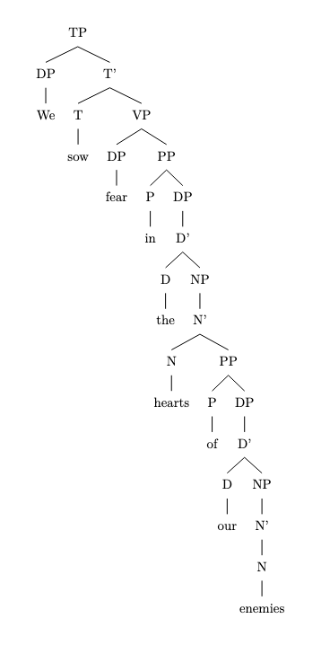

3. Expanding the prepositional phrase recursion:
"We sow fear in the depths of the dark hearts of our enemies."

rec_17.txt gpt-3.5-turbo-0125 temperature=1.0
PROMPT: Consider the sentence below and complete the following three tasks:
1. Does the sentence in question contain an instance of recursion? If so, identify the recursive part and say what kind of recursion it is. Note that there are different types of recursion, e.g. adjectival recursion (an adjective modifying an adjective-modified noun), Saxon Genitive a.k.a. possessive 's recursion (an 's-possessed 's-possessor), prepositional phrase recursion (a prepositional phrase with another prepositional phrase inside), clausal recursion (a clause within another clause), and so on.
2. Provide code for a syntactic tree representing the structure of the sentence that can be rendered with LaTeX's forest package. Assume X-bar theory.
3. If you identified that the sentence contains a recursive structure, expand it by adding another layer of recursion (of the same type) to the identified structure.
"Even their recipe for the basic dough of the pie crust is heavily guarded."
REPLY: 1. Yes, the sentence contains an instance of possessive 's recursion. The possessive form "their" is modifying "recipe," which is itself the possessor of the noun phrase "the basic dough of the pie crust."

2. Here is the code for a syntactic tree representing the structure of the sentence using X-bar theory and LaTeX's forest package:

\begin{forest}
[TP
[DP
[D
[Even]
]
[PossP
[D
[their]
]
[NP
[N
[recipe]
]
]
]
]
[T'
[T
[is]
]
[VP
[AdvP
[Adv
[heavily]
]
[V'
[V
[guarded]
]
[PP
[P
[for]
]
[DP
[D
[the]
]
[AdjP
[Adj
[basic]
]
[NP
[N
[dough]
[PP
[P
[of]
]
[NP
[D
[the]
]
[N
[pie]
[N
[crust]
]
]
]
]
]
]
]
]
]
]
]
]
]
]
\end{forest}
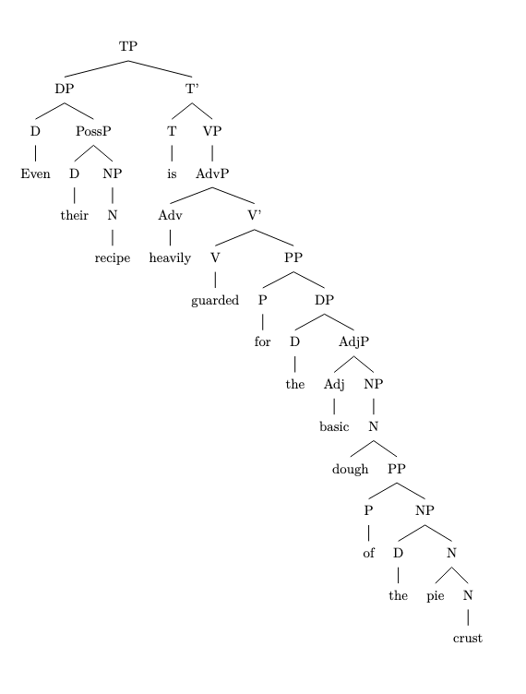
3. Adding another layer of possessive 's recursion to the structure:

"Even their recipe for the basic dough of the pie crust of the bakery is heavily guarded."

rec_16.txt gpt-3.5-turbo-0125 temperature=1.0
PROMPT: Consider the sentence below and complete the following three tasks:
1. Does the sentence in question contain an instance of recursion? If so, identify the recursive part and say what kind of recursion it is. Note that there are different types of recursion, e.g. adjectival recursion (an adjective modifying an adjective-modified noun), Saxon Genitive a.k.a. possessive 's recursion (an 's-possessed 's-possessor), prepositional phrase recursion (a prepositional phrase with another prepositional phrase inside), clausal recursion (a clause within another clause), and so on.
2. Provide code for a syntactic tree representing the structure of the sentence that can be rendered with LaTeX's forest package. Assume X-bar theory.
3. If you identified that the sentence contains a recursive structure, expand it by adding another layer of recursion (of the same type) to the identified structure.
"There is a little treat for you in the cupboard between the lamps."
REPLY: 1. The sentence contains prepositional phrase recursion, as the prepositional phrase "in the cupboard between the lamps" contains another prepositional phrase "between the lamps".

2. Code for the syntactic tree representing the structure of the sentence:
\begin{forest}
[TP
[There]
[VP
[V
[is]
]
[NP
[Det
[a]
]
[AP
[Adj
[little]
]
[N
[treat]
]
]
[PP
[P
[for]
]
[NP
[pro]
[you]
]
]
[PP
[P
[in]
]
[NP
[Det
[the]
]
[N
[cupboard]
[PP
[P
[between]
]
[NP
[Det
[the]
]
[N
[lamps]
]
]
]
]
]
]
]
]
]
\end{forest}
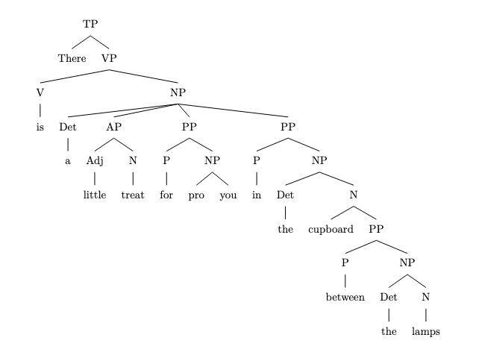
3. Expanded sentence with another layer of prepositional phrase recursion:
"There is a little treat for you in the cupboard between the lamps under the table."

rec_19.txt gpt-3.5-turbo-0125 temperature=1.0
PROMPT: Consider the sentence below and complete the following three tasks:
1. Does the sentence in question contain an instance of recursion? If so, identify the recursive part and say what kind of recursion it is. Note that there are different types of recursion, e.g. adjectival recursion (an adjective modifying an adjective-modified noun), Saxon Genitive a.k.a. possessive 's recursion (an 's-possessed 's-possessor), prepositional phrase recursion (a prepositional phrase with another prepositional phrase inside), clausal recursion (a clause within another clause), and so on.
2. Provide code for a syntactic tree representing the structure of the sentence that can be rendered with LaTeX's forest package. Assume X-bar theory.
3. If you identified that the sentence contains a recursive structure, expand it by adding another layer of recursion (of the same type) to the identified structure.
"You must remember that you should always run all the basic diagnostics first."
REPLY: 1. The sentence contains clausal recursion. The clause "you should always run all the basic diagnostics first" is embedded within the larger clause "you must remember."

2. Syntactic tree representation for the sentence:

\begin{forest}
[CP
[C'
[C
[You]
[must]
]
[TP
[T'
[T
[remember]
]
[CP
[C'
[C
[that]
]
[TP
[T'
[T
[you]
[should]
]
[VP
[V'
[V
[always]
[run]
]
[NP
[all the basic diagnostics, roof]
]
[AdvP
[first]
]
]
]
]
]
]
]
]
]
]
]
\end{forest}
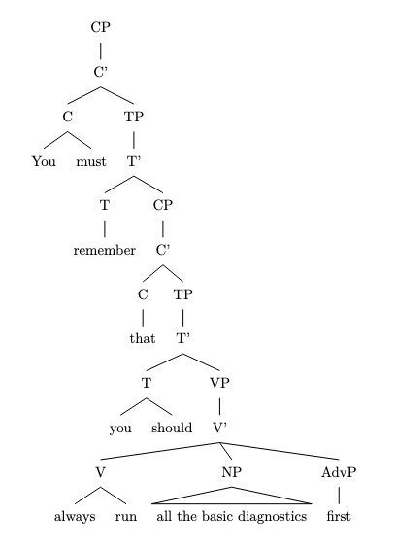
3. Expanding the clausal recursion:

"You must remember that you should always tell yourself that you must remember that you should always run all the basic diagnostics first."

rec_20.txt gpt-3.5-turbo-0125 temperature=1.0
PROMPT: Consider the sentence below and complete the following three tasks:
1. Does the sentence in question contain an instance of recursion? If so, identify the recursive part and say what kind of recursion it is. Note that there are different types of recursion, e.g. adjectival recursion (an adjective modifying an adjective-modified noun), Saxon Genitive a.k.a. possessive 's recursion (an 's-possessed 's-possessor), prepositional phrase recursion (a prepositional phrase with another prepositional phrase inside), clausal recursion (a clause within another clause), and so on.
2. Provide code for a syntactic tree representing the structure of the sentence that can be rendered with LaTeX's forest package. Assume X-bar theory.
3. If you identified that the sentence contains a recursive structure, expand it by adding another layer of recursion (of the same type) to the identified structure.
"She announced her victory to irritate her detractors."
REPLY: 1. Yes, the sentence contains clausal recursion. The phrase "to irritate her detractors" is a clause (infinitival clause) that serves as an adverbial modifying the verb "announced."

2. Here is the code for a syntactic tree representing the structure of the sentence using X-bar theory in LaTeX with the forest package:

\documentclass{article}
\usepackage{forest}
\begin{document}

\begin{forest}
[S
[NP
[she]
]
[VP
[V
[announced]
]
[NP
[N
[her victory]
]
]
[CP
[C
[to]
]
[IP
[NP
[her]
]
[VP
[V
[irritate]
]
[NP
[her detractors]
]
]
]
]
]
]
\end{forest}

\end{document}
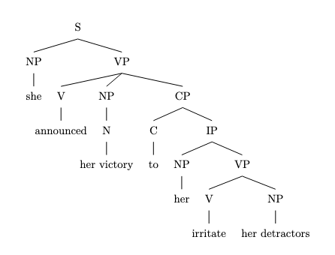
3. Expanding the clausal recursion further by adding another layer of the same type:

"She announced her victory to irritate her detractors to win the competition."

rec_18.txt gpt-3.5-turbo-0125 temperature=1.0
PROMPT: Consider the sentence below and complete the following three tasks:
1. Does the sentence in question contain an instance of recursion? If so, identify the recursive part and say what kind of recursion it is. Note that there are different types of recursion, e.g. adjectival recursion (an adjective modifying an adjective-modified noun), Saxon Genitive a.k.a. possessive 's recursion (an 's-possessed 's-possessor), prepositional phrase recursion (a prepositional phrase with another prepositional phrase inside), clausal recursion (a clause within another clause), and so on.
2. Provide code for a syntactic tree representing the structure of the sentence that can be rendered with LaTeX's forest package. Assume X-bar theory.
3. If you identified that the sentence contains a recursive structure, expand it by adding another layer of recursion (of the same type) to the identified structure.
"Drowning your sorrows in a glass of whiskey is at best a temporary solution."
REPLY: 1. The sentence contains an instance of clausal recursion. The verb phrase "drowning your sorrows in a glass of whiskey" contains a subordinate clause "in a glass of whiskey", which is nested within the verb phrase "drowning your sorrows".

2. Syntactic tree representation with X-bar theory:

\begin{forest}
[S
[NP
[N
[D[Your]]
[N[sorrows]]
]
]
[VP
[V[Drowning]]
[S
[NP
[D[a]]
[N[glass]]
[PP
[P[in]
[NP
[D[a]]
[N[whiskey]]
]
]
]
]
]
]
[PP
[P[in]]
[NP
[D[a]]
[N[solution]]
]
]
]
\end{forest}
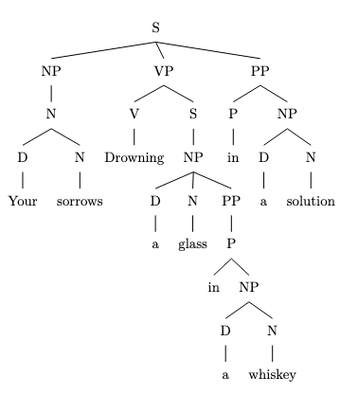
3. Expanding the clausal recursion:

"Drowning your sorrows in a glass of whiskey that you bought at the local liquor store is at best a temporary solution."

rec_22.txt gpt-3.5-turbo-0125 temperature=1.0
PROMPT: Consider the sentence below and complete the following three tasks:
1. Does the sentence in question contain an instance of recursion? If so, identify the recursive part and say what kind of recursion it is. Note that there are different types of recursion, e.g. adjectival recursion (an adjective modifying an adjective-modified noun), Saxon Genitive a.k.a. possessive 's recursion (an 's-possessed 's-possessor), prepositional phrase recursion (a prepositional phrase with another prepositional phrase inside), clausal recursion (a clause within another clause), and so on.
2. Provide code for a syntactic tree representing the structure of the sentence that can be rendered with LaTeX's forest package. Assume X-bar theory.
3. If you identified that the sentence contains a recursive structure, expand it by adding another layer of recursion (of the same type) to the identified structure.
"The few that could understand the manifesto's complex worldview appreciated it."
REPLY: 1. The sentence contains an instance of clausal recursion. The noun phrase "the few that could understand the manifesto's complex worldview" contains a relative clause "that could understand the manifesto's complex worldview" which is embedded within the noun phrase.

2. Code for syntactic tree:

\begin{forest}
[TP
[DP
[D [The]]
[NP
[AP [few]]
[CP
[C [that]]
[TP
[DP [could]]
[VP
[V [understand]]
[DP
[D [the]]
[NP
[N [manifesto]]
[PP
[P ['s]]
[NP [complex worldview]]
]
]
]
]
]
]
]
]
[VP
[V [appreciated]]
[DP [it]]
]
]
\end{forest}
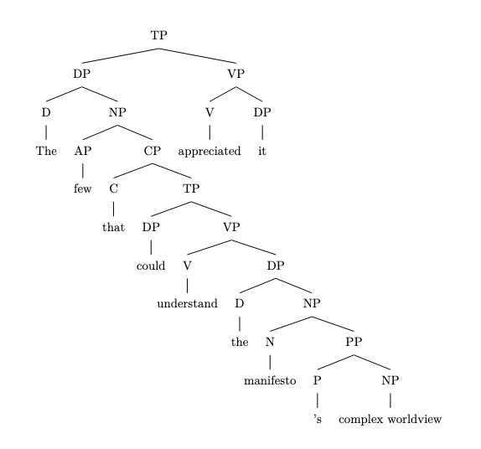
3. Expanding clausal recursion:

"The few that could understand the manifesto's complex worldview that the critics had dissected appreciated it."

rec_21.txt gpt-3.5-turbo-0125 temperature=1.0
PROMPT: Consider the sentence below and complete the following three tasks:
1. Does the sentence in question contain an instance of recursion? If so, identify the recursive part and say what kind of recursion it is. Note that there are different types of recursion, e.g. adjectival recursion (an adjective modifying an adjective-modified noun), Saxon Genitive a.k.a. possessive 's recursion (an 's-possessed 's-possessor), prepositional phrase recursion (a prepositional phrase with another prepositional phrase inside), clausal recursion (a clause within another clause), and so on.
2. Provide code for a syntactic tree representing the structure of the sentence that can be rendered with LaTeX's forest package. Assume X-bar theory.
3. If you identified that the sentence contains a recursive structure, expand it by adding another layer of recursion (of the same type) to the identified structure.
"Paul cherished his worn-out diary, whose pages were heavily marked by stains"
REPLY: 1. The sentence contains an instance of possessive 's recursion, where "his worn-out diary" is the possessive noun phrase with the 's-possessed noun "diary" modified by the possessive 's-possessor "his".

2. Syntactic tree code:

\begin{forest}
[DP
[D [Paul]]
[NP
[N'
[N [cherished]]
[NP
[D [his]]
[N'
[N [diary]]
[PP
[P [by]]
[NP
[N'
[Adj [worn-out]]
[N [pages]]
]
[VP
[V [were]]
[ADJ [heavily]]
[ADJ [marked]]
]
]
]
]
]
]
]
]
\end{forest}
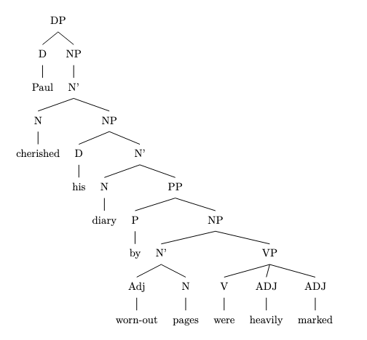
3. If we add another layer of possessive 's recursion:
"Paul cherished his worn-out diary's missing pages, whose stains were impossible to remove."

The additional layer of possessive 's recursion would be between "diary's missing pages", with the 's-possessed noun "pages" modified by the possessive 's-possessor "diary's".

rec_25.txt gpt-3.5-turbo-0125 temperature=1.0
PROMPT: Consider the sentence below and complete the following three tasks:
1. Does the sentence in question contain an instance of recursion? If so, identify the recursive part and say what kind of recursion it is. Note that there are different types of recursion, e.g. adjectival recursion (an adjective modifying an adjective-modified noun), Saxon Genitive a.k.a. possessive 's recursion (an 's-possessed 's-possessor), prepositional phrase recursion (a prepositional phrase with another prepositional phrase inside), clausal recursion (a clause within another clause), and so on.
2. Provide code for a syntactic tree representing the structure of the sentence that can be rendered with LaTeX's forest package. Assume X-bar theory.
3. If you identified that the sentence contains a recursive structure, expand it by adding another layer of recursion (of the same type) to the identified structure.
"Pieces of a diary Paul tore to shreds lay on the ground."
REPLY: 1. The sentence contains prepositional phrase recursion. The recursive part is "Pieces of a diary." This is a prepositional phrase ("of a diary") within another prepositional phrase ("Pieces of").

2. Syntax tree code:

\begin{forest}
[S
[NP
[Noun
[Pieces]
[of a diary]
]
]
[VP
[NP
[Noun
[Paul]
]
]
[VP
[V
[tore]
]
[PP
[P
[to]
]
[NP
[Noun
[shreds]
]
]
]
]
]
[VP
[V
[lay]
]
[PP
[P
[on]
]
[DP
[Det
[the]
]
[Noun
[ground]
]
]
]
]
]
\end{forest}
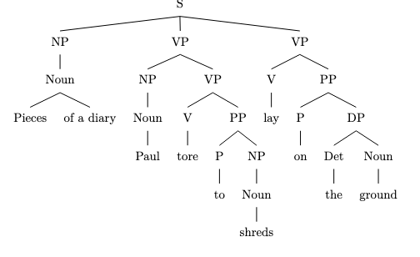
3. If we were to add another layer of prepositional phrase recursion to "Pieces of a diary," the expanded sentence would be: "Pieces of the torn pages of a diary Paul tore to shreds lay on the ground."

rec_23.txt gpt-3.5-turbo-0125 temperature=1.0
PROMPT: Consider the sentence below and complete the following three tasks:
1. Does the sentence in question contain an instance of recursion? If so, identify the recursive part and say what kind of recursion it is. Note that there are different types of recursion, e.g. adjectival recursion (an adjective modifying an adjective-modified noun), Saxon Genitive a.k.a. possessive 's recursion (an 's-possessed 's-possessor), prepositional phrase recursion (a prepositional phrase with another prepositional phrase inside), clausal recursion (a clause within another clause), and so on.
2. Provide code for a syntactic tree representing the structure of the sentence that can be rendered with LaTeX's forest package. Assume X-bar theory.
3. If you identified that the sentence contains a recursive structure, expand it by adding another layer of recursion (of the same type) to the identified structure.
"The mirror the girl punched shattered into a million pieces."
REPLY: 1. Yes, the sentence contains clausal recursion. The recursive part is "the mirror the girl punched," where "the girl punched" is a clause embedded within the noun phrase "the mirror."

2. Code for a syntactic tree representing the structure of the sentence:

\begin{forest}
[S
[NP
[D [The]]
[N'
[N [mirror]]
[CP
[C [that]]
[S
[NP [D [the]]
[N' [N [girl]]
[VP [V [punched]]]]
[VP [V [shattered]]
[PP [P [into]]
[NP [D [a]]
[N' [Adj [million]] [N [pieces]]]]]]
]
]
]
]
]
\end{forest}

DID NOT COMPILE; Added bracket (AM)
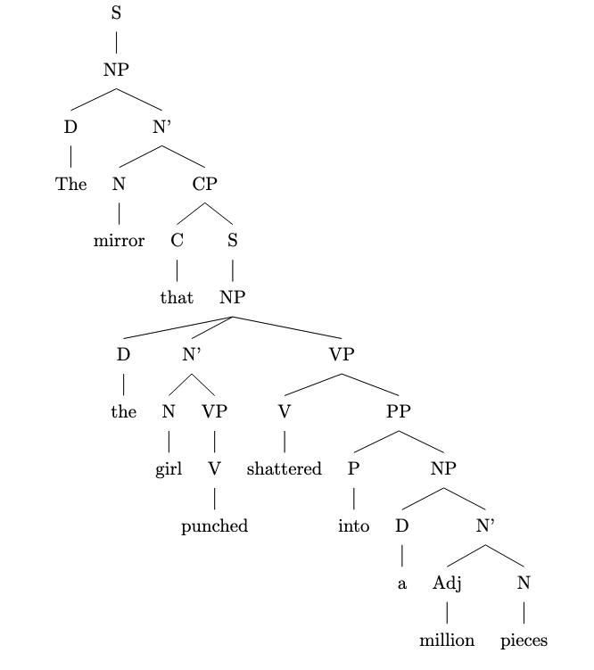
3. Expanding the clausal recursion:

"The mirror that the girl punched that the boy broke shattered into a million pieces."

rec_24.txt gpt-3.5-turbo-0125 temperature=1.0
PROMPT: Consider the sentence below and complete the following three tasks:
1. Does the sentence in question contain an instance of recursion? If so, identify the recursive part and say what kind of recursion it is. Note that there are different types of recursion, e.g. adjectival recursion (an adjective modifying an adjective-modified noun), Saxon Genitive a.k.a. possessive 's recursion (an 's-possessed 's-possessor), prepositional phrase recursion (a prepositional phrase with another prepositional phrase inside), clausal recursion (a clause within another clause), and so on.
2. Provide code for a syntactic tree representing the structure of the sentence that can be rendered with LaTeX's forest package. Assume X-bar theory.
3. If you identified that the sentence contains a recursive structure, expand it by adding another layer of recursion (of the same type) to the identified structure.
"Every desk I put a heavy lamp on eventually cracked."
REPLY: 1. Yes, the sentence contains clausal recursion. The recursive part is "I put a heavy lamp on", where "put" is the main verb of the sentence and "a heavy lamp" is the direct object of "put". The embedded clause "I put a heavy lamp on" functions as the object of the verb "desk".

2. Syntactic tree in X-bar theory:
\[
\begin{forest}
[S
[DP
[D'
[D
[Every]
]
[NP
[N'
[N
[desk]
]
[CP
[C'
[C
[(trace)]
]
[TP
[DP
[I]
]
[T'
[T
[put]
]
[VP
[V'
[V
[a]
]
[DP
[D'
[D
[heavy]
]
[NP
[N'
[N
[lamp]
]
[PP
[P'
[P
[on]
]
[DP
[(trace)]
]
]
]
]
]
]
]
]
]
]
]
]
]
]
]
]
]
[VP
[V'
[V
[eventually]
]
[VP
[V'
[V
[cracked]
]
]
]
]
]
]
\end{forest}
\]
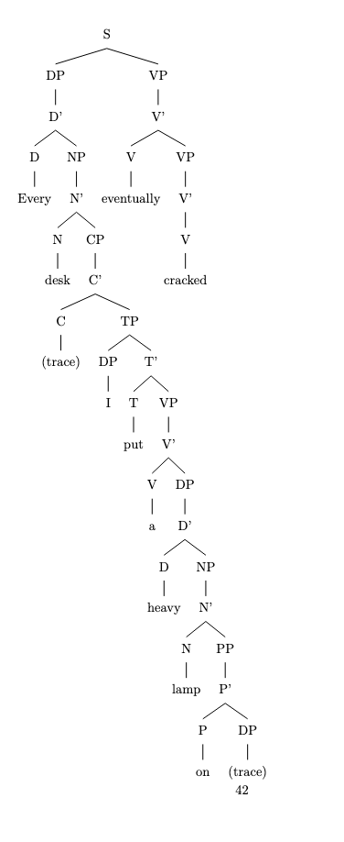
3. Expanding the clausal recursion:
"Every desk I put a heavy lamp that my grandmother gave me on eventually cracked."

rec_27.txt gpt-3.5-turbo-0125 temperature=1.0
PROMPT: Consider the sentence below and complete the following three tasks:
1. Does the sentence in question contain an instance of recursion? If so, identify the recursive part and say what kind of recursion it is. Note that there are different types of recursion, e.g. adjectival recursion (an adjective modifying an adjective-modified noun), Saxon Genitive a.k.a. possessive 's recursion (an 's-possessed 's-possessor), prepositional phrase recursion (a prepositional phrase with another prepositional phrase inside), clausal recursion (a clause within another clause), and so on.
2. Provide code for a syntactic tree representing the structure of the sentence that can be rendered with LaTeX's forest package. Assume X-bar theory.
3. If you identified that the sentence contains a recursive structure, expand it by adding another layer of recursion (of the same type) to the identified structure.
"The expert every investigator we dispatched questioned remained completely silent."
REPLY: 1. Yes, the sentence contains clausal recursion. The recursive part is "every investigator we dispatched questioned".

2. Here is the code for the syntactic tree representation of the sentence using X-bar theory:

\begin{forest}
[TP
[DP
[D'
[D
[The]
]
[NP
[N'
[N
[expert]
]
]
]
]
]
[T'
[T
[every]
]
[VP
[DP
[D'
[D
[investigator]
]
[CP
[C'
[C
[who]
]
[TP
[DP
[D'
[D
[we]
]
[N'
[N
[dispatched]
]
]
]
]
[T'
[T
[questioned]
]
[VP
[V'
[V
[remained]
]
[AdvP
[completely]
]
]
]
]
]
]
]
]
]
]
]
]
\end{forest}
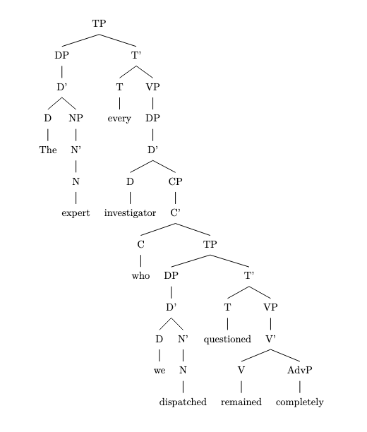
3. To add another layer of clausal recursion, we can further embed another clause within the existing relative clause "every investigator we dispatched questioned":

"The expert every investigator we dispatched who arrived late questioned remained completely silent."

rec_26.txt gpt-3.5-turbo-0125 temperature=1.0
PROMPT: Consider the sentence below and complete the following three tasks:
1. Does the sentence in question contain an instance of recursion? If so, identify the recursive part and say what kind of recursion it is. Note that there are different types of recursion, e.g. adjectival recursion (an adjective modifying an adjective-modified noun), Saxon Genitive a.k.a. possessive 's recursion (an 's-possessed 's-possessor), prepositional phrase recursion (a prepositional phrase with another prepositional phrase inside), clausal recursion (a clause within another clause), and so on.
2. Provide code for a syntactic tree representing the structure of the sentence that can be rendered with LaTeX's forest package. Assume X-bar theory.
3. If you identified that the sentence contains a recursive structure, expand it by adding another layer of recursion (of the same type) to the identified structure.
"The expert every journalist questioned remained completely silent."
REPLY: 1. Yes, the sentence contains clausal recursion. The clause "every journalist questioned" is embedded within the main clause "The expert remained completely silent."

2. Here is the code for the syntactic tree representing the structure of the sentence using X-bar theory in LaTeX with the forest package:

\documentclass{article}
\usepackage{forest}

\begin{document}

\begin{forest}
[CP
[C'
[C
[that]
]
[TP
[DP
[the expert]
]
[T'
[T
[every]
]
[VP
[V'
[V
[journalist]
]
[VP
[V'
[V
[questioned]
]
[DP
[Pro]
]
]
]
]
]
]
]
]
[TP
[DP
[the expert]
]
[T'
[T
[remained]
]
[AdvP
[completely]
]
[VP
[AdjP
[silent]
]
]
]
]
]
\end{forest}

\end{document}
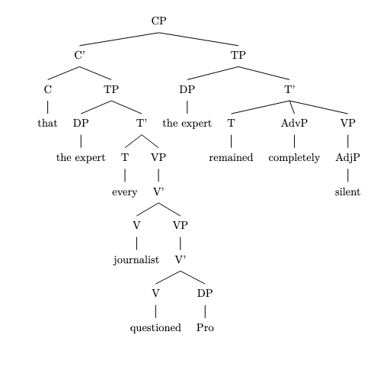
3. To expand the sentence with another layer of clausal recursion, we can add a relative clause modifying "the expert":

"The expert every journalist questioned who had been called as a witness remained completely silent."

rec_28.txt gpt-3.5-turbo-0125 temperature=1.0
PROMPT: Consider the sentence below and complete the following three tasks:
1. Does the sentence in question contain an instance of recursion? If so, identify the recursive part and say what kind of recursion it is. Note that there are different types of recursion, e.g. adjectival recursion (an adjective modifying an adjective-modified noun), Saxon Genitive a.k.a. possessive 's recursion (an 's-possessed 's-possessor), prepositional phrase recursion (a prepositional phrase with another prepositional phrase inside), clausal recursion (a clause within another clause), and so on.
2. Provide code for a syntactic tree representing the structure of the sentence that can be rendered with LaTeX's forest package. Assume X-bar theory.
3. If you identified that the sentence contains a recursive structure, expand it by adding another layer of recursion (of the same type) to the identified structure.
"The astronomy the ancients we revere studied was not separate from astrology."
REPLY: 1. Yes, the sentence contains clausal recursion in the form of noun clause recursion. The recursive part is "the astronomy the ancients we revere studied" where "the ancients we revere studied" is a relative clause embedded within the noun phrase "the astronomy".

2. Syntactic tree code:
\begin{forest}
[TP
[DP
[D
[The]
]
[NP
[N
[astronomy]
]
[CP
[C
[that]
]
[TP
[DP
[D
[the]
]
[NP
[N
[ancients]
]
[CP
[C
[we]
]
[TP
[DP
[D
[revere]
]
]
[T
[studied]
]
]
]
]
]
]
]
]
]
[T
[was]
]
[not separate from]
[DP
[N
[astrology]
]
]
]
\end{forest}
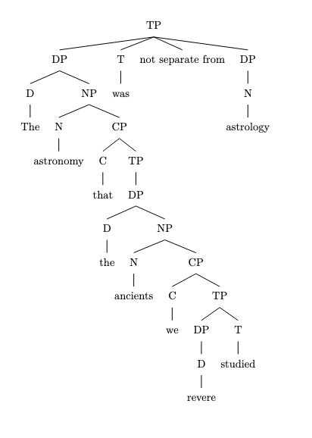
3. Expanded syntactic tree code:
\begin{forest}
[TP
[DP
[D
[The]
]
[NP
[N
[astronomy]
]
[CP
[C
[that]
]
[TP
[DP
[D
[the]
]
[NP
[N
[ancients]
]
[CP
[C
[we]
]
[TP
[DP
[D
[revere]
]
[NP
[N
[ideas]
]
[CP
[C
[that]
]
[TP
[DP
[D
[our]
]
[N
[cultures]
]
[T
[have]
]
]
]
]
]
]
[T
[studied]
]
]
]
]
]
]
]
]
]
[T
[was]
]
[not separate from]
[DP
[N
[astrology]
]
]
]
\end{forest}
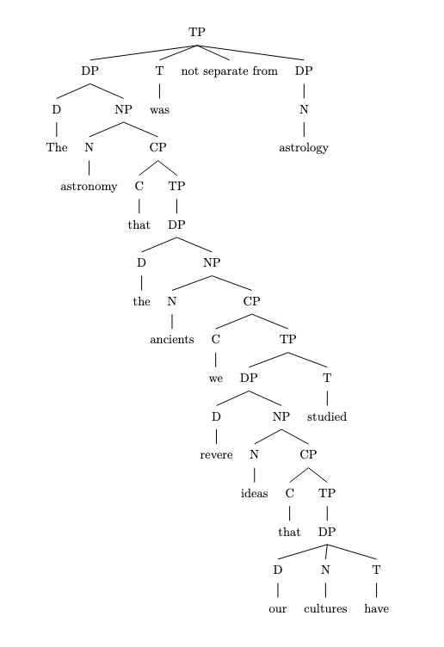

rec_29.txt gpt-3.5-turbo-0125 temperature=1.0
PROMPT: Consider the sentence below and complete the following three tasks:
1. Does the sentence in question contain an instance of recursion? If so, identify the recursive part and say what kind of recursion it is. Note that there are different types of recursion, e.g. adjectival recursion (an adjective modifying an adjective-modified noun), Saxon Genitive a.k.a. possessive 's recursion (an 's-possessed 's-possessor), prepositional phrase recursion (a prepositional phrase with another prepositional phrase inside), clausal recursion (a clause within another clause), and so on.
2. Provide code for a syntactic tree representing the structure of the sentence that can be rendered with LaTeX's forest package. Assume X-bar theory.
3. If you identified that the sentence contains a recursive structure, expand it by adding another layer of recursion (of the same type) to the identified structure.
"A candidate the committee we put together rejected developed the imposter syndrome."
REPLY: 1. Yes, the sentence contains clausal recursion. The recursive part is "the committee we put together rejected," where the clause "the committee" is embedded within the main clause "A candidate... rejected."

2. Syntactic tree code:
\begin{forest}
[TP
[DP [D [A]] [NP [N [candidate]] [CP [C [0]] [TP [DP [D [the]] [NP [N [committee]] [CP [C [0]] [TP [DP [D [we]] [NP [0]]] [T$'$ [T [put]] [VP [V [together]] [DP [D [0]] [NP [0]]]]]]]]]]]]
[T$'$ [T [rejected]] [VP [V [developed]] [DP [D [the]] [NP [N [syndrome]]]]]]
]
\end{forest}

DID NOT COMPILE

3. Expanding the clausal recursion:
"A candidate the committee the company hired we put together rejected developed the imposter syndrome."

rec_30.txt gpt-3.5-turbo-0125 temperature=1.0
PROMPT: Consider the sentence below and complete the following three tasks:
1. Does the sentence in question contain an instance of recursion? If so, identify the recursive part and say what kind of recursion it is. Note that there are different types of recursion, e.g. adjectival recursion (an adjective modifying an adjective-modified noun), Saxon Genitive a.k.a. possessive 's recursion (an 's-possessed 's-possessor), prepositional phrase recursion (a prepositional phrase with another prepositional phrase inside), clausal recursion (a clause within another clause), and so on.
2. Provide code for a syntactic tree representing the structure of the sentence that can be rendered with LaTeX's forest package. Assume X-bar theory.
3. If you identified that the sentence contains a recursive structure, expand it by adding another layer of recursion (of the same type) to the identified structure.
"The worldview that the prose Nietzsche wrote expressed was unprecedented."
REPLY: 1. Yes, the sentence contains an instance of clausal recursion. The recursive part is "that the prose Nietzsche wrote expressed" because it is a subordinate clause within the main clause "The worldview was unprecedented."

2. Here is the code for a syntactic tree representation of the sentence using X-bar theory and LaTeX's forest package:

\begin{forest}
[CP
[C$'$
[C
[that]
]
[TP
[DP
[D$'$
[D
[the]
]
[NP
[N$'$
[N
[prose]
]
[CP
[C$'$
[C
[Nietzsche]
]
[TP
[DP
[$\emptyset$]
]
[T$'$
[T
[wrote]
]
[VP
[V$'$
[V
[expressed]
]
[DP
[D$'$
[D
[$\emptyset$]
]
[N$'$
[N
[$\emptyset$]
]
]
]
]
]
]
]
]
]
]
]
]
]
]
]
]
[C$'$
[C
[was]
]
[AP
[A$'$
[A
[unprecedented]
]
]
]
]
]
\end{forest}
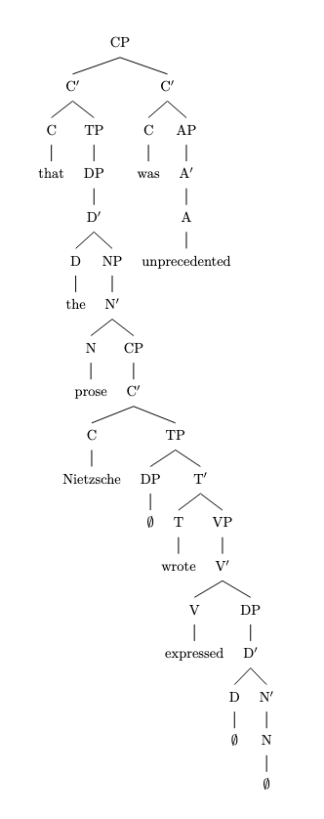
3. Here is the expanded version of the sentence with an additional layer of clausal recursion:

"The worldview that the prose Nietzsche wrote expressed that the critic praised was unprecedented."

Messages generated with 14284 tokens

gpt-4-0314

rec_01.txt gpt-4-0314 temperature=1.0
PROMPT: Consider the sentence below and complete the following three tasks:
1. Does the sentence in question contain an instance of recursion? If so, identify the recursive part and say what kind of recursion it is. Note that there are different types of recursion, e.g. adjectival recursion (an adjective modifying an adjective-modified noun), Saxon Genitive a.k.a. possessive 's recursion (an 's-possessed 's-possessor), prepositional phrase recursion (a prepositional phrase with another prepositional phrase inside), clausal recursion (a clause within another clause), and so on.
2. Provide code for a syntactic tree representing the structure of the sentence that can be rendered with LaTeX's forest package. Assume X-bar theory.
3. If you identified that the sentence contains a recursive structure, expand it by adding another layer of recursion (of the same type) to the identified structure.
"Jack van der Molen might be the sneaky old thief."
REPLY: 1. Yes, the sentence contains an instance of recursion. The recursive part is the adjectival recursion where "sneaky" modifies "old thief," which is already modified by "old."

2. Here's the code for a syntactic tree representing the structure of the sentence using LaTeX's forest package and X-bar theory:

```
\documentclass{standalone}
\usepackage[edges]{forest}

\begin{document}
\begin{forest}
for tree={parent anchor=south, child anchor=north}
[CP
[DP
[Jack van der Molen]
]
[C’
[TP
[might]
[T’
[T]
[VP
[be]
[VP
[DP
[D[the]]
[NP
[AdjP
[Adj[sneaky]]
[NP
[AdjP
[Adj[old]]
[N[thief]]
]
]
]
]
]
[V’
[V]
]
]
]
]
]
]
]
\end{forest}
\end{document}
```
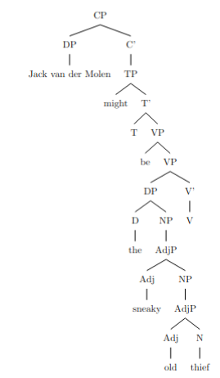
3. To expand the sentence by adding another layer of recursion (adjectival recursion), we can add another adjective modifier. Here's the modified sentence:

"Jack van der Molen might be the crafty sneaky old thief."

rec_10.txt gpt-4-0314 temperature=1.0
PROMPT: Consider the sentence below and complete the following three tasks:
1. Does the sentence in question contain an instance of recursion? If so, identify the recursive part and say what kind of recursion it is. Note that there are different types of recursion, e.g. adjectival recursion (an adjective modifying an adjective-modified noun), Saxon Genitive a.k.a. possessive 's recursion (an 's-possessed 's-possessor), prepositional phrase recursion (a prepositional phrase with another prepositional phrase inside), clausal recursion (a clause within another clause), and so on.
2. Provide code for a syntactic tree representing the structure of the sentence that can be rendered with LaTeX's forest package. Assume X-bar theory.
3. If you identified that the sentence contains a recursive structure, expand it by adding another layer of recursion (of the same type) to the identified structure.
"The footprints clearly revealed Beth's young companion's escape route."
REPLY: 1. Yes, the sentence contains an instance of recursion. The recursive part is the Saxon Genitive or possessive 's recursion: "Beth's young companion's escape route." It involves an 's-possessed noun phrase which in turn, has another 's-possessor ('young companion's escape route').

2. Syntactic tree code for the given sentence (using forest package in LaTeX):

```
\usepackage{forest}
...

\begin{forest}
[S
[NP [D [The]] [N' [N [footprints]]]]
[VP
[Adv [clearly]]
[V' [V [revealed]]
[NP
[NP [N' [N [Beth's]]]]
[Adj [young]]
[N' [N [companion's]]]
[N' [N [escape route]]]]]]]
\end{forest}
```
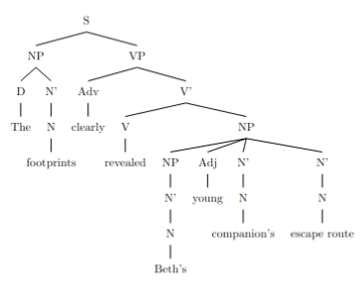
3. To add another layer of recursion to the identified structure, we can expand "Beth's young companion's escape route" as follows: "Beth's cousin's young companion's escape route."

The updated sentence is: "The footprints clearly revealed Beth's cousin's young companion's escape route."

rec_04.txt gpt-4-0314 temperature=1.0
PROMPT: Consider the sentence below and complete the following three tasks:
1. Does the sentence in question contain an instance of recursion? If so, identify the recursive part and say what kind of recursion it is. Note that there are different types of recursion, e.g. adjectival recursion (an adjective modifying an adjective-modified noun), Saxon Genitive a.k.a. possessive 's recursion (an 's-possessed 's-possessor), prepositional phrase recursion (a prepositional phrase with another prepositional phrase inside), clausal recursion (a clause within another clause), and so on.
2. Provide code for a syntactic tree representing the structure of the sentence that can be rendered with LaTeX's forest package. Assume X-bar theory.
3. If you identified that the sentence contains a recursive structure, expand it by adding another layer of recursion (of the same type) to the identified structure.
"Unidentified flying objects may have conflicting characteristics."
REPLY: 1. Yes, the sentence contains an instance of recursion. Specifically, it contains adjectival recursion, where an adjective (conflicting) modifies an adjective-modified noun (characteristics).

2. The code for a syntactic tree representing the structure of the sentence, using X-bar theory and the LaTeX forest package:

```
\begin{forest}
[TP
[DP
[D
[Unidentified]]
[NP
[N'
[N
[flying objects]]]]]
[T'
[T
[may]]]
[VP
[V'
[V [have]]]
[DP
[D
[conflicting]]
[NP
[N'
[N
[characteristics]]]]]]]
\end{forest}
```
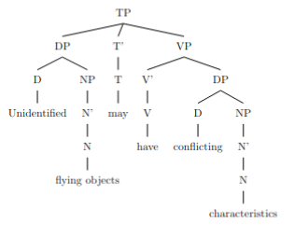
3. To add another layer of recursion, we can further modify the adjective-modified noun with another adjective:
"Unidentified flying objects may have strange conflicting characteristics."

In this expanded sentence, "strange" is an additional adjective modifying the already modified noun "conflicting characteristics."

rec_06.txt gpt-4-0314 temperature=1.0
PROMPT: Consider the sentence below and complete the following three tasks:
1. Does the sentence in question contain an instance of recursion? If so, identify the recursive part and say what kind of recursion it is. Note that there are different types of recursion, e.g. adjectival recursion (an adjective modifying an adjective-modified noun), Saxon Genitive a.k.a. possessive 's recursion (an 's-possessed 's-possessor), prepositional phrase recursion (a prepositional phrase with another prepositional phrase inside), clausal recursion (a clause within another clause), and so on.
2. Provide code for a syntactic tree representing the structure of the sentence that can be rendered with LaTeX's forest package. Assume X-bar theory.
3. If you identified that the sentence contains a recursive structure, expand it by adding another layer of recursion (of the same type) to the identified structure.
"A small child can easily get lost in a vast American mall."
REPLY: 1. Yes, the sentence contains an instance of recursion. It is a prepositional phrase recursion, specifically, the prepositional phrase "in a vast American mall" contains another prepositional phrase "in a vast American mall."

2. Here is the code for a syntactic tree representing the structure of the sentence using LaTeX's forest package:

\begin{forest}
[TP [NP [Det [A small]] [N [child]]]
[T' [T [can]]
[VP [V [easily get]]
[NP [Det [lost]]
[PP [P [in]]
[NP [Det [a vast]] [N [American mall]]]]]]]][]
\end{forest}

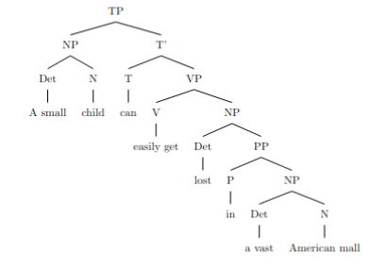
3. Expanding the recursive structure with another layer of prepositional phrase recursion:

"A small child can easily get lost in a vast American mall on a busy Saturday."

The added prepositional phrase is "on a busy Saturday."

rec_08.txt gpt-4-0314 temperature=1.0
PROMPT: Consider the sentence below and complete the following three tasks:
1. Does the sentence in question contain an instance of recursion? If so, identify the recursive part and say what kind of recursion it is. Note that there are different types of recursion, e.g. adjectival recursion (an adjective modifying an adjective-modified noun), Saxon Genitive a.k.a. possessive 's recursion (an 's-possessed 's-possessor), prepositional phrase recursion (a prepositional phrase with another prepositional phrase inside), clausal recursion (a clause within another clause), and so on.
2. Provide code for a syntactic tree representing the structure of the sentence that can be rendered with LaTeX's forest package. Assume X-bar theory.
3. If you identified that the sentence contains a recursive structure, expand it by adding another layer of recursion (of the same type) to the identified structure.
"The Old Continent's civilizations' advances have shaped history."
REPLY: 1. Yes, the sentence contains an instance of recursion. Specifically, it is an example of Saxon Genitive (or possessive 's) recursion. The recursive part is "The Old Continent's civilizations'."

2. Here is the code for a syntactic tree representing the structure of the sentence that can be rendered with LaTeX's forest package:
```
\begin{forest}
for tree={parent anchor=south, child anchor=north, align=center, base=top}
[TP
[DP
[D
[The]
]
[NP
[NP
[NP
[N
[Old]
]
]
[N'
[N
[Continent]
]
]
]
[NP'
[N
['s]
]
[N'
[N
[civilizations]
]
]
]
]
]
[T'
[T
[']
]
[VP
[V'
[V
[advances]
]
[NP
[N'
[N
[']
]
[V'
[V
[have]
]
[V'
[V
[shaped]
]
[NP
[N'
[N
[history]
]
]
]
]
]
]
]
]
]
]
]
\end{forest}
```
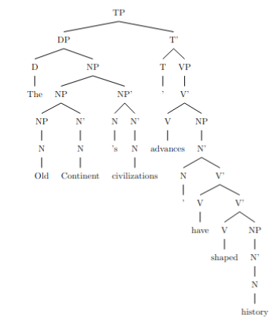
3. To expand the sentence by adding another layer of recursion (of the same type) to the identified structure, we can add another Saxon Genitive:

"The Old Continent's early civilizations' scholars' advances have shaped history."

This adds another level of possessive 's recursion with the addition of "early civilizations' scholars'."

rec_09.txt gpt-4-0314 temperature=1.0
PROMPT: Consider the sentence below and complete the following three tasks:
1. Does the sentence in question contain an instance of recursion? If so, identify the recursive part and say what kind of recursion it is. Note that there are different types of recursion, e.g. adjectival recursion (an adjective modifying an adjective-modified noun), Saxon Genitive a.k.a. possessive 's recursion (an 's-possessed 's-possessor), prepositional phrase recursion (a prepositional phrase with another prepositional phrase inside), clausal recursion (a clause within another clause), and so on.
2. Provide code for a syntactic tree representing the structure of the sentence that can be rendered with LaTeX's forest package. Assume X-bar theory.
3. If you identified that the sentence contains a recursive structure, expand it by adding another layer of recursion (of the same type) to the identified structure.
"This town's only road's potholes are driving me insane."
REPLY: 1. Yes, the sentence contains an instance of recursion. The recursive part is the Saxon Genitive a.k.a. possessive 's recursion, where we have an 's-possessed 's-possessor: "town's only road's".

2. Syntactic tree code (forest package):

\begin{forest}
[CP
[DP [Det [This]] [NP [N [town]] [D^ ['] [NP [PossP [only]] [N [road]] [D^ ['] [N [potholes]]]]]]]
[C^0]
[IP
[DP [me]]
[I^0
[I [are]] [VP
[V [driving]]
[NP [DP [me]]]
[AP [insane]]
]
]
]
]
\end{forest}
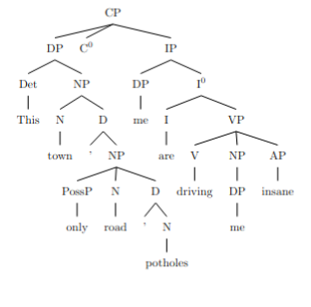
3. Adding another layer of recursion:

"This town's old road's only lane's potholes are driving me insane."

Where we added "old road's" to the recursive structure, which is again an example of the Saxon Genitive or possessive 's recursion.

rec_02.txt gpt-4-0314 temperature=1.0
PROMPT: Consider the sentence below and complete the following three tasks:
1. Does the sentence in question contain an instance of recursion? If so, identify the recursive part and say what kind of recursion it is. Note that there are different types of recursion, e.g. adjectival recursion (an adjective modifying an adjective-modified noun), Saxon Genitive a.k.a. possessive 's recursion (an 's-possessed 's-possessor), prepositional phrase recursion (a prepositional phrase with another prepositional phrase inside), clausal recursion (a clause within another clause), and so on.
2. Provide code for a syntactic tree representing the structure of the sentence that can be rendered with LaTeX's forest package. Assume X-bar theory.
3. If you identified that the sentence contains a recursive structure, expand it by adding another layer of recursion (of the same type) to the identified structure.
"Now the six trainees construct a medium-sized sturdy lamp."
REPLY: 1. Yes, the sentence contains an instance of recursion. Specifically, it has adjectival recursion: "medium-sized sturdy lamp." In this case, "medium-sized" modifies the adjective "sturdy," which in turn modifies the noun "lamp."

2. The code for a syntactic tree representing the structure of the sentence using LaTeX's forest package is as follows:

```
\documentclass{standalone}
\usepackage[linguistics]{forest}

\begin{document}
\begin{forest}
[TP
[AdvP
[Now]
]
[T'
[T
[the]
]
[VP
[NP
[Det
[six]
]
[N'
[N
[trainees]
]
]
]
[V'
[V
[construct]
]
[NP
[AP
[AP
[A
[medium-sized]
]
]
[A'
[A
[sturdy]
]
]
]
[N'
[N
[lamp]
]
]
]
]
]
]
]
\end{forest}
\end{document}
```
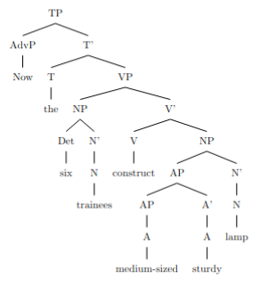

3. Expanding the identified adjectival recursion, I will add another adjective "colorful" to the structure on top of "medium-sized sturdy lamp":
"Now the six trainees construct a colorful medium-sized sturdy lamp."

rec_03.txt gpt-4-0314 temperature=1.0
PROMPT: Consider the sentence below and complete the following three tasks:
1. Does the sentence in question contain an instance of recursion? If so, identify the recursive part and say what kind of recursion it is. Note that there are different types of recursion, e.g. adjectival recursion (an adjective modifying an adjective-modified noun), Saxon Genitive a.k.a. possessive 's recursion (an 's-possessed 's-possessor), prepositional phrase recursion (a prepositional phrase with another prepositional phrase inside), clausal recursion (a clause within another clause), and so on.
2. Provide code for a syntactic tree representing the structure of the sentence that can be rendered with LaTeX's forest package. Assume X-bar theory.
3. If you identified that the sentence contains a recursive structure, expand it by adding another layer of recursion (of the same type) to the identified structure.
"Luna has been chasing the small white mouse all day long."
REPLY: 1. Yes, the sentence contains an instance of recursion. It is an adjectival recursion, where two adjectives "small" and "white" are modifying the noun "mouse".

2. Here is the code for a syntactic tree using LaTeX's forest package representing the structure of the sentence under X-bar theory:

```
\begin{forest}
[TP
[DP[Luna]]
[T'
[T[has\\been]]
[VP
[V'[V[chasing]]]
[DP
[D'[D[the]]]
[NP
[AdjP[A[small]][Adj'[A[white]]]]
[N'[N[mouse]]]
]
]
]
[AdvP
[Adv[all\\day\\long]]
]
]
\end{forest}
```

DID NOT COMPILE; ADDED BRACKET
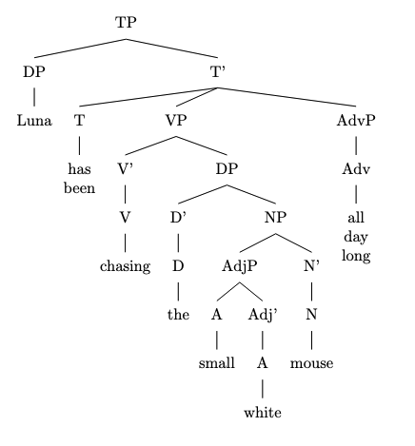
3. To add another layer of recursion (of the same type), we can introduce another adjective to modify the "mouse":

"Luna has been chasing the small white furry mouse all day long."

rec_11.txt gpt-4-0314 temperature=1.0
PROMPT: Consider the sentence below and complete the following three tasks:
1. Does the sentence in question contain an instance of recursion? If so, identify the recursive part and say what kind of recursion it is. Note that there are different types of recursion, e.g. adjectival recursion (an adjective modifying an adjective-modified noun), Saxon Genitive a.k.a. possessive 's recursion (an 's-possessed 's-possessor), prepositional phrase recursion (a prepositional phrase with another prepositional phrase inside), clausal recursion (a clause within another clause), and so on.
2. Provide code for a syntactic tree representing the structure of the sentence that can be rendered with LaTeX's forest package. Assume X-bar theory.
3. If you identified that the sentence contains a recursive structure, expand it by adding another layer of recursion (of the same type) to the identified structure.
"He spotted the infamous manuscript in the wizard's library's dark corner."
REPLY: 1. Yes, the sentence contains an instance of recursion. The recursive part is the Saxon Genitive a.k.a. possessive 's recursion, which is present in "the wizard's library's dark corner." Here, "the library's dark corner" is possessed by "the wizard," and "the dark corner" is possessed by "the library."

2. Here is a code for a syntactic tree representing the structure of the sentence:

```
\begin{forest}
[TP
[DP
[D [He]]
]
[T'
[V [spotted]]
[VP
[DP
[D [the]]
[NP
[A [infamous]]
[N [manuscript]]
]
]
[PP
[P [in]]
[DP
[DP
[DP
[D [the]]
[NP
[N [wizard]]
[N' [N [\textsc{'s}]]]
]
]
[NP
[N [library]]
[N' [N [\textsc{'s}]]]
]
]
[NP
[A [dark]]
[N [corner]]
]
]
]
]
]
]
\end{forest}
```
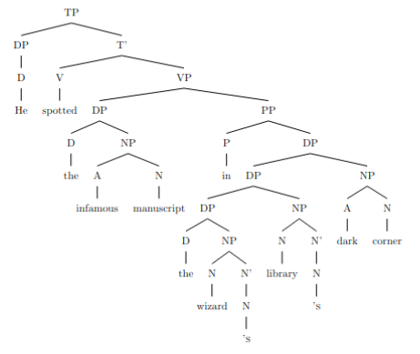
3. To expand the identified structure with another layer of recursion, we can add another possessive 's structure:

"He spotted the infamous manuscript in the wizard's library's dark corner's hidden shelf."

rec_07.txt gpt-4-0314 temperature=1.0
PROMPT: Consider the sentence below and complete the following three tasks:
1. Does the sentence in question contain an instance of recursion? If so, identify the recursive part and say what kind of recursion it is. Note that there are different types of recursion, e.g. adjectival recursion (an adjective modifying an adjective-modified noun), Saxon Genitive a.k.a. possessive 's recursion (an 's-possessed 's-possessor), prepositional phrase recursion (a prepositional phrase with another prepositional phrase inside), clausal recursion (a clause within another clause), and so on.
2. Provide code for a syntactic tree representing the structure of the sentence that can be rendered with LaTeX's forest package. Assume X-bar theory.
3. If you identified that the sentence contains a recursive structure, expand it by adding another layer of recursion (of the same type) to the identified structure.
"A sudden shriek penetrated the cold winter's night's dead silence."
REPLY: 1. Yes, the sentence contains an instance of recursion. The recursive part is the possessive 's recursion (Saxon Genitive), which can be observed in "winter's night's dead silence."

2. The code for a syntactic tree representing the structure of the sentence using LaTeX's forest package is as follows:

```
\begin{forest}
for tree={s sep=10pt}
[TP
[DP
[D']
[D [-A]]
[NP
[\textit{a sudden shriek}]]]
[T'
[T [-ed]]
[VP
[V'
[V [\textit{penetrated}]]
[DP
[D'
[D [-the]]
[NP
[NP
[N'
[N'
[N [\textit{silence}]]]
[A'
[A [\textit{dead}]]]]]
[NP [0, no edge]
[NP
[\textit{winter's night's}]]]]]]]]]
\end{forest}
```
DOES NOT COMPILE; ADDED BRACKET
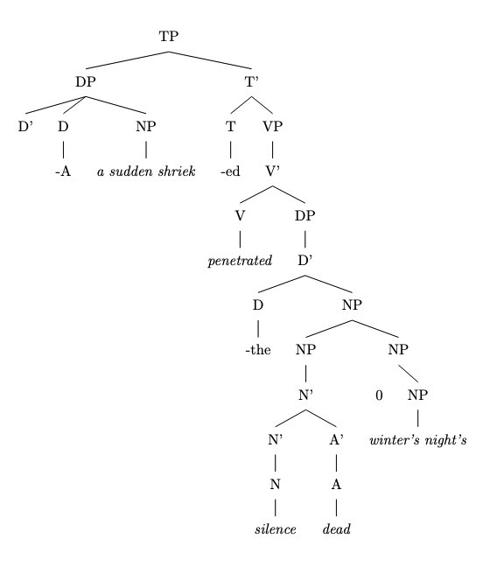

3. An expansion of the sentence while adding another layer of recursion could be: "A sudden shriek penetrated the cold December's winter's night's dead silence." Here, the possessive 's recursion is expanded to include "December's winter's night's."

rec_05.txt gpt-4-0314 temperature=1.0
PROMPT: Consider the sentence below and complete the following three tasks:
1. Does the sentence in question contain an instance of recursion? If so, identify the recursive part and say what kind of recursion it is. Note that there are different types of recursion, e.g. adjectival recursion (an adjective modifying an adjective-modified noun), Saxon Genitive a.k.a. possessive 's recursion (an 's-possessed 's-possessor), prepositional phrase recursion (a prepositional phrase with another prepositional phrase inside), clausal recursion (a clause within another clause), and so on.
2. Provide code for a syntactic tree representing the structure of the sentence that can be rendered with LaTeX's forest package. Assume X-bar theory.
3. If you identified that the sentence contains a recursive structure, expand it by adding another layer of recursion (of the same type) to the identified structure.
"My cranky geriatric manager is beyond incompetent."
REPLY: 1. Yes, the sentence contains an instance of recursion. The recursive part is the adjectival recursion, as we have an adjective ("cranky") modifying another adjective-modified noun ("geriatric manager").

2. Here's the code for a syntactic tree representing the structure of the sentence using LaTeX's forest package:

```
\begin{forest}
for tree={s sep=7mm, inner sep=0}
[TP
[DP [D [My]] [NP [AdjP [Adj [cranky]] [AdjP [Adj [geriatric]]] ] [NP [manager]]]]
[VP [V [is]] [AdjP [Adj [beyond]] [Adj [incompetent]] ]]
]
\end{forest}
```
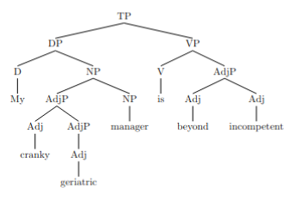
3. Expanding the sentence by adding another layer of adjectival recursion:

"My slightly cranky geriatric manager is beyond incompetent."

Here's the code for a syntactic tree representing the structure of the expanded sentence using LaTeX's forest package:

```
\begin{forest}
for tree={s sep=7mm, inner sep=0}
[TP
[DP [D [My]] [NP [AdjP [Adj [slightly]] [AdjP [Adj [cranky]]] ] [AdjP [Adj [geriatric]]] [NP [manager]]]]
[VP [V [is]] [AdjP [Adj [beyond]] [Adj [incompetent]] ]]
]
\end{forest}
```

rec_12.txt gpt-4-0314 temperature=1.0
PROMPT: Consider the sentence below and complete the following three tasks:
1. Does the sentence in question contain an instance of recursion? If so, identify the recursive part and say what kind of recursion it is. Note that there are different types of recursion, e.g. adjectival recursion (an adjective modifying an adjective-modified noun), Saxon Genitive a.k.a. possessive 's recursion (an 's-possessed 's-possessor), prepositional phrase recursion (a prepositional phrase with another prepositional phrase inside), clausal recursion (a clause within another clause), and so on.
2. Provide code for a syntactic tree representing the structure of the sentence that can be rendered with LaTeX's forest package. Assume X-bar theory.
3. If you identified that the sentence contains a recursive structure, expand it by adding another layer of recursion (of the same type) to the identified structure.
"Do I dare challenge my advisor's thesis' central argument?"
REPLY: 1. Yes, the sentence contains an instance of recursion. It is Saxon Genitive recursion with the possessive 's. The recursive part is "my advisor's thesis' central argument."

2. Here is the code for a syntactic tree representing the structure of the sentence:

```
\documentclass{standalone}
\usepackage{forest}
\begin{document}
\begin{forest}
[CP
[C' [C [Do]]]
[IP
[NP [I [-I [dare]]]]
[I'
[I [challenge]]]
[VP
[V' [V [e]]]
[NP
[D [my]]
[N'
[N [advisor's]]
[N' [N [thesis' [central argument]]]]
]
]
]
]
]
]
\end{forest}
\end{document}
```

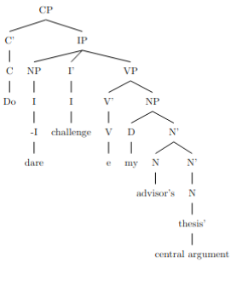1
1
3. Expanding the sentence with another layer of recursion of the same type (Saxon Genitive), the sentence becomes:

"Do I dare challenge my advisor's brother's thesis' central argument?"

Here, "my advisor's brother's thesis' central argument" has an additional layer of Saxon Genitive recursion.

rec_15.txt gpt-4-0314 temperature=1.0
PROMPT: Consider the sentence below and complete the following three tasks:
1. Does the sentence in question contain an instance of recursion? If so, identify the recursive part and say what kind of recursion it is. Note that there are different types of recursion, e.g. adjectival recursion (an adjective modifying an adjective-modified noun), Saxon Genitive a.k.a. possessive 's recursion (an 's-possessed 's-possessor), prepositional phrase recursion (a prepositional phrase with another prepositional phrase inside), clausal recursion (a clause within another clause), and so on.
2. Provide code for a syntactic tree representing the structure of the sentence that can be rendered with LaTeX's forest package. Assume X-bar theory.
3. If you identified that the sentence contains a recursive structure, expand it by adding another layer of recursion (of the same type) to the identified structure.
"He had been warned about the dangers of tobacco."
REPLY: 1. Yes, the sentence contains an instance of recursion. The recursion is a clausal recursion, as the sentence contains a passive participle clause within the main clause. The recursive part is "been warned about the dangers of tobacco" which can be further analyzed as "been warned (about the dangers (of tobacco))".

2. Syntactic tree code for LaTeX's forest package:
```
\documentclass{standalone}
\usepackage[linguistics]{forest}

\begin{document}
\begin{forest}
for tree={s sep=8ex,l sep=16ex,font=\footnotesize}
[
[TP
[NP, name=subj
[He]
]
[T'
[T
[had+Aux]
]
[VP
[V'
[V+Aux
[been]
]
[V'
[V
[warned]
]
[PP
[P
[about]
]
[NP
[NP
[the]
[N
[dangers]
]
]
[PP
[P
[of]
]
[NP
[tobacco]
]
]
]
]
]
]
]
]
]
]
\end{forest}
\end{document}
```
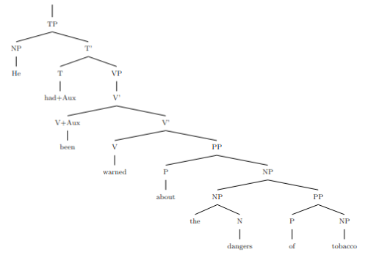
3. Expanded sentence with another layer of clausal recursion: "He had been warned about the dangers of tobacco, which had been discussed in the health magazine."

rec_13.txt gpt-4-0314 temperature=1.0
PROMPT: Consider the sentence below and complete the following three tasks:
1. Does the sentence in question contain an instance of recursion? If so, identify the recursive part and say what kind of recursion it is. Note that there are different types of recursion, e.g. adjectival recursion (an adjective modifying an adjective-modified noun), Saxon Genitive a.k.a. possessive 's recursion (an 's-possessed 's-possessor), prepositional phrase recursion (a preI positional phrase with another prepositional phrase inside), clausal recursion (a clause within another clause), and so on.
2. Provide code for a syntactic tree representing the structure of the sentence that can be rendered with LaTeX's forest package. Assume X-bar theory.
3. If you identified that the sentence contains a recursive structure, expand it by adding another layer of recursion (of the same type) to the identified structure.
"She saw someone loitering by the entrance to the library."
REPLY: 1. Yes, the sentence contains an instance of recursion. Specifically, it has prepositional phrase recursion. The recursive part is "by the entrance to the library." Inside this prepositional phrase, there is another prepositional phrase "to the library."

2. Here is the code for a syntactic tree representing the structure of the sentence using LaTeX's forest package and assuming X-bar theory:

\begin{forest}
for tree={font=\sffamily, s sep=3cm}
[CP
[TP
[DP
[She]
]
[T'
[T[-ed]]
[VP
[V
[saw]
]
[DP
[D
[someone]
]
]
[VP'
[V[-ing]]
[PP %[By]
[P
[by]
]
[NP
[Det[the]]
[N' [N [entrance] ]
[PP %[to]
[P [to]]
[DP
[Det[the]]
[N'[ N[library]]]
]
]
]
]
]
]
]
]
]
]
\end{forest}

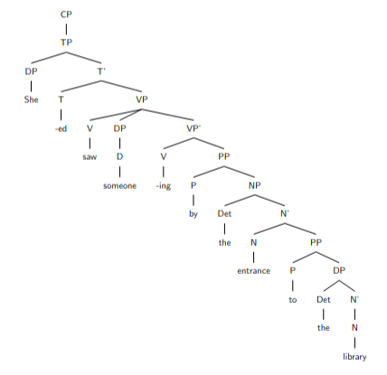

3. Expanding the recursive structure by adding another layer of prepositional phrase recursion:

"She saw someone loitering by the entrance to the library near the old oak tree."

The additional layer of prepositional phrase recursion is "near the old oak tree."

rec_14.txt gpt-4-0314 temperature=1.0
PROMPT: Consider the sentence below and complete the following three tasks:
1. Does the sentence in question contain an instance of recursion? If so, identify the recursive part and say what kind of recursion it is. Note that there are different types of recursion, e.g. adjectival recursion (an adjective modifying an adjective-modified noun), Saxon Genitive a.k.a. possessive 's recursion (an 's-possessed 's-possessor), prepositional phrase recursion (a prepositional phrase with another prepositional phrase inside), clausal recursion (a clause within another clause), and so on.
2. Provide code for a syntactic tree representing the structure of the sentence that can be rendered with LaTeX's forest package. Assume X-bar theory.
3. If you identified that the sentence contains a recursive structure, expand it by adding another layer of recursion (of the same type) to the identified structure.
"We sow fear in the hearts of our enemies."
REPLY: 1. Yes, the sentence contains an instance of recursion. It is a prepositional phrase recursion, with one prepositional phrase ("in the hearts") nested within another prepositional phrase ("of our enemies").

2. Syntactic tree code:
```
\begin{forest}
[S
[NP [PRON [We]]]
[VP
[V [sow]]
[NP
[N [fear]]
]
[PP
[P [in]]
[NP
[Det [the]]
[N'
[N [hearts]]
[PP
[P [of]]
[NP
[PossP [PRON [our]]]
[N [enemies]]
]
]
]
]
]
]
]
\end{forest}
```
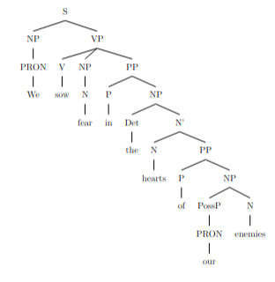
3. Expanded sentence with an additional layer of recursion: "We sow fear in the hearts of the leaders of our enemies."

rec_17.txt gpt-4-0314 temperature=1.0
PROMPT: Consider the sentence below and complete the following three tasks:
1. Does the sentence in question contain an instance of recursion? If so, identify the recursive part and say what kind of recursion it is. Note that there are different types of recursion, e.g. adjectival recursion (an adjective modifying an adjective-modified noun), Saxon Genitive a.k.a. possessive 's recursion (an 's-possessed 's-possessor), prepositional phrase recursion (a prepositional phrase with another prepositional phrase inside), clausal recursion (a clause within another clause), and so on.
2. Provide code for a syntactic tree representing the structure of the sentence that can be rendered with LaTeX's forest package. Assume X-bar theory.
3. If you identified that the sentence contains a recursive structure, expand it by adding another layer of recursion (of the same type) to the identified structure.
"Even their recipe for the basic dough of the pie crust is heavily guarded."
REPLY: 1. Yes, the sentence contains an instance of recursion. The recursive part is the prepositional phrase recursion: "for the basic dough" is a prepositional phrase inside another prepositional phrase "of the pie crust."

2. Syntactic tree code:

```
\begin{forest}
[S
[AdvP [Even] ]
[DP [D [their] ]
[NP [N'[N [recipe] ]
[PP [P [for] ]
[DP [D [the] ]
[NP [A [basic] ]
[N'[N [dough] ]
[PP [P [of] ]
[DP [D [the] ]
[NP [N'[N [pie]]]
[N'[N [crust]]]
]
]
]
]
]
]
]
]
]
[VP [AUX [is]]
[AdjP [A [heavily]]
[Adj'[A [guarded]]
]
]
]
]
\end{forest}
```

DOES NOT COMPILE; ADDED BRACKET (AM)
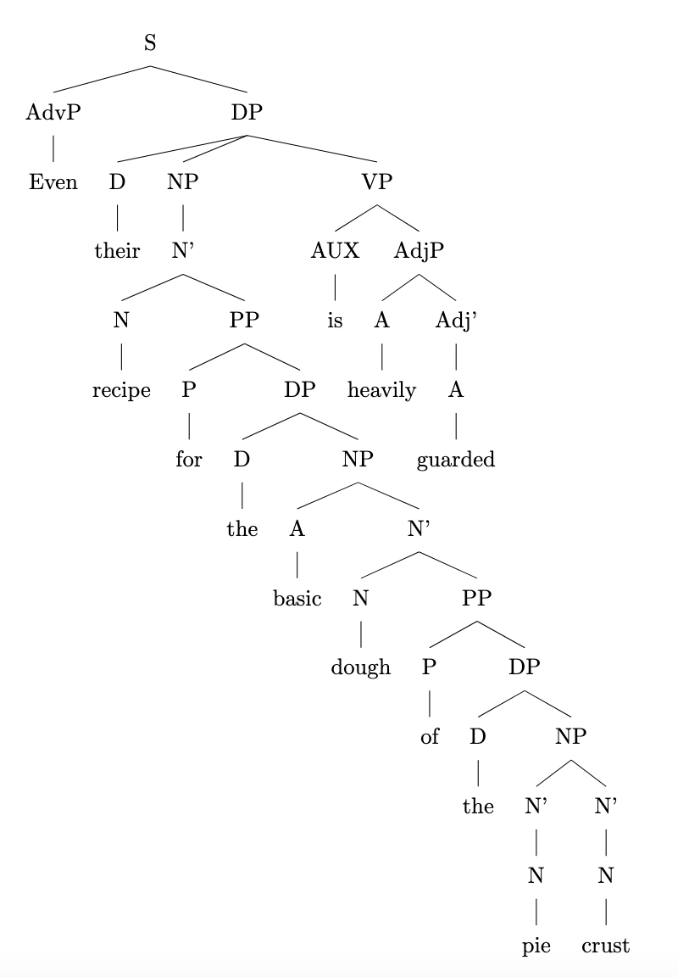

3. Expanded sentence with another layer of recursion (prepositional phrase recursion):

"Even their recipe for the basic dough of the pie crust with a hint of cinnamon is heavily guarded."

rec_16.txt gpt-4-0314 temperature=1.0
PROMPT: Consider the sentence below and complete the following three tasks:
1. Does the sentence in question contain an instance of recursion? If so, identify the recursive part and say what kind of recursion it is. Note that there are different types of recursion, e.g. adjectival recursion (an adjective modifying an adjective-modified noun), Saxon Genitive a.k.a. possessive 's recursion (an 's-possessed 's-possessor), prepositional phrase recursion (a prepositional phrase with another prepositional phrase inside), clausal recursion (a clause within another clause), and so on.
2. Provide code for a syntactic tree representing the structure of the sentence that can be rendered with LaTeX's forest package. Assume X-bar theory.
3. If you identified that the sentence contains a recursive structure, expand it by adding another layer of recursion (of the same type) to the identified structure.
"There is a little treat for you in the cupboard between the lamps."
REPLY: 1. Yes, the sentence contains an instance of recursion. The recursive part is the prepositional phrase (PP) recursion found in "in the cupboard between the lamps." Here, "between the lamps" is nested inside the other prepositional phrase "in the cupboard."

2. Here is the code for a syntactic tree representing the structure of the sentence using LaTeX's forest package and X-bar theory:

\begin{forest}
[TP
[NP
[Det [There]]
]
[T'
[T [is]]
[VP
[V']
[NP
[Det [a]]
[AdjP
[Adj [little]]
]
[NP'
[N' [N [treat]]]
[PP
[P [for]]
[NP [N [you]]]
]
]
]
[PP
[P [in]]
[NP
[Det [the]]
[N' [N [cupboard]]]
[PP
[P [between]]
[NP
[Det [the]]
[N' [N [lamps]]]
]
]
]
]
]
]
]
\end{forest}
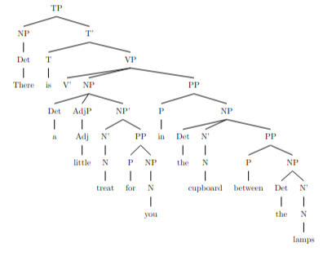
3. To add another layer of recursion (of the same type), we can expand the prepositional phrase recursion as follows:

"There is a little treat for you in the cupboard between the lamps above the books."

Here, "above the books" is nested inside the other prepositional phrase "in the cupboard between the lamps."

rec_19.txt gpt-4-0314 temperature=1.0
PROMPT: Consider the sentence below and complete the following three tasks:
1. Does the sentence in question contain an instance of recursion? If so, identify the recursive part and say what kind of recursion it is. Note that there are different types of recursion, e.g. adjectival recursion (an adjective modifying an adjective-modified noun), Saxon Genitive a.k.a. possessive 's recursion (an 's-possessed 's-possessor), prepositional phrase recursion (a prepositional phrase with another prepositional phrase inside), clausal recursion (a clause within another clause), and so on.
2. Provide code for a syntactic tree representing the structure of the sentence that can be rendered with LaTeX's forest package. Assume X-bar theory.
3. If you identified that the sentence contains a recursive structure, expand it by adding another layer of recursion (of the same type) to the identified structure.
"You must remember that you should always run all the basic diagnostics first."
REPLY: 1. Yes, the sentence contains an instance of recursion. The recursive part is the adjectival recursion, where an adjective (basic) modifies an adjective-modified noun (diagnostics).

2. Syntactic tree code for LaTeX's forest package:

```

```

DOES NOT COMPILE

3. Expanding the sentence with another layer of adjectival recursion (adding "crucial" as an adjective):
"You must remember that you should always run all the crucial basic diagnostics first."

rec_20.txt gpt-4-0314 temperature=1.0
PROMPT: Consider the sentence below and complete the following three tasks:
1. Does the sentence in question contain an instance of recursion? If so, identify the recursive part and say what kind of recursion it is. Note that there are different types of recursion, e.g. adjectival recursion (an adjective modifying an adjective-modified noun), Saxon Genitive a.k.a. possessive 's recursion (an 's-possessed 's-possessor), prepositional phrase recursion (a prepositional phrase with another prepositional phrase inside), clausal recursion (a clause within another clause), and so on.
2. Provide code for a syntactic tree representing the structure of the sentence that can be rendered with LaTeX's forest package. Assume X-bar theory.
3. If you identified that the sentence contains a recursive structure, expand it by adding another layer of recursion (of the same type) to the identified structure.
"She announced her victory to irritate her detractors."
REPLY: 1. Yes, the sentence contains an instance of recursion. The recursive part is the clausal recursion, specifically the embedded clause "to irritate her detractors" within the main clause "She announced her victory."

2. Syntactic tree code for LaTeX's forest package:

```
\begin{forest}
for tree={parent anchor=south, child anchor=north, align=center,base=top}
[TP
[NP
[She, name=subject]
]
[T'
[T]
[VP
[V'
[V
[announced, name=verb]
]
[NP
[her]
[victory]
]
]
[PP
[to]
[IP
[irritate]
[NP
[her]
[detractors]
]
]
]
]
]
]
\end{forest}
```
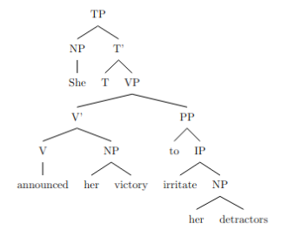
3. To expand the sentence by adding another layer of recursion, we can embed another clausal recursion inside the existing one: "She announced her victory to irritate her detractors who always criticized her."

New sentence: "She announced her victory to irritate her detractors who always criticized her."

rec_18.txt gpt-4-0314 temperature=1.0
PROMPT: Consider the sentence below and complete the following three tasks:
1. Does the sentence in question contain an instance of recursion? If so, identify the recursive part and say what kind of recursion it is. Note that there are different types of recursion, e.g. adjectival recursion (an adjective modifying an adjective-modified noun), Saxon Genitive a.k.a. possessive 's recursion (an 's-possessed 's-possessor), prepositional phrase recursion (a prepositional phrase with another prepositional phrase inside), clausal recursion (a clause within another clause), and so on.
2. Provide code for a syntactic tree representing the structure of the sentence that can be rendered with LaTeX's forest package. Assume X-bar theory.
3. If you identified that the sentence contains a recursive structure, expand it by adding another layer of recursion (of the same type) to the identified structure.
"Drowning your sorrows in a glass of whiskey is at best a temporary solution."
REPLY: 1. Yes, the sentence contains an instance of recursion in the form of a prepositional phrase recursion. The recursive part is "in a glass of whiskey", where "of whiskey" is a prepositional phrase within the larger prepositional phrase "in a glass of whiskey".

2. Code for a syntactic tree with LaTeX's forest package:

```
\begin{forest}
[S
[VP
[V'
[V [Drowning]] [NP [your sorrows]]]
[PP
[P [in]]
[NP
[Det [a]]
[N'
[N [glass]]
[PP
[P [of]]
[NP [whiskey]]]]]]]
[VP
[AUX [is]]
[AP
[A
[Deg [at best]]]
[A'
[A [temporary]]
[N [solution]]]]]]
\end{forest}
```
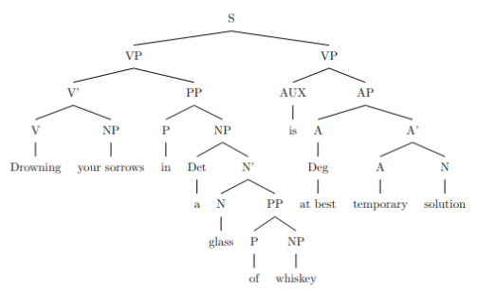
3. Expanding the recursive structure with another layer of recursion:

"Drowning your sorrows in a glass of whiskey from a famous distillery is at best a temporary solution."

Here, "from a famous distillery" is another prepositional phrase added within the recursive structure, resulting in "in a glass of whiskey from a famous distillery".

rec_22.txt gpt-4-0314 temperature=1.0
PROMPT: Consider the sentence below and complete the following three tasks:
1. Does the sentence in question contain an instance of recursion? If so, identify the recursive part and say what kind of recursion it is. Note that there are different types of recursion, e.g. adjectival recursion (an adjective modifying an adjective-modified noun), Saxon Genitive a.k.a. possessive 's recursion (an 's-possessed 's-possessor), prepositional phrase recursion (a prepositional phrase with another prepositional phrase inside), clausal recursion (a clause within another clause), and so on.
2. Provide code for a syntactic tree representing the structure of the sentence that can be rendered with LaTeX's forest package. Assume X-bar theory.
3. If you identified that the sentence contains a recursive structure, expand it by adding another layer of recursion (of the same type) to the identified structure.
"The few that could understand the manifesto's complex worldview appreciated it."
REPLY: 1. Yes, the sentence contains an instance of recursion. The recursive part is the clausal recursion, with the clause "that could understand the manifesto's complex worldview" embedded within the main clause.

2. Syntactic tree code for LaTeX's forest package:
```
\begin{forest}
[IP
[DP [D [The]] [NP [Adj [few]]]]
[I'
[VP
[V [could]]
[VP
[V [understand]]
[CP
[C [that]]
[IP
[DP [pro]]
[I'
[VP
[V [appreciate]]
[DP [D [the]] [NP [N [manifesto]] [NP [Saxon Genitive ['s]] [N [complex worldview]]]]]
]
]
]
]
]
]
]
]
\end{forest}
```
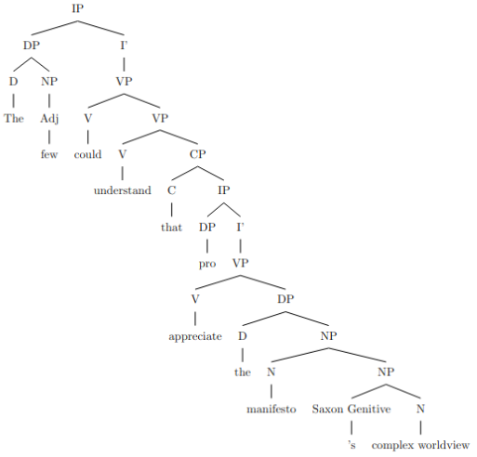
3. Expanded recursive sentence with an additional layer of clausal recursion:
"The few that could understand the manifesto's complex worldview, which was written by a brilliant thinker, appreciated it."

rec_21.txt gpt-4-0314 temperature=1.0
PROMPT: Consider the sentence below and complete the following three tasks:
1. Does the sentence in question contain an instance of recursion? If so, identify the recursive part and say what kind of recursion it is. Note that there are different types of recursion, e.g. adjectival recursion (an adjective modifying an adjective-modified noun), Saxon Genitive a.k.a. possessive 's recursion (an 's-possessed 's-possessor), prepositional phrase recursion (a prepositional phrase with another prepositional phrase inside), clausal recursion (a clause within another clause), and so on.
2. Provide code for a syntactic tree representing the structure of the sentence that can be rendered with LaTeX's forest package. Assume X-bar theory.
3. If you identified that the sentence contains a recursive structure, expand it by adding another layer of recursion (of the same type) to the identified structure.
"Paul cherished his worn-out diary, whose pages were heavily marked by stains"
REPLY: 1. Yes, the sentence contains an instance of recursion. The recursive part is the relative clause "whose pages were heavily marked by stains". This is an example of clausal recursion since a clause is within another clause.

2. Here's the code for a syntactic tree representing the structure of the sentence that can be rendered with LaTeX's forest package:

\begin{forest}
[S
[NP [N [Paul]]]
[VP
[V [cherished]]
[NP
[D [his]]
[N' [A [worn-out]] [N [diary]]]
[CP
[C [$\emptyset$]]
[S
[NP [D [whose]] [N [pages]]]
[VP [V' [V [were]] [A' [A [heavily]] [A [marked]]]] [PP [P [by]] [NP [N [stains]]]]]
]
]
]
]
]
\end{forest}
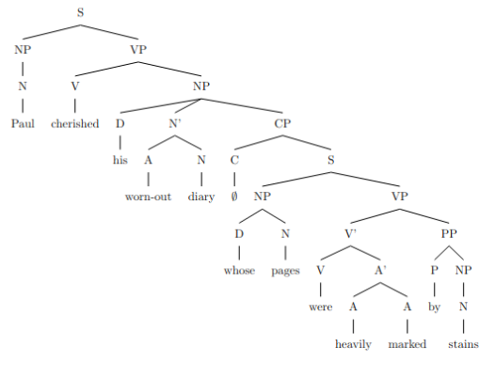
3. To expand the recursive structure with another layer of recursion, we can add another relative clause to the existing one:

"Paul cherished his worn-out diary, whose pages were heavily marked by stains, that were caused by countless spills."

This adds another relative clause "that were caused by countless spills" to the already existing recursive structure.

rec_25.txt gpt-4-0314 temperature=1.0
PROMPT: Consider the sentence below and complete the following three tasks:
1. Does the sentence in question contain an instance of recursion? If so, identify the recursive part and say what kind of recursion it is. Note that there are different types of recursion, e.g. adjectival recursion (an adjective modifying an adjective-modified noun), Saxon Genitive a.k.a. possessive 's recursion (an 's-possessed 's-possessor), prepositional phrase recursion (a prepositional phrase with another prepositional phrase inside), clausal recursion (a clause within another clause), and so on.
2. Provide code for a syntactic tree representing the structure of the sentence that can be rendered with LaTeX's forest package. Assume X-bar theory.
3. If you identified that the sentence contains a recursive structure, expand it by adding another layer of recursion (of the same type) to the identified structure.
"Pieces of a diary Paul tore to shreds lay on the ground."
REPLY: 1. Yes, the sentence contains an instance of recursion. The recursive part is the prepositional phrase recursion: "of a diary Paul tore to shreds" inside the noun phrase "Pieces of a diary Paul tore to shreds".

2. The code for a syntactic tree representing the structure of the sentence is as follows:

\begin{forest}
[NP
[N [Pieces]]
[PP
[P [of]]
[NP'
[NP
[Det [a]]
[N [diary]]
]
[CP
[C [that]]
[IP
[NP [Paul]]
[VP
[V [tore]]
[PP
[P [to]]
[NP
[N [shreds]]
]
]
]
]
]
]
]
]
\end{forest}
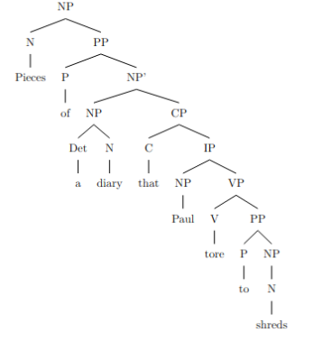

3. If we expand the sentence by adding another layer of recursion (of the same type), we get:
"Pieces of a diary of a famous writer Paul tore to shreds lay on the ground."

Here, "of a famous writer" is the additional prepositional phrase inside the noun phrase "a diary of a famous writer Paul tore to shreds".

rec_23.txt gpt-4-0314 temperature=1.0
PROMPT: Consider the sentence below and complete the following three tasks:
1. Does the sentence in question contain an instance of recursion? If so, identify the recursive part and say what kind of recursion it is. Note that there are different types of recursion, e.g. adjectival recursion (an adjective modifying an adjective-modified noun), Saxon Genitive a.k.a. possessive 's recursion (an 's-possessed 's-possessor), prepositional phrase recursion (a prepositional phrase with another prepositional phrase inside), clausal recursion (a clause within another clause), and so on.
2. Provide code for a syntactic tree representing the structure of the sentence that can be rendered with LaTeX's forest package. Assume X-bar theory.
3. If you identified that the sentence contains a recursive structure, expand it by adding another layer of recursion (of the same type) to the identified structure.
"The mirror the girl punched shattered into a million pieces."
REPLY: 1. Yes, the sentence contains an instance of recursion. The recursive part is the clausal recursion in the form of a relative clause, "the girl punched," which modifies the noun "mirror."

2. Here's the code for a syntactic tree representing the structure of the sentence, using LaTeX's forest package:

\begin{forest}
for tree={parent anchor=south, child anchor=north,align=center,base=top}
[TP
[DP
[D [The] ]
[NP [N[N[mirror] ]
[CP [C [ (that)] ]
[TP [DP [D [the] ]
[NP [N [girl] ]
]]
[VP [V[punched] ]
[NP [-pro-] ]]]]]]
[VP [V [shattered] ]
[PP [P [into] ]
[DP [D [a] ]
[NP [N[ [million] ][pieces] ]]]]]]]]
\end{forest}
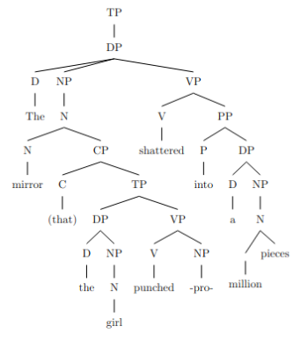
3. To add another layer of recursion, let's add an additional relative clause modifying the noun "girl":

"The mirror the girl who wore a red dress punched shattered into a million pieces."

The sentence now contains an additional clausal recursion ("who wore a red dress") within the initial clausal recursion ("the girl punched").

rec_24.txt gpt-4-0314 temperature=1.0
PROMPT: Consider the sentence below and complete the following three tasks:
1. Does the sentence in question contain an instance of recursion? If so, identify the recursive part and say what kind of recursion it is. Note that there are different types of recursion, e.g. adjectival recursion (an adjective modifying an adjective-modified noun), Saxon Genitive a.k.a. possessive 's recursion (an 's-possessed 's-possessor), prepositional phrase recursion (a prepositional phrase with another prepositional phrase inside), clausal recursion (a clause within another clause), and so on.
2. Provide code for a syntactic tree representing the structure of the sentence that can be rendered with LaTeX's forest package. Assume X-bar theory.
3. If you identified that the sentence contains a recursive structure, expand it by adding another layer of recursion (of the same type) to the identified structure.
"Every desk I put a heavy lamp on eventually cracked."
REPLY: 1. Yes, the sentence contains an instance of recursion. The recursion is a prepositional phrase recursion, as seen in the "on eventually cracked" part of the sentence.

2.
```
\begin{forest}
[S
[NP
[Det [Every]]
[N'
[Noun [desk]]
[CP
[C [I]]
[S'
[VP
[Verb [put]]
[NP
[Det [a]]
[Adj [heavy]]
[Noun [lamp]]
]
[PP
[P [on]]
[NP [D [eventually]] [Noun [cracked]]]
]
]
]
]
]
]
]

\end{forest}
```
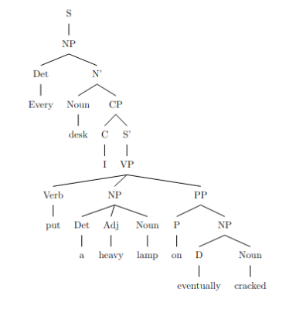
3. Expanded sentence with another layer of recursion: "Every desk I put a heavy lamp on in the dimly lit room eventually cracked."

The expanded sentence includes another prepositional phrase "in the dimly lit room" within the original prepositional phrase "on eventually cracked".

rec_27.txt gpt-4-0314 temperature=1.0
PROMPT: Consider the sentence below and complete the following three tasks:
1. Does the sentence in question contain an instance of recursion? If so, identify the recursive part and say what kind of recursion it is. Note that there are different types of recursion, e.g. adjectival recursion (an adjective modifying an adjective-modified noun), Saxon Genitive a.k.a. possessive 's recursion (an 's-possessed 's-possessor), prepositional phrase recursion (a prepositional phrase with another prepositional phrase inside), clausal recursion (a clause within another clause), and so on.
2. Provide code for a syntactic tree representing the structure of the sentence that can be rendered with LaTeX's forest package. Assume X-bar theory.
3. If you identified that the sentence contains a recursive structure, expand it by adding another layer of recursion (of the same type) to the identified structure.
"The expert every investigator we dispatched questioned remained completely silent."
REPLY: 1. Yes, the sentence contains an instance of recursion. The recursive part is the noun phrase "every investigator we dispatched questioned." This is an example of clausal recursion, as the relative clause "we dispatched" is embedded within the larger clause "every investigator we dispatched questioned."

2. The code for a syntactic tree representing the structure of the sentence is as follows:

\begin{forest}
[CP
[C]
[IP
[NP[D[The]][N'[N[expert]][CP
[C'[C[ø]][IP
[NP[D[every]][N'[N[investigator]][CP
[C'[C[ø]][IP
[NP[we]][VP[V[dispatched]]]
]]]]]]]]
]]
[VP
[V'[V[questioned]][AdvP[Adv[completely]][AdjP[Adj[silent]]]]]
]
]
]
\end{forest}
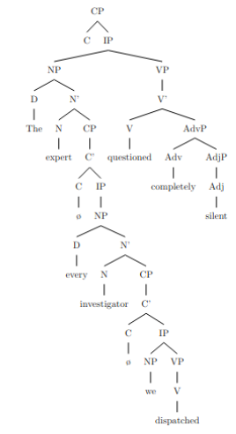
3. Expanding the sentence with another layer of recursion, adding a relative clause within the original relative clause:

"The expert every investigator we dispatched after receiving reports questioned remained completely silent."

Here, "after receiving reports" is added as another instance of clausal recursion within the original relative clause "we dispatched."

rec_26.txt gpt-4-0314 temperature=1.0
PROMPT: Consider the sentence below and complete the following three tasks:
1. Does the sentence in question contain an instance of recursion? If so, identify the recursive part and say what kind of recursion it is. Note that there are different types of recursion, e.g. adjectival recursion (an adjective modifying an adjective-modified noun), Saxon Genitive a.k.a. possessive 's recursion (an 's-possessed 's-possessor), prepositional phrase recursion (a prepositional phrase with another prepositional phrase inside), clausal recursion (a clause within another clause), and so on.
2. Provide code for a syntactic tree representing the structure of the sentence that can be rendered with LaTeX's forest package. Assume X-bar theory.
3. If you identified that the sentence contains a recursive structure, expand it by adding another layer of recursion (of the same type) to the identified structure.
"The expert every journalist questioned remained completely silent."
REPLY: 1. Yes, the sentence contains an instance of clausal recursion. The clausal recursion appears as a relative clause "every journalist questioned" inside the main clause "The expert remained completely silent."

2. Here is the code for a syntactic tree representing the structure of the sentence:

```
\begin{forest}
for tree={align=center, parent anchor=south, child anchor=north, base=top}
[TP
[DP
[D [The]]
[NP
[AdjP
[Adj [expert]]
]
[N'
[N [\\ \\ ]]
[CP
[C [every]]
[TP
[NP
[N [journalist]]
]
[T'
[T [questioned]]
[VP
[V [\\ \\ ]]
[NP
[N [\\ \\ ]]
]
]
]
]
]
]
]
]
[T'
[T [remained]]
[VP
[AdvP
[Adv [completely]]
]
[V'
[V [silent]]
]
]
]
]
\end{forest}
```
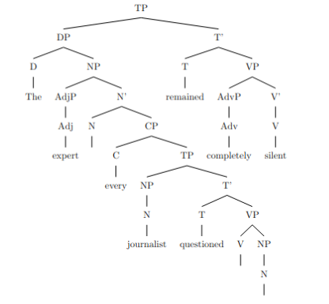

3. Here is the sentence with another layer of clausal recursion added:

"The expert every journalist who arrived early questioned remained completely silent."

In this sentence, the additional clausal recursion is "who arrived early" within the "every journalist questioned" relative clause.

rec_28.txt gpt-4-0314 temperature=1.0
PROMPT: Consider the sentence below and complete the following three tasks:
1. Does the sentence in question contain an instance of recursion? If so, identify the recursive part and say what kind of recursion it is. Note that there are different types of recursion, e.g. adjectival recursion (an adjective modifying an adjective-modified noun), Saxon Genitive a.k.a. possessive 's recursion (an 's-possessed 's-possessor), prepositional phrase recursion (a prepositional phrase with another prepositional phrase inside), clausal recursion (a clause within another clause), and so on.
2. Provide code for a syntactic tree representing the structure of the sentence that can be rendered with LaTeX's forest package. Assume X-bar theory.
3. If you identified that the sentence contains a recursive structure, expand it by adding another layer of recursion (of the same type) to the identified structure.
"The astronomy the ancients we revere studied was not separate from astrology."
REPLY: 1. Yes, the sentence contains an instance of recursion. The specific type of recursion here is a nominal recursion, as "the ancients we revere" is embedded inside the noun phrase "the astronomy the ancients we revere studied."

2. Here is the code for the syntactic tree using the forest package in LaTeX, under X-bar theory:

\begin{forest}
[CP
[C]
[TP
[NP
[Det [the]]
[N'
[N [astronomy]]
[CP
[C]
[TP
[NP
[Det [the]]
[N' [N [ancients]]]
[AP [A [we revere]]]]
[T'
[T]
[VP
[V [studied]]
[NP
[Det [the]]
[N'
[N [ancients]]
[AP [A [we revere]]]]
]]]]]
[T']
[T [was]]
[VP
[]
[AP
[A [not separate]]
[PP
[P [from]]
[NP
[N [astrology]]]
]]]]]]
\end{forest}

DOES NOT COMPILE

3. To expand the sentence by adding another layer of recursion, we can expand the nominal recursion within the noun phrase "the ancients we revere": "The astronomy the brilliant ancients we revere studied was not separate from astrology."

In this sentence, "brilliant" is an adjective that modifies the noun phrase "the ancients we revere," adding adjectival recursion to the nominal recursion.

rec_29.txt gpt-4-0314 temperature=1.0
PROMPT: Consider the sentence below and complete the following three tasks:
1. Does the sentence in question contain an instance of recursion? If so, identify the recursive part and say what kind of recursion it is. Note that there are different types of recursion, e.g. adjectival recursion (an adjective modifying an adjective-modified noun), Saxon Genitive a.k.a. possessive 's recursion (an 's-possessed 's-possessor), prepositional phrase recursion (a prepositional phrase with another prepositional phrase inside), clausal recursion (a clause within another clause), and so on.
2. Provide code for a syntactic tree representing the structure of the sentence that can be rendered with LaTeX's forest package. Assume X-bar theory.
3. If you identified that the sentence contains a recursive structure, expand it by adding another layer of recursion (of the same type) to the identified structure.
"A candidate the committee we put together rejected developed the imposter syndrome."
REPLY: 1. Yes, the sentence contains an instance of clausal recursion. The recursive part is "the committee we put together rejected." Within the main clause, there is another clause "we put together."

2. The LaTeX code for a syntactic tree representing the structure of the sentence using X-bar theory:
```
\documentclass{standalone}
\usepackage{forest}

\begin{document}

\begin{forest}
for tree={s sep=5mm, inner sep=1, l=0, l sep=10mm}
[
[TP
[DP
[D[the]]
[NP
[N
[N[candidate]]
[CP
[C[that]]
[TP
[DP
[D[the]]
[NP
[NP[committee]]
[CP
[C[that]]
[TP
[DP[we]]
[Vbar
[V[put]]
[DP
[D[together] ]
]
]
]
]
]
]
[Vbar
[V[rejected]]
[]
]
]
]
]
]
]
[Vbar
[V[developed]]
[NP[the imposter syndrome]]
]
]
]
\end{forest}

\end{document}
```
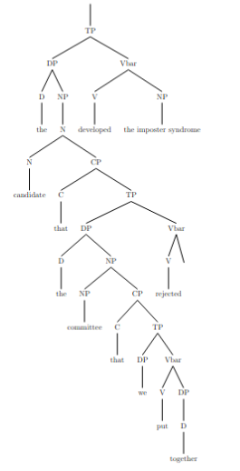
3. Expanding the recursive structure by adding another layer of clausal recursion:

"A candidate the committee we put together for the event that changed everything rejected developed the imposter syndrome."

Here, "the event that changed everything" is embedded within the previous recursive structure.

rec_30.txt gpt-4-0314 temperature=1.0
PROMPT: Consider the sentence below and complete the following three tasks:
1. Does the sentence in question contain an instance of recursion? If so, identify the recursive part and say what kind of recursion it is. Note that there are different types of recursion, e.g. adjectival recursion (an adjective modifying an adjective-modified noun), Saxon Genitive a.k.a. possessive 's recursion (an 's-possessed 's-possessor), prepositional phrase recursion (a prepositional phrase with another prepositional phrase inside), clausal recursion (a clause within another clause), and so on.
2. Provide code for a syntactic tree representing the structure of the sentence that can be rendered with LaTeX's forest package. Assume X-bar theory.
3. If you identified that the sentence contains a recursive structure, expand it by adding another layer of recursion (of the same type) to the identified structure.
"The worldview that the prose Nietzsche wrote expressed was unprecedented."
REPLY: 1. Yes, the sentence contains an instance of recursion. It is clausal recursion, as there is a clause within another clause: "the prose Nietzsche wrote" is embedded within the main clause "The worldview that ... expressed was unprecedented."

2. Here is the code for a syntactic tree representing the structure of the sentence using LaTeX's forest package and X-bar theory:

```
\begin{forest}
for tree={s sep=1mm}
[CP
[DP
[D
[The]
]
[NP
[N'
[N
[worldview]
]
]
]
]
[C'
[C
[that]
]
[IP
[DP
[D
[the]
]
[NP
[N'
[AdjP
[Adj'
[Adj
[prose]
]
]
]
[N'
[N
[Nietzsche]
]
[IP
[I'
[V
[wrote]
]
]
]
]
]
]
]
[I'
[VP
[V'
[V
[expressed]
]
[DP
[D
[was]
]
[N'
[AdjP
[Adj'
[Adj
[unprecedented]
]
]
]
]
]
]
]
]
]
]
]
\end{forest}
```
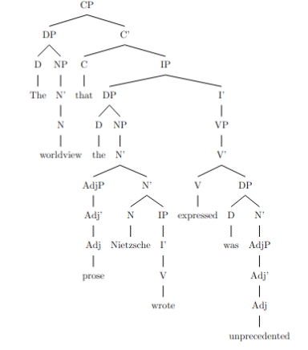
3. To add another layer of recursion of the same type (clausal recursion), the sentence can be expanded as follows: "The worldview that the prose Nietzsche wrote when he lived in Italy expressed was unprecedented." Here, the clause "when he lived in Italy" is embedded within the already embedded clause "the prose Nietzsche wrote."

Messages generated with 14679 tokens

meta.llama3-1-405b-instruct-v1

rec_01.txt arn:aws:bedrock:us-west-2::foundation-model/meta.llama3-1-405b-instruct-v1:0 temperature=0.5
PROMPT: Consider the sentence below and complete the following three tasks:
1. Does the sentence in question contain an instance of recursion? If so, identify the recursive part and say what kind of recursion it is. Note that there are different types of recursion, e.g. adjectival recursion (an adjective modifying an adjective-modified noun), Saxon Genitive a.k.a. possessive 's recursion (an 's-possessed 's-possessor), prepositional phrase recursion (a prepositional phrase with another prepositional phrase inside), clausal recursion (a clause within another clause), and so on.
2. Provide code for a syntactic tree representing the structure of the sentence that can be rendered with LaTeX's forest package. Assume X-bar theory.
3. If you identified that the sentence contains a recursive structure, expand it by adding another layer of recursion (of the same type) to the identified structure.
"Jack van der Molen might be the sneaky old thief."
REPLY: 1. The sentence contains an instance of adjectival recursion. The recursive part is "sneaky old thief," where "sneaky" and "old" are both adjectives modifying the noun "thief." This is an example of multiple adjectives modifying a single noun.

2. Here is the LaTeX code for a syntactic tree representing the structure of the sentence using the forest package, assuming X-bar theory:
```
\documentclass{article}
\usepackage[linguistics]{forest}

\begin{document}

\begin{forest}
[TP
[DP [Jack van der Molen]]
[T'
[T [might]]
[VP
[V [be]]
[DP
[D [the]]
[NP
[AdjP [sneaky]]
[AdjP [old]]
[N [thief]]
]
]
]
]
]
\end{forest}

\end{document}
```

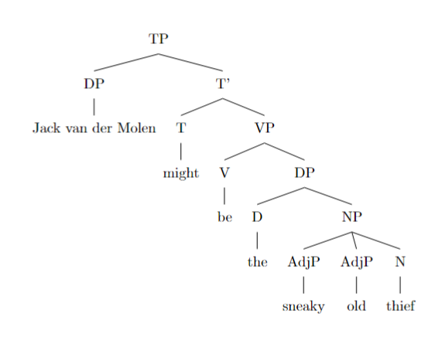

3. To add another layer of recursion to the identified structure, we can add another adjective to modify the noun "thief." Here is the revised sentence:
"Jack van der Molen might be the sneaky old cunning thief."

In this revised sentence, we have added another adjective "cunning" to modify the noun "thief," creating another layer of adjectival recursion. The revised LaTeX code for the syntactic tree would be:
```
\documentclass{article}
\usepackage[linguistics]{forest}

\begin{document}

\begin{forest}
[TP
[DP [Jack van der Molen]]
[T'
[T [might]]
[VP
[V [be]]
[DP
[D [the]]
[NP
[AdjP [sneaky]]
[AdjP [old]]
[AdjP [cunning]]
[N [thief]]
]
]
]
]
]
\end{forest}

\end{document}
```
Note that this revised sentence still follows the same structure as the original sentence, but with an additional layer of adjectival recursion.

rec_10.txt arn:aws:bedrock:us-west-2::foundation-model/meta.llama3-1-405b-instruct-v1:0 temperature=0.5
PROMPT: Consider the sentence below and complete the following three tasks:
1. Does the sentence in question contain an instance of recursion? If so, identify the recursive part and say what kind of recursion it is. Note that there are different types of recursion, e.g. adjectival recursion (an adjective modifying an adjective-modified noun), Saxon Genitive a.k.a. possessive 's recursion (an 's-possessed 's-possessor), prepositional phrase recursion (a prepositional phrase with another prepositional phrase inside), clausal recursion (a clause within another clause), and so on.
2. Provide code for a syntactic tree representing the structure of the sentence that can be rendered with LaTeX's forest package. Assume X-bar theory.
3. If you identified that the sentence contains a recursive structure, expand it by adding another layer of recursion (of the same type) to the identified structure.
"The footprints clearly revealed Beth's young companion's escape route."
REPLY: 1. The sentence contains an instance of recursion, specifically Saxon Genitive (possessive 's) recursion. The recursive part is "Beth's young companion's", where "Beth's" is the possessor of "young companion's", and "young companion's" is the possessor of "escape route".

2. Here is the code for a syntactic tree representing the structure of the sentence using LaTeX's forest package, assuming X-bar theory:
```
\documentclass{article}
\usepackage[linguistics]{forest}

\begin{document}

\begin{forest}
[DP
[D\\the]
[NP
[N\\footprints]
[CP
[C\\clearly]
[VP
[V\\revealed]
[DP
[D\\Beth's]
[NP
[AP
[A\\young]
[N\\companion's]
]
[N\\escape route]
]
]
]
]
]
]
\end{forest}

\end{document}
```
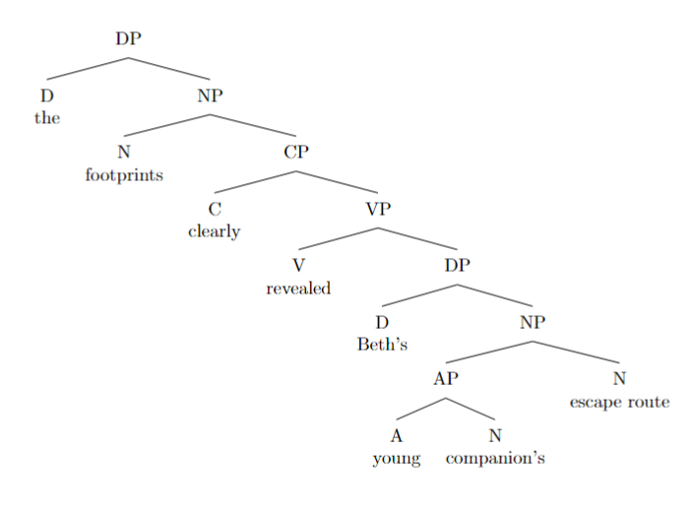

Note: This code represents the sentence structure using a simplified X-bar theory, where DP stands for Determiner Phrase, NP for Noun Phrase, CP for Complementizer Phrase, VP for Verb Phrase, AP for Adjective Phrase, and so on.

3. To expand the recursive structure, I will add another layer of Saxon Genitive recursion to the identified structure. Here is the modified sentence:
"The footprints clearly revealed Beth's young companion's friend's escape route."

In this expanded sentence, "Beth's young companion's" is the possessor of "friend's", and "friend's" is the possessor of "escape route". The added layer of recursion is of the same type (Saxon Genitive) as the original recursive structure.

rec_04.txt arn:aws:bedrock:us-west-2::foundation-model/meta.llama3-1-405b-instruct-v1:0 temperature=0.5
PROMPT: Consider the sentence below and complete the following three tasks:
1. Does the sentence in question contain an instance of recursion? If so, identify the recursive part and say what kind of recursion it is. Note that there are different types of recursion, e.g. adjectival recursion (an adjective modifying an adjective-modified noun), Saxon Genitive a.k.a. possessive 's recursion (an 's-possessed 's-possessor), prepositional phrase recursion (a prepositional phrase with another prepositional phrase inside), clausal recursion (a clause within another clause), and so on.
2. Provide code for a syntactic tree representing the structure of the sentence that can be rendered with LaTeX's forest package. Assume X-bar theory.
3. If you identified that the sentence contains a recursive structure, expand it by adding another layer of recursion (of the same type) to the identified structure.
"Unidentified flying objects may have conflicting characteristics."
REPLY: 1. The sentence "Unidentified flying objects may have conflicting characteristics" contains an instance of adjectival recursion. The recursive part is "unidentified flying objects", where "unidentified" and "flying" are both adjectives modifying the noun "objects". This is an example of multiple adjectives modifying a single noun, rather than an adjective modifying an adjective-modified noun. However, it can still be considered a form of recursion.

2. Here is the LaTeX code for the syntactic tree using the forest package:

```
\documentclass{article}
\usepackage[linguistics]{forest}

\begin{document}

\begin{forest}
[TP
[DP [AdjP [Adj [unidentified]]
[AdjP [Adj [flying]]
[NP [N [objects]]]]]
[T' [T [may]]
[VP [V [have]]
[DP [AdjP [Adj [conflicting]]
[NP [N [characteristics]]]]]]]
]
\end{forest}

\end{document}
```

DOES NOT COMPILE; ADDED BRACKET
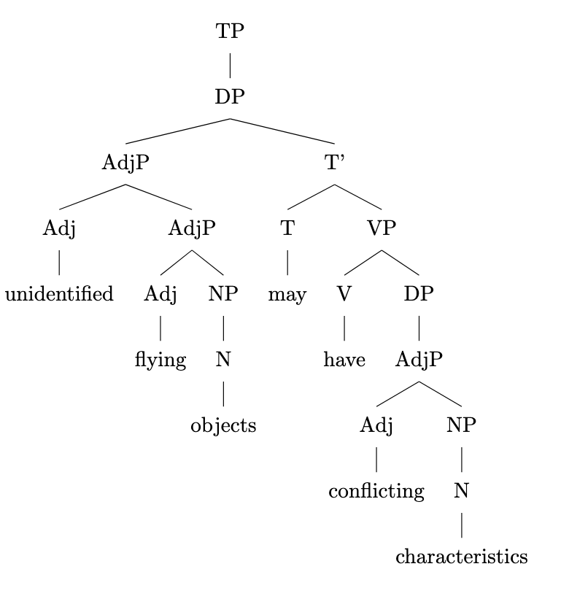
3. To expand the sentence by adding another layer of recursion to the identified structure, we can add another adjective to modify "unidentified flying objects". Here is the revised sentence:

"Unidentified flying glowing objects may have conflicting characteristics."

In this revised sentence, "glowing" is another adjective modifying the noun "objects", adding another layer of recursion to the adjectival structure. The revised LaTeX code for the syntactic tree would be:

```
\documentclass{article}
\usepackage[linguistics]{forest}

\begin{document}

\begin{forest}
[TP
[DP [AdjP [Adj [unidentified]]
[AdjP [Adj [flying]]
[AdjP [Adj [glowing]]
[NP [N [objects]]]]]]
[T' [T [may]]
[VP [V [have]]
[DP [AdjP [Adj [conflicting]]
[NP [N [characteristics]]]]]]]
]
\end{forest}

\end{document}
```

rec_06.txt arn:aws:bedrock:us-west-2::foundation-model/meta.llama3-1-405b-instruct-v1:0 temperature=0.5
PROMPT: Consider the sentence below and complete the following three tasks:
1. Does the sentence in question contain an instance of recursion? If so, identify the recursive part and say what kind of recursion it is. Note that there are different types of recursion, e.g. adjectival recursion (an adjective modifying an adjective-modified noun), Saxon Genitive a.k.a. possessive 's recursion (an 's-possessed 's-possessor), prepositional phrase recursion (a prepositional phrase with another prepositional phrase inside), clausal recursion (a clause within another clause), and so on.
2. Provide code for a syntactic tree representing the structure of the sentence that can be rendered with LaTeX's forest package. Assume X-bar theory.
3. If you identified that the sentence contains a recursive structure, expand it by adding another layer of recursion (of the same type) to the identified structure.
"A small child can easily get lost in a vast American mall."
REPLY: 1. The sentence contains an instance of adjectival recursion: "a vast American mall". The recursive part is the adjective "American" modifying the adjective-modified noun "vall mall" (modified by "vast"). However, this is a simple case of a sequence of adjectives rather than true recursion where the same structure is embedded within itself. A more typical example of adjectival recursion would be "a wonderfully beautiful sunny day" where "beautiful" is modified by "wonderfully" and "sunny" is modified by the "wonderfully beautiful" phrase.

2. Here is the code for the syntactic tree:
```
\begin{forest}
[S
[NP [Det [a]]
[AP [Adj [small]]
[N [child]]]]
[VP [V [can]]
[VP [Adv [easily]]
[V [get]]
[VP [V [lost]]
[PP [P [in]]
[NP [Det [a]]
[AP [Adj [vast]]
[AP [Adj [American]]
[N [mall]]]]]]]]
\end{forest}
```

DOES NOT COMPILE; ADDED BRACKETS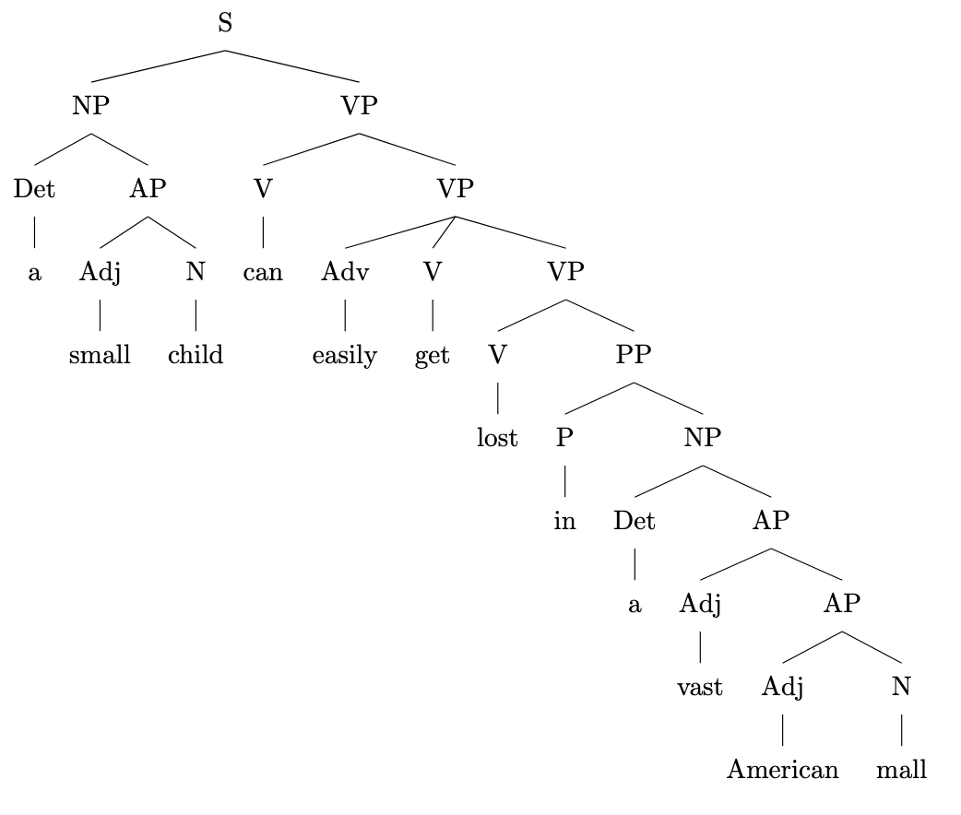

3. To add another layer of recursion to the identified structure, we can modify the adjective "American" with another adjective, e.g. "typical":
"A small child can easily get lost in a vast typical American mall."

However, as mentioned earlier, this is not true recursion. For true recursion, consider the following example:
"A small child can easily get lost in a wonderfully beautiful sunny American mall."

In this case, we can add another layer of recursion by modifying the adjective "wonderfully" with another adverb, e.g. "incredibly":
"A small child can easily get lost in an incredibly wonderfully beautiful sunny American mall."

rec_08.txt arn:aws:bedrock:us-west-2::foundation-model/meta.llama3-1-405b-instruct-v1:0 temperature=0.5
PROMPT: Consider the sentence below and complete the following three tasks:
1. Does the sentence in question contain an instance of recursion? If so, identify the recursive part and say what kind of recursion it is. Note that there are different types of recursion, e.g. adjectival recursion (an adjective modifying an adjective-modified noun), Saxon Genitive a.k.a. possessive 's recursion (an 's-possessed 's-possessor), prepositional phrase recursion (a prepositional phrase with another prepositional phrase inside), clausal recursion (a clause within another clause), and so on.
2. Provide code for a syntactic tree representing the structure of the sentence that can be rendered with LaTeX's forest package. Assume X-bar theory.
3. If you identified that the sentence contains a recursive structure, expand it by adding another layer of recursion (of the same type) to the identified structure.
"The Old Continent's civilizations' advances have shaped history."
REPLY: 1. The sentence contains an instance of recursion, specifically Saxon Genitive recursion (an 's-possessed 's-possessor). The recursive part is "The Old Continent's civilizations' advances".

2. Here is the LaTeX code for a syntactic tree representing the structure of the sentence using the forest package:
```
\documentclass{article}
\usepackage[linguistics]{forest}

\begin{document}

\begin{forest}
[TP
[DP [The Old Continent's civilizations' advances]]
[T' [T [have]]
[VP [V [shaped]]
[DP [history]]]]]
\end{forest}

\end{document}
```
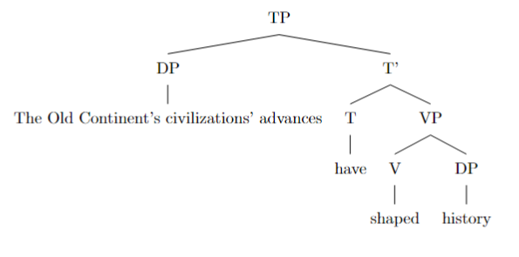

However, to better represent the Saxon Genitive recursion, we can break down the DP "The Old Continent's civilizations' advances" further:
```
\documentclass{article}
\usepackage[linguistics]{forest}

\begin{document}

\begin{forest}
[TP
[DP [DP [The Old Continent]]
[D' [D ['s]]
[DP [DP [civilizations]]
[D' [D ['s]]
[NP [advances]]]]]]
[T' [T [have]]
[VP [V [shaped]]
[DP [history]]]]]
\end{forest}

\end{document}
```

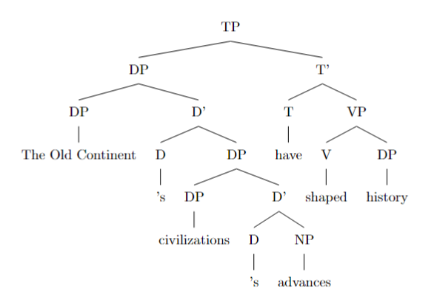
3. To expand the sentence by adding another layer of recursion (of the same type) to the identified structure, we can modify the sentence to:
"The Old Continent's civilizations' empires' advances have shaped history."

This adds another layer of Saxon Genitive recursion, where "empires" is the new 's-possessed 's-possessor. The updated LaTeX code for the syntactic tree would be:
```
\documentclass{article}
\usepackage[linguistics]{forest}

\begin{document}

\begin{forest}
[TP
[DP [DP [The Old Continent]]
[D' [D ['s]]
[DP [DP [civilizations]]
[D' [D ['s]]
[DP [DP [empires]]
[D' [D ['s]]
[NP [advances]]]]]]]]
[T' [T [have]]
[VP [V [shaped]]
[DP [history]]]]]
\end{forest}

\end{document}
```

rec_09.txt arn:aws:bedrock:us-west-2::foundation-model/meta.llama3-1-405b-instruct-v1:0 temperature=0.5
PROMPT: Consider the sentence below and complete the following three tasks:
1. Does the sentence in question contain an instance of recursion? If so, identify the recursive part and say what kind of recursion it is. Note that there are different types of recursion, e.g. adjectival recursion (an adjective modifying an adjective-modified noun), Saxon Genitive a.k.a. possessive 's recursion (an 's-possessed 's-possessor), prepositional phrase recursion (a prepositional phrase with another prepositional phrase inside), clausal recursion (a clause within another clause), and so on.
2. Provide code for a syntactic tree representing the structure of the sentence that can be rendered with LaTeX's forest package. Assume X-bar theory.
3. If you identified that the sentence contains a recursive structure, expand it by adding another layer of recursion (of the same type) to the identified structure.
"This town's only road's potholes are driving me insane."
REPLY: 1. The sentence contains an instance of recursion, specifically Saxon Genitive (possessive 's) recursion. The recursive part is "This town's only road's", where "town's" is the first 's-possessor and "road's" is the second 's-possessor.

2. Here is the code for a syntactic tree representing the structure of the sentence using LaTeX's forest package, assuming X-bar theory:
```
\begin{forest}
[S
[NP [Det [This]]
[N' [N [town]]
[PossP [Poss ['s]]
[NP [Det [only]]
[N' [N [road]]
[PossP [Poss ['s]]
[NP [N [potholes]]]]]]]]
[VP [V [are]]
[VP [V [driving]]
[NP [N [me]]
[AdjP [Adj [insane]]]]]]
]
\end{forest}
```

DOES NOT COMPILE; ADDED BRACKET (AM)
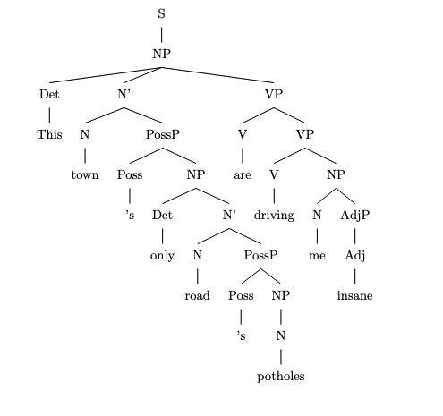
3. To expand the recursive structure, I will add another layer of Saxon Genitive recursion to the identified structure. Here is the modified sentence:
"This town's only road's potholes' edges are driving me insane."

In this expanded sentence, I added another 's-possessor "potholes'" to the existing recursive structure, making it a three-layered Saxon Genitive recursion. The modified syntactic tree would be:
```
\begin{forest}
[S
[NP [Det [This]]
[N' [N [town]]
[PossP [Poss ['s]]
[NP [Det [only]]
[N' [N [road]]
[PossP [Poss ['s]]
[NP [N [potholes]]
[PossP [Poss ['s]]
[NP [N [edges]]]]]]]]]]
[VP [V [are]]
[VP [V [driving]]
[NP [N [me]]
[AdjP [Adj [insane]]]]]]
]
\end{forest}
```

rec_02.txt arn:aws:bedrock:us-west-2::foundation-model/meta.llama3-1-405b-instruct-v1:0 temperature=0.5
PROMPT: Consider the sentence below and complete the following three tasks:
1. Does the sentence in question contain an instance of recursion? If so, identify the recursive part and say what kind of recursion it is. Note that there are different types of recursion, e.g. adjectival recursion (an adjective modifying an adjective-modified noun), Saxon Genitive a.k.a. possessive 's recursion (an 's-possessed 's-possessor), prepositional phrase recursion (a prepositional phrase with another prepositional phrase inside), clausal recursion (a clause within another clause), and so on.
2. Provide code for a syntactic tree representing the structure of the sentence that can be rendered with LaTeX's forest package. Assume X-bar theory.
3. If you identified that the sentence contains a recursive structure, expand it by adding another layer of recursion (of the same type) to the identified structure.
"Now the six trainees construct a medium-sized sturdy lamp."
REPLY: 1. The sentence contains an instance of adjectival recursion. The recursive part is "medium-sized sturdy lamp", where "sturdy" is an adjective modifying the noun "lamp", and "medium-sized" is an adjective modifying the adjective-modified noun "sturdy lamp". This is an example of left-branching recursion, where the modifier precedes the modified element.

2. Here is the code for a syntactic tree representing the structure of the sentence using LaTeX's forest package:
```
\documentclass{article}
\usepackage[linguistics]{forest}

\begin{document}

\begin{forest}
[TP
[DP [Now] [D' [the] [NP [six] [N' [trainees]]]]]
[T' [T [construct]]
[VP
[V' [V [construct]]
[DP [a] [D' [D [a]] [NP
[AP [medium-sized] [AP [sturdy] [NP [lamp]]]]]]]]]
\end{forest}

\end{document}
```
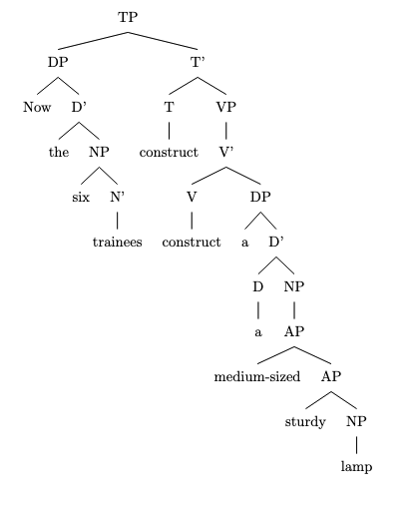
DOES NOT COMPILE; ADDED BRACKETS (AM)

3. To expand the sentence by adding another layer of recursion, we can add another adjective to modify the adjective-modified noun "medium-sized sturdy lamp". For example:
"Now the six trainees construct a beautiful medium-sized sturdy lamp."

In this expanded sentence, "beautiful" is an adjective modifying the adjective-modified noun "medium-sized sturdy lamp", which is itself an adjective-modified noun. This adds another layer of left-branching recursion to the structure. The updated code for the syntactic tree would be:
```
\documentclass{article}
\usepackage[linguistics]{forest}

\begin{document}

\begin{forest}
[TP
[DP [Now] [D' [the] [NP [six] [N' [trainees]]]]]
[T' [T [construct]]
[VP
[V' [V [construct]]
[DP [a] [D' [D [a]] [NP
[AP [beautiful] [AP [medium-sized] [AP [sturdy] [NP [lamp]]]]]]]]]
\end{forest}

\end{document}
```

rec_03.txt arn:aws:bedrock:us-west-2::foundation-model/meta.llama3-1-405b-instruct-v1:0 temperature=0.5
PROMPT: Consider the sentence below and complete the following three tasks:
1. Does the sentence in question contain an instance of recursion? If so, identify the recursive part and say what kind of recursion it is. Note that there are different types of recursion, e.g. adjectival recursion (an adjective modifying an adjective-modified noun), Saxon Genitive a.k.a. possessive 's recursion (an 's-possessed 's-possessor), prepositional phrase recursion (a prepositional phrase with another prepositional phrase inside), clausal recursion (a clause within another clause), and so on.
2. Provide code for a syntactic tree representing the structure of the sentence that can be rendered with LaTeX's forest package. Assume X-bar theory.
3. If you identified that the sentence contains a recursive structure, expand it by adding another layer of recursion (of the same type) to the identified structure.
"Luna has been chasing the small white mouse all day long."
REPLY: 1. The sentence contains an instance of adjectival recursion. The recursive part is "small white mouse", where "white" modifies "mouse" and "small" modifies the "white"-modified "mouse". This is an example of adjectival recursion, where an adjective modifies an adjective-modified noun.

2. Here is the code for a syntactic tree representing the structure of the sentence using LaTeX's forest package, assuming X-bar theory:
```
\documentclass{article}
\usepackage[linguistics]{forest}

\begin{document}

\begin{forest}
[S
[NP [Luna]]
[VP
[V [has been chasing]]
[NP
[Det [the]]
[AdjP
[Adj [small]]
[AdjP
[Adj [white]]
[N [mouse]]
]
]
]
[PP
[P [all]]
[NP
[N [day]]
[Adv [long]]
]
]
]
]
\end{forest}

\end{document}
```

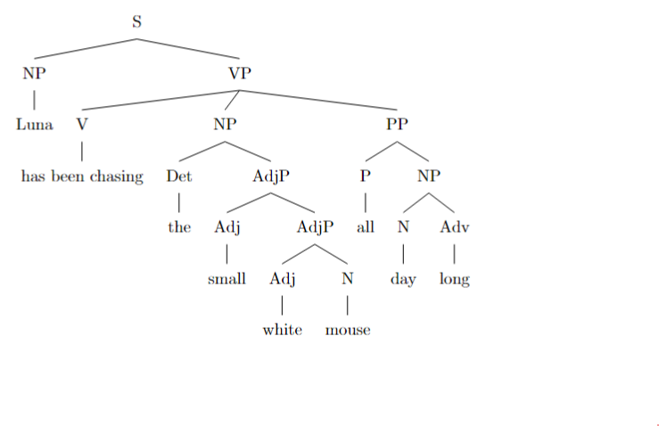

3. To expand the sentence by adding another layer of recursion to the identified adjectival recursion structure, we can add another adjective to modify the "small white mouse". For example:
"Luna has been chasing the tiny small white mouse all day long."

In this expanded sentence, "tiny" modifies the "small white mouse", adding another layer of adjectival recursion. The updated syntactic tree would be:
```
\documentclass{article}
\usepackage[linguistics]{forest}

\begin{document}

\begin{forest}
[S
[NP [Luna]]
[VP
[V [has been chasing]]
[NP
[Det [the]]
[AdjP
[Adj [tiny]]
[AdjP
[Adj [small]]
[AdjP
[Adj [white]]
[N [mouse]]
]
]
]
]
[PP
[P [all]]
[NP
[N [day]]
[Adv [long]]
]
]
]
]
\end{forest}

\end{document}
```

rec_11.txt arn:aws:bedrock:us-west-2::foundation-model/meta.llama3-1-405b-instruct-v1:0 temperature=0.5
PROMPT: Consider the sentence below and complete the following three tasks:
1. Does the sentence in question contain an instance of recursion? If so, identify the recursive part and say what kind of recursion it is. Note that there are different types of recursion, e.g. adjectival recursion (an adjective modifying an adjective-modified noun), Saxon Genitive a.k.a. possessive 's recursion (an 's-possessed 's-possessor), prepositional phrase recursion (a prepositional phrase with another prepositional phrase inside), clausal recursion (a clause within another clause), and so on.
2. Provide code for a syntactic tree representing the structure of the sentence that can be rendered with LaTeX's forest package. Assume X-bar theory.
3. If you identified that the sentence contains a recursive structure, expand it by adding another layer of recursion (of the same type) to the identified structure.
"He spotted the infamous manuscript in the wizard's library's dark corner."
REPLY: 1. Yes, the sentence contains an instance of recursion. The recursive part is "the wizard's library's dark corner," which is an example of Saxon Genitive recursion (an 's-possessed 's-possessor).

2. Here is the code for a syntactic tree representing the structure of the sentence using LaTeX's forest package, assuming X-bar theory:
```
\documentclass{article}
\usepackage[linguistics]{forest}

\begin{document}

\begin{forest}
[TP
[DP [He]]
[T' [T [spotted]]
[VP
[DP [the infamous manuscript]]
[PP
[P [in]]
[DP
[DP [the wizard's library's]]
[NP [dark corner]]
]
]
]
]
]
\end{forest}

\end{document}
```

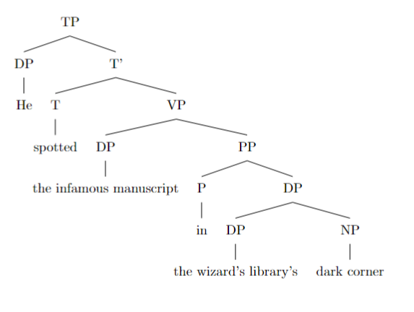

Note that this is a simplified representation, and some details (such as the internal structure of the DP "the infamous manuscript") are omitted for clarity.

3. To expand the recursive structure, we can add another layer of Saxon Genitive recursion to the possessive phrase:
"He spotted the infamous manuscript in the wizard's library's owner's dark corner's secret compartment."

In this expanded sentence, we have added another layer of recursion to the original possessive phrase, making it "the wizard's library's owner's dark corner's secret compartment". This new phrase has the same structure as the original, but with an additional layer of possession.

rec_07.txt arn:aws:bedrock:us-west-2::foundation-model/meta.llama3-1-405b-instruct-v1:0 temperature=0.5
PROMPT: Consider the sentence below and complete the following three tasks:
1. Does the sentence in question contain an instance of recursion? If so, identify the recursive part and say what kind of recursion it is. Note that there are different types of recursion, e.g. adjectival recursion (an adjective modifying an adjective-modified noun), Saxon Genitive a.k.a. possessive 's recursion (an 's-possessed 's-possessor), prepositional phrase recursion (a prepositional phrase with another prepositional phrase inside), clausal recursion (a clause within another clause), and so on.
2. Provide code for a syntactic tree representing the structure of the sentence that can be rendered with LaTeX's forest package. Assume X-bar theory.
3. If you identified that the sentence contains a recursive structure, expand it by adding another layer of recursion (of the same type) to the identified structure.
"A sudden shriek penetrated the cold winter's night's dead silence."
REPLY: 1. The sentence contains an instance of recursion, specifically Saxon Genitive (possessive 's) recursion. The recursive part is "winter's night's", where "night's" is a possessive phrase modifying "silence", and "winter's" is a possessive phrase modifying "night's".

2. Here is the code for a syntactic tree representing the structure of the sentence using LaTeX's forest package:
```latex
\documentclass{article}
\usepackage[linguistics]{forest}

\begin{document}

\begin{forest}
[TP
[DP [A sudden shriek]]
[T' [T penetrated]
[DP [D the]
[NP [NP [N night's]]
[N' [N silence]]
[PossP [NP [N winter's]]
[Poss' [Poss 's]]]]]]]
\end{forest}

\end{document}
```

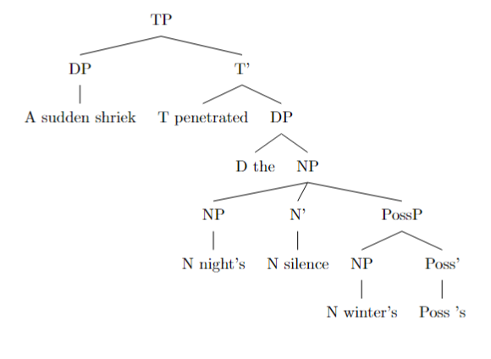

Note: This code uses the X-bar theory notation, where TP represents the Tense Phrase, DP represents the Determiner Phrase, T' represents the Tense head, PossP represents the Possessive Phrase, and Poss' represents the Possessive head.

3. To add another layer of recursion to the identified structure, we can modify the sentence to:
"A sudden shriek penetrated the cold winter's night's autumn's silence."

Here, we added another possessive phrase "autumn's" modifying "night's", creating another layer of Saxon Genitive recursion. The updated syntactic tree would be:
```latex
\documentclass{article}
\usepackage[linguistics]{forest}

\begin{document}

\begin{forest}
[TP
[DP [A sudden shriek]]
[T' [T penetrated]
[DP [D the]
[NP [NP [N night's]]
[N' [N silence]]
[PossP [NP [N autumn's]]
[Poss' [Poss 's]]
[PossP [NP [N winter's]]
[Poss' [Poss 's]]]]]]]]
\end{forest}

\end{document}
```
Note that this updated sentence may sound a bit unnatural, but it illustrates the recursive structure. In natural language, it's more common to see only one or two levels of recursion, as excessive recursion can lead to awkward or hard-to-parse sentences.

rec_05.txt arn:aws:bedrock:us-west-2::foundation-model/meta.llama3-1-405b-instruct-v1:0 temperature=0.5
PROMPT: Consider the sentence below and complete the following three tasks:
1. Does the sentence in question contain an instance of recursion? If so, identify the recursive part and say what kind of recursion it is. Note that there are different types of recursion, e.g. adjectival recursion (an adjective modifying an adjective-modified noun), Saxon Genitive a.k.a. possessive 's recursion (an 's-possessed 's-possessor), prepositional phrase recursion (a prepositional phrase with another prepositional phrase inside), clausal recursion (a clause within another clause), and so on.
2. Provide code for a syntactic tree representing the structure of the sentence that can be rendered with LaTeX's forest package. Assume X-bar theory.
3. If you identified that the sentence contains a recursive structure, expand it by adding another layer of recursion (of the same type) to the identified structure.
"My cranky geriatric manager is beyond incompetent."
REPLY: 1. The sentence contains an instance of adjectival recursion. The recursive part is "cranky geriatric manager", where "cranky" and "geriatric" are both adjectives modifying the noun "manager". This is an example of multiple adjectives modifying a single noun, which can be considered a form of recursion.

2. Here is the code for a syntactic tree representing the structure of the sentence using LaTeX's forest package, assuming X-bar theory:
```
\documentclass{article}
\usepackage[linguistics]{forest}

\begin{document}

\begin{forest}
[TP
[DP [D [my]]
[NP [AdjP [Adj [cranky]]
[AdjP [Adj [geriatric]]
[N [manager]]]]]
[VP [V [is]]
[PP [P [beyond]]
[AdjP [Adj [incompetent]]]]]
\end{forest}

\end{document}
```
DOES NOT COMPILE; ADDED BRACKETS (AM)
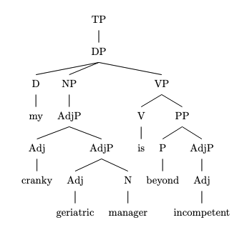
This code represents the sentence as a tree with the following structure:

* TP (Tense Phrase)
+ DP (Determiner Phrase)
- D (Determiner) "my"
- NP (Noun Phrase)
- AdjP (Adjective Phrase) "cranky"
- AdjP (Adjective Phrase) "geriatric"
- N (Noun) "manager"
+ VP (Verb Phrase)
- V (Verb) "is"
- PP (Prepositional Phrase)
- P (Preposition) "beyond"
- AdjP (Adjective Phrase) "incompetent"

3. To add another layer of recursion to the identified structure, we can add another adjective to modify the noun "manager". For example:
"My cranky geriatric senile manager is beyond incompetent."

In this expanded sentence, we have added the adjective "senile" to modify the noun "manager", which is already modified by the adjectives "cranky" and "geriatric". This adds another layer of adjectival recursion to the sentence.

Here is the updated code for the syntactic tree:
```
\documentclass{article}
\usepackage[linguistics]{forest}

\begin{document}

\begin{forest}
[TP
[DP [D [my]]
[NP [AdjP [Adj [cranky]]
[AdjP [Adj [geriatric]]
[AdjP [Adj [senile]]
[N [manager]]]]]]
[VP [V [is]]
[PP [P [beyond]]
[AdjP [Adj [incompetent]]]]]
\end{forest}

\end{document}
```
This code represents the updated sentence as a tree with the additional layer of adjectival recursion.

rec_12.txt arn:aws:bedrock:us-west-2::foundation-model/meta.llama3-1-405b-instruct-v1:0 temperature=0.5
PROMPT: Consider the sentence below and complete the following three tasks:
1. Does the sentence in question contain an instance of recursion? If so, identify the recursive part and say what kind of recursion it is. Note that there are different types of recursion, e.g. adjectival recursion (an adjective modifying an adjective-modified noun), Saxon Genitive a.k.a. possessive 's recursion (an 's-possessed 's-possessor), prepositional phrase recursion (a prepositional phrase with another prepositional phrase inside), clausal recursion (a clause within another clause), and so on.
2. Provide code for a syntactic tree representing the structure of the sentence that can be rendered with LaTeX's forest package. Assume X-bar theory.
3. If you identified that the sentence contains a recursive structure, expand it by adding another layer of recursion (of the same type) to the identified structure.
"Do I dare challenge my advisor's thesis' central argument?"
REPLY: 1. The sentence contains an instance of Saxon Genitive recursion, where "my advisor's thesis" is a possessive construction within another possessive construction "my advisor's thesis' central argument". The recursive part is the possessive 's attached to "thesis", which is already a possessed noun.

2. Here is the LaTeX code for the syntactic tree:
```
\documentclass{article}
\usepackage[linguistics]{forest}

\begin{document}

\begin{forest}
[CP
[C'
[C
[Do]
]
[IP
[I'
[I
[I]
]
[VP
[V'
[V
[dare]
]
[VP
[V'
[V
[challenge]
]
[DP
[D'
[D
[my]
]
[NP
[N'
[N
[advisor's]
]
[NP
[N'
[N
[thesis']
]
[NP
[N'
[N
[central argument]
]
]
]
]
]
]
]
]
]
]
]
]
]
]
]
]
]
\end{forest}

\end{document}
```
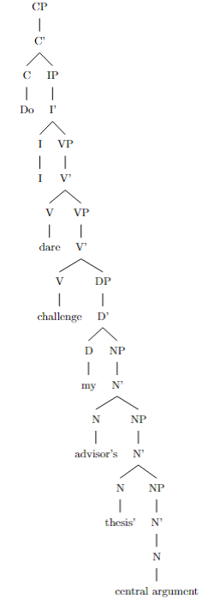
Note: The tree assumes a simplified X-bar structure, with some nodes omitted for clarity.

3. To add another layer of recursion, we can modify the sentence to: "Do I dare challenge my advisor's thesis' central argument's underlying assumption?"

In this expanded sentence, we've added another possessive 's to "central argument", creating another layer of Saxon Genitive recursion. The new recursive structure is: "my advisor's thesis' central argument's underlying assumption".

rec_15.txt arn:aws:bedrock:us-west-2::foundation-model/meta.llama3-1-405b-instruct-v1:0 temperature=0.5
PROMPT: Consider the sentence below and complete the following three tasks:
1. Does the sentence in question contain an instance of recursion? If so, identify the recursive part and say what kind of recursion it is. Note that there are different types of recursion, e.g. adjectival recursion (an adjective modifying an adjective-modified noun), Saxon Genitive a.k.a. possessive 's recursion (an 's-possessed 's-possessor), prepositional phrase recursion (a prepositional phrase with another prepositional phrase inside), clausal recursion (a clause within another clause), and so on.
2. Provide code for a syntactic tree representing the structure of the sentence that can be rendered with LaTeX's forest package. Assume X-bar theory.
3. If you identified that the sentence contains a recursive structure, expand it by adding another layer of recursion (of the same type) to the identified structure.
"He had been warned about the dangers of tobacco."
REPLY: 1. The sentence contains an instance of prepositional phrase recursion: "about the dangers of tobacco". The recursive part is "of tobacco", which is a prepositional phrase within another prepositional phrase "about the dangers". This is an example of right-branching recursion, where a phrase is embedded within another phrase on its right side.

2. Here is the LaTeX code for the syntactic tree using the forest package:
```
\documentclass{article}
\usepackage[linguistics]{forest}

\begin{document}

\begin{forest}
[TP
[T'
[T [had]]
[VP
[V' [been warned]]
[PP [about]
[DP [the dangers]
[PP [of]
[DP [tobacco]]
]
]
]
]
]
[DP [he]]
]
\end{forest}

\end{document}
```

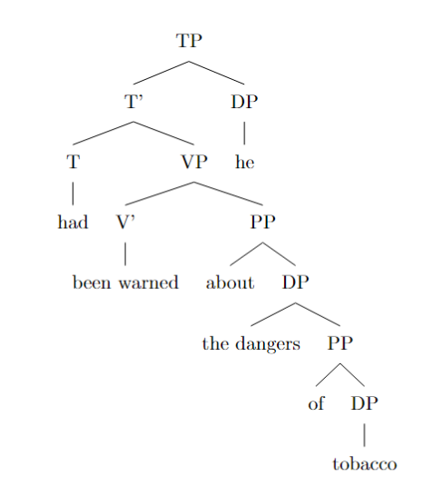
This code represents the sentence structure according to X-bar theory, with the main clause (TP) containing a subject (DP "he") and a verb phrase (VP) with a verb (V' "been warned") and a prepositional phrase (PP "about the dangers of tobacco").

3. To expand the recursive structure, we can add another layer of prepositional phrase recursion to the existing structure. Here is the modified sentence:
"He had been warned about the dangers of the addiction to tobacco."

In this expanded sentence, we have added another prepositional phrase "to tobacco" within the existing prepositional phrase "of the addiction", which is itself within the prepositional phrase "about the dangers". This adds another layer of right-branching recursion to the structure. The modified LaTeX code for the syntactic tree would be:
```
\documentclass{article}
\usepackage[linguistics]{forest}

\begin{document}

\begin{forest}
[TP
[T'
[T [had]]
[VP
[V' [been warned]]
[PP [about]
[DP [the dangers]
[PP [of]
[DP [the addiction]
[PP [to]
[DP [tobacco]]
]
]
]
]
]
]
]
[DP [he]]
]
\end{forest}

\end{document}
```
This code represents the expanded sentence structure with the additional layer of prepositional phrase recursion.

rec_13.txt arn:aws:bedrock:us-west-2::foundation-model/meta.llama3-1-405b-instruct-v1:0 temperature=0.5
PROMPT: Consider the sentence below and complete the following three tasks:
1. Does the sentence in question contain an instance of recursion? If so, identify the recursive part and say what kind of recursion it is. Note that there are different types of recursion, e.g. adjectival recursion (an adjective modifying an adjective-modified noun), Saxon Genitive a.k.a. possessive 's recursion (an 's-possessed 's-possessor), prepositional phrase recursion (a prepositional phrase with another prepositional phrase inside), clausal recursion (a clause within another clause), and so on.
2. Provide code for a syntactic tree representing the structure of the sentence that can be rendered with LaTeX's forest package. Assume X-bar theory.
3. If you identified that the sentence contains a recursive structure, expand it by adding another layer of recursion (of the same type) to the identified structure.
"She saw someone loitering by the entrance to the library."
REPLY: 1. The sentence in question contains an instance of prepositional phrase recursion. The recursive part is "by the entrance to the library," where "to the library" is a prepositional phrase embedded within the larger prepositional phrase "by the entrance to the library."

2. Here is the LaTeX code for a syntactic tree representing the structure of the sentence using the forest package, assuming X-bar theory:
```latex
\documentclass{article}
\usepackage[linguistics]{forest}

\begin{document}

\begin{forest}
[TP
[DP [She]]
[T' [T [did]]
[VP [V [saw]]
[DP [someone]]
[PP [P [loitering]]
[PP [P [by]]
[DP [the entrance]]
[PP [P [to]]
[DP [the library]]
]
]
]
]
]
]
\end{forest}

\end{document}
```
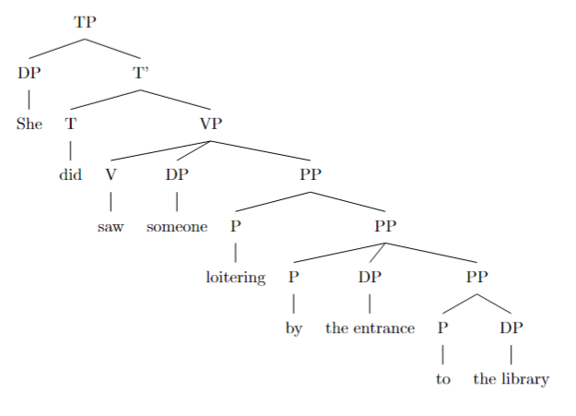

3. To expand the recursive structure, we can add another layer of prepositional phrase recursion to the existing structure. Here is the revised sentence:
"She saw someone loitering by the entrance to the path to the library."

In this revised sentence, we've added another prepositional phrase "to the path" within the existing prepositional phrase "by the entrance to the library," creating an additional layer of recursion.

rec_14.txt arn:aws:bedrock:us-west-2::foundation-model/meta.llama3-1-405b-instruct-v1:0 temperature=0.5
PROMPT: Consider the sentence below and complete the following three tasks:
1. Does the sentence in question contain an instance of recursion? If so, identify the recursive part and say what kind of recursion it is. Note that there are different types of recursion, e.g. adjectival recursion (an adjective modifying an adjective-modified noun), Saxon Genitive a.k.a. possessive 's recursion (an 's-possessed 's-possessor), prepositional phrase recursion (a prepositional phrase with another prepositional phrase inside), clausal recursion (a clause within another clause), and so on.
2. Provide code for a syntactic tree representing the structure of the sentence that can be rendered with LaTeX's forest package. Assume X-bar theory.
3. If you identified that the sentence contains a recursive structure, expand it by adding another layer of recursion (of the same type) to the identified structure.
"We sow fear in the hearts of our enemies."
REPLY: 1. The sentence contains an instance of prepositional phrase recursion: "in the hearts of our enemies". The recursive part is "of our enemies", which is a prepositional phrase embedded within another prepositional phrase "in the hearts". This is an example of PP-attachment, where a prepositional phrase is attached to a noun phrase.

2. Here is the LaTeX code for the syntactic tree using the forest package:
```
\documentclass{article}
\usepackage[linguistics]{forest}

\begin{document}

\begin{forest}
[VP
[V [we] [sow]]
[NP [fear]]
[PP [in]
[NP [the] [hearts]
[PP [of]
[NP [our] [enemies]]
]
]
]
]
\end{forest}

\end{document}
```

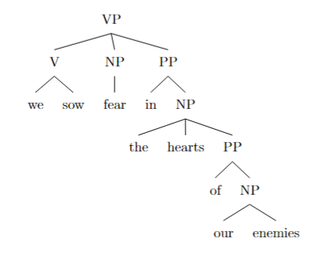

This code represents the sentence structure as a tree, with the VP (verb phrase) as the root node, and the V (verb), NP (noun phrase), and PP (prepositional phrase) as its children.

3. To add another layer of recursion to the identified structure, we can modify the sentence to: "We sow fear in the hearts of the families of our enemies." Here, we've added another prepositional phrase "of the families" embedded within the existing prepositional phrase "of our enemies". This expanded sentence contains an additional layer of prepositional phrase recursion.

The updated LaTeX code for the syntactic tree would be:
```
\documentclass{article}
\usepackage[linguistics]{forest}

\begin{document}

\begin{forest}
[VP
[V [we] [sow]]
[NP [fear]]
[PP [in]
[NP [the] [hearts]
[PP [of]
[NP [the] [families]
[PP [of]
[NP [our] [enemies]]
]
]
]
]
]
]
\end{forest}

\end{document}
```
This updated code represents the expanded sentence structure with an additional layer of prepositional phrase recursion.

rec_17.txt arn:aws:bedrock:us-west-2::foundation-model/meta.llama3-1-405b-instruct-v1:0 temperature=0.5
PROMPT: Consider the sentence below and complete the following three tasks:
1. Does the sentence in question contain an instance of recursion? If so, identify the recursive part and say what kind of recursion it is. Note that there are different types of recursion, e.g. adjectival recursion (an adjective modifying an adjective-modified noun), Saxon Genitive a.k.a. possessive 's recursion (an 's-possessed 's-possessor), prepositional phrase recursion (a prepositional phrase with another prepositional phrase inside), clausal recursion (a clause within another clause), and so on.
2. Provide code for a syntactic tree representing the structure of the sentence that can be rendered with LaTeX's forest package. Assume X-bar theory.
3. If you identified that the sentence contains a recursive structure, expand it by adding another layer of recursion (of the same type) to the identified structure.
"Even their recipe for the basic dough of the pie crust is heavily guarded."
REPLY: 1. The sentence contains an instance of prepositional phrase recursion. The recursive part is "of the pie crust", which is a prepositional phrase modifying the noun "dough", which is itself part of another prepositional phrase "for the basic dough". This is an example of right-branching recursion, where a phrase is embedded within another phrase on its right side.

2. Here is the code for a syntactic tree representing the structure of the sentence using LaTeX's forest package, assuming X-bar theory:
```
\documentclass{article}
\usepackage[linguistics]{forest}

\begin{document}

\begin{forest}
[TP
[DP [Even] [their recipe]]
[T' [T [is]]
[VP [V [heavily guarded]]
[PP [P [for]]
[DP [the basic dough]
[PP [P [of]]
[DP [the pie crust]]]]]]]
\end{forest}

\end{document}
```

DOES NOT COMPILE; ADDED BRACKET (AM)
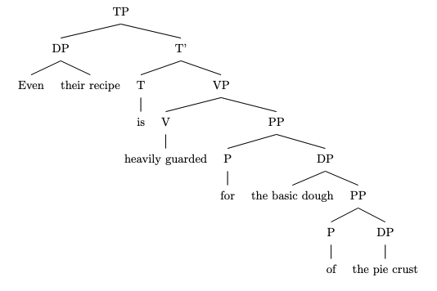
This code represents the sentence as a tree with the following structure:

* TP (Tense Phrase)
+ DP (Determiner Phrase) "Even their recipe"
+ T' (Tense Phrase)
- T (Tense) "is"
- VP (Verb Phrase)
- V (Verb) "heavily guarded"
- PP (Prepositional Phrase)
- P (Preposition) "for"
- DP (Determiner Phrase) "the basic dough"
- PP (Prepositional Phrase)
- P (Preposition) "of"
- DP (Determiner Phrase) "the pie crust"

3. To expand the sentence by adding another layer of recursion, we can add another prepositional phrase modifying the noun "crust". For example:

"Even their recipe for the basic dough of the pie crust of the dessert menu is heavily guarded."

In this expanded sentence, we have added another prepositional phrase "of the dessert menu" modifying the noun "crust", which is itself part of another prepositional phrase "of the pie crust". This adds another layer of right-branching recursion to the sentence. The updated syntactic tree would be:
```
\documentclass{article}
\usepackage[linguistics]{forest}

\begin{document}

\begin{forest}
[TP
[DP [Even] [their recipe]]
[T' [T [is]]
[VP [V [heavily guarded]]
[PP [P [for]]
[DP [the basic dough]
[PP [P [of]]
[DP [the pie crust]
[PP [P [of]]
[DP [the dessert menu]]]]]]]]
\end{forest}

\end{document}
```
This code represents the expanded sentence as a tree with the additional layer of recursion.

rec_16.txt arn:aws:bedrock:us-west-2::foundation-model/meta.llama3-1-405b-instruct-v1:0 temperature=0.5
PROMPT: Consider the sentence below and complete the following three tasks:
1. Does the sentence in question contain an instance of recursion? If so, identify the recursive part and say what kind of recursion it is. Note that there are different types of recursion, e.g. adjectival recursion (an adjective modifying an adjective-modified noun), Saxon Genitive a.k.a. possessive 's recursion (an 's-possessed 's-possessor), prepositional phrase recursion (a prepositional phrase with another prepositional phrase inside), clausal recursion (a clause within another clause), and so on.
2. Provide code for a syntactic tree representing the structure of the sentence that can be rendered with LaTeX's forest package. Assume X-bar theory.
3. If you identified that the sentence contains a recursive structure, expand it by adding another layer of recursion (of the same type) to the identified structure.
"There is a little treat for you in the cupboard between the lamps."
REPLY: 1. The sentence contains an instance of prepositional phrase recursion. The recursive part is "in the cupboard between the lamps", where "between the lamps" is a prepositional phrase modifying the noun "cupboard", which is itself part of another prepositional phrase "in the cupboard".

2. Here is the code for a syntactic tree representing the structure of the sentence using LaTeX's forest package, assuming X-bar theory:
```
\documentclass{article}
\usepackage[linguistics]{forest}

\begin{document}

\begin{forest}
[TP
[T'
[T [there]]
[VP
[V' [is]]
[DP
[D' [a]]
[NP
[AP [little]]
[N' [treat]]
]
]
[PP
[P' [for]]
[DP
[D' [you]]
]
]
[PP
[P' [in]]
[DP
[D' [the]]
[NP
[N' [cupboard]]
[PP
[P' [between]]
[DP
[D' [the]]
[NP
[N' [lamps]]
]
]
]
]
]
]
]
]
]
\end{forest}

\end{document}
```
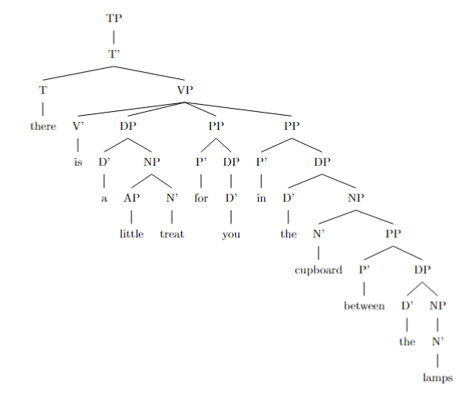
3. To expand the sentence by adding another layer of recursion (of the same type) to the identified structure, we can add another prepositional phrase modifying the noun "lamps", for example:
"There is a little treat for you in the cupboard between the lamps on the table."

In this expanded sentence, the new prepositional phrase "on the table" modifies the noun "lamps", which is itself part of another prepositional phrase "between the lamps", which in turn modifies the noun "cupboard". This adds another layer of prepositional phrase recursion to the original sentence.

rec_19.txt arn:aws:bedrock:us-west-2::foundation-model/meta.llama3-1-405b-instruct-v1:0 temperature=0.5
PROMPT: Consider the sentence below and complete the following three tasks:
1. Does the sentence in question contain an instance of recursion? If so, identify the recursive part and say what kind of recursion it is. Note that there are different types of recursion, e.g. adjectival recursion (an adjective modifying an adjective-modified noun), Saxon Genitive a.k.a. possessive 's recursion (an 's-possessed 's-possessor), prepositional phrase recursion (a prepositional phrase with another prepositional phrase inside), clausal recursion (a clause within another clause), and so on.
2. Provide code for a syntactic tree representing the structure of the sentence that can be rendered with LaTeX's forest package. Assume X-bar theory.
3. If you identified that the sentence contains a recursive structure, expand it by adding another layer of recursion (of the same type) to the identified structure.
"You must remember that you should always run all the basic diagnostics first."
REPLY: 1. The sentence contains an instance of clausal recursion, where a clause ("that you should always run all the basic diagnostics first") is embedded within another clause ("You must remember..."). Specifically, this is an example of finite clausal recursion, where a subordinate clause is embedded within a main clause.

2. Here is the LaTeX code for a syntactic tree representing the structure of the sentence using the forest package, assuming X-bar theory:
```latex
\documentclass{article}
\usepackage[linguistics]{forest}

\begin{document}

\begin{forest}
[TP
[DP [You]]
[T' [T [must]]
[VP [V [remember]]
[CP [C [that]]
[TP
[DP [you]]
[T' [T [should]]
[VP [AdvP [always]]
[VP [V [run]]
[DP [Det [all]]
[NP [Adj [basic]]
[N [diagnostics]]]]
[AdvP [first]]]]]]]]]
\end{forest}

\end{document}
```

DOES NOT COMPILE; ADDED BRACKET (AM)
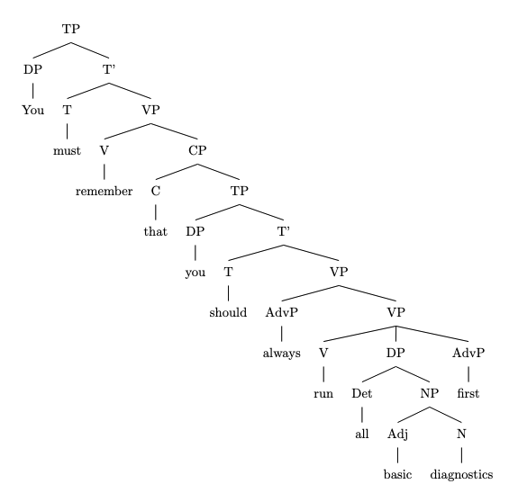
This code represents the sentence as a tree structure, with the main clause ("You must remember...") as the top-level TP (Tense Phrase) node, and the embedded clause ("that you should always run...") as a CP (Complementizer Phrase) node within the VP (Verb Phrase) of the main clause.

3. To expand the recursive structure, I will add another layer of clausal recursion by embedding another clause within the existing embedded clause. Here is the modified sentence:
"You must remember that you should always run all the basic diagnostics first, because if you don't, you might miss something important."

In this expanded sentence, the new embedded clause ("because if you don't, you might miss something important") is a subordinate clause within the existing embedded clause ("that you should always run..."). This adds another layer of finite clausal recursion to the sentence. The LaTeX code for the syntactic tree of this expanded sentence would be:
```latex
\documentclass{article}
\usepackage[linguistics]{forest}

\begin{document}

\begin{forest}
[TP
[DP [You]]
[T' [T [must]]
[VP [V [remember]]
[CP [C [that]]
[TP
[DP [you]]
[T' [T [should]]
[VP [AdvP [always]]
[VP [V [run]]
[DP [Det [all]]
[NP [Adj [basic]]
[N [diagnostics]]]]
[AdvP [first]]]
[CP [C [because]]
[TP
[DP [you]]
[T' [T [don't]]
[VP [V [might]]
[VP [V [miss]]
[DP [Det [something]]
[Adj [important]]]]]]]]]]]]]
\end{forest}

\end{document}
```
Note that this code adds a new CP node within the existing CP node, representing the new embedded clause.

rec_20.txt arn:aws:bedrock:us-west-2::foundation-model/meta.llama3-1-405b-instruct-v1:0 temperature=0.5
PROMPT: Consider the sentence below and complete the following three tasks:
1. Does the sentence in question contain an instance of recursion? If so, identify the recursive part and say what kind of recursion it is. Note that there are different types of recursion, e.g. adjectival recursion (an adjective modifying an adjective-modified noun), Saxon Genitive a.k.a. possessive 's recursion (an 's-possessed 's-possessor), prepositional phrase recursion (a prepositional phrase with another prepositional phrase inside), clausal recursion (a clause within another clause), and so on.
2. Provide code for a syntactic tree representing the structure of the sentence that can be rendered with LaTeX's forest package. Assume X-bar theory.
3. If you identified that the sentence contains a recursive structure, expand it by adding another layer of recursion (of the same type) to the identified structure.
"She announced her victory to irritate her detractors."
REPLY: 1. The sentence contains an instance of recursion, specifically clausal recursion. The recursive part is "to irritate her detractors", which is a subordinate clause within the main clause "She announced her victory".

2. Here is the code for a syntactic tree representing the structure of the sentence using LaTeX's forest package, assuming X-bar theory:
```
\documentclass{article}
\usepackage[linguistics]{forest}

\begin{document}

\begin{forest}
[TP
[DP [She]]
[T'
[T [announced]]
[VP
[DP [her victory]]
[PP
[P [to]]
[CP
[C [\emptyset]]
[IP
[DP [PRO]]
[I'
[I [irritate]]
[DP [her detractors]]
]
]
]
]
]
]
]
\end{forest}

\end{document}
```
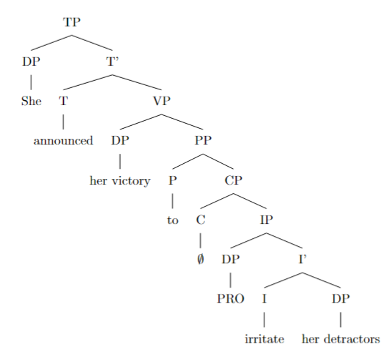

3. To expand the recursive structure, we can add another layer of clausal recursion by adding a subordinate clause within the existing subordinate clause. Here is the modified sentence:

"She announced her victory to irritate her detractors who were trying to undermine her campaign."

The added recursive structure is "who were trying to undermine her campaign", which is a subordinate clause within the existing subordinate clause "to irritate her detractors".

rec_18.txt arn:aws:bedrock:us-west-2::foundation-model/meta.llama3-1-405b-instruct-v1:0 temperature=0.5
PROMPT: Consider the sentence below and complete the following three tasks:
1. Does the sentence in question contain an instance of recursion? If so, identify the recursive part and say what kind of recursion it is. Note that there are different types of recursion, e.g. adjectival recursion (an adjective modifying an adjective-modified noun), Saxon Genitive a.k.a. possessive 's recursion (an 's-possessed 's-possessor), prepositional phrase recursion (a prepositional phrase with another prepositional phrase inside), clausal recursion (a clause within another clause), and so on.
2. Provide code for a syntactic tree representing the structure of the sentence that can be rendered with LaTeX's forest package. Assume X-bar theory.
3. If you identified that the sentence contains a recursive structure, expand it by adding another layer of recursion (of the same type) to the identified structure.
"Drowning your sorrows in a glass of whiskey is at best a temporary solution."
REPLY: 1. The sentence contains an instance of prepositional phrase recursion: "in a glass of whiskey" is a prepositional phrase with another prepositional phrase "of whiskey" inside. This is a case of nested prepositional phrases.

2. Here is the LaTeX code for a syntactic tree representing the structure of the sentence using the forest package:
```
\documentclass{article}
\usepackage[linguistics]{forest}

\begin{document}

\begin{forest}
[VP
[V
[Drowning]
]
[NP
[your sorrows]
]
[PP
[in]
[NP
[a glass]
[PP
[of]
[NP
[whiskey]
]
]
]
]
[VP
[is]
[AP
[at best]
[a temporary solution]
]
]
]
\end{forest}

\end{document}
```

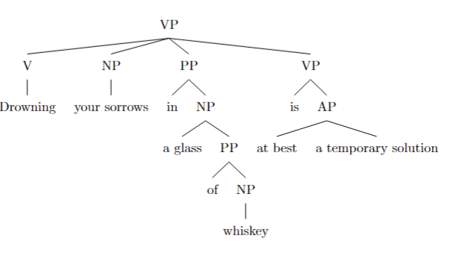

3. To add another layer of recursion to the identified structure, we can modify the prepositional phrase "of whiskey" to include another prepositional phrase, for example:
"Drowning your sorrows in a glass of whiskey from the top shelf is at best a temporary solution."

In this expanded sentence, the prepositional phrase "of whiskey" now contains another prepositional phrase "from the top shelf", adding another layer of recursion to the structure. The modified LaTeX code for the syntactic tree would be:
```
\documentclass{article}
\usepackage[linguistics]{forest}

\begin{document}

\begin{forest}
[VP
[V
[Drowning]
]
[NP
[your sorrows]
]
[PP
[in]
[NP
[a glass]
[PP
[of]
[NP
[whiskey]
[PP
[from]
[NP
[the top shelf]
]
]
]
]
]
]
[VP
[is]
[AP
[at best]
[a temporary solution]
]
]
]
\end{forest}

\end{document}
```

rec_22.txt arn:aws:bedrock:us-west-2::foundation-model/meta.llama3-1-405b-instruct-v1:0 temperature=0.5
PROMPT: Consider the sentence below and complete the following three tasks:
1. Does the sentence in question contain an instance of recursion? If so, identify the recursive part and say what kind of recursion it is. Note that there are different types of recursion, e.g. adjectival recursion (an adjective modifying an adjective-modified noun), Saxon Genitive a.k.a. possessive 's recursion (an 's-possessed 's-possessor), prepositional phrase recursion (a prepositional phrase with another prepositional phrase inside), clausal recursion (a clause within another clause), and so on.
2. Provide code for a syntactic tree representing the structure of the sentence that can be rendered with LaTeX's forest package. Assume X-bar theory.
3. If you identified that the sentence contains a recursive structure, expand it by adding another layer of recursion (of the same type) to the identified structure.
"The few that could understand the manifesto's complex worldview appreciated it."
REPLY: 1. The sentence contains an instance of recursion, specifically a clausal recursion. The recursive part is "that could understand the manifesto's complex worldview", which is a clause within the main clause "The few... appreciated it".

2. Here is the code for a syntactic tree representing the structure of the sentence using LaTeX's forest package, assuming X-bar theory:
```
\documentclass{article}
\usepackage[linguistics]{forest}

\begin{document}

\begin{forest}
[TP
[DP [The] [few]]
[T'
[T [did]]
[VP
[V [appreciate]]
[DP [it]]
[CP
[C [that]]
[TP
[DP [PRO]]
[T'
[T [could]]
[VP
[V [understand]]
[DP
[D [the]]
[NP
[N [manifesto]]
[POS ['s]]
[NP
[Adj [complex]]
[N [worldview]]
]
]
]
]
]
]
]
]
]
]
\end{forest}

\end{document}
```

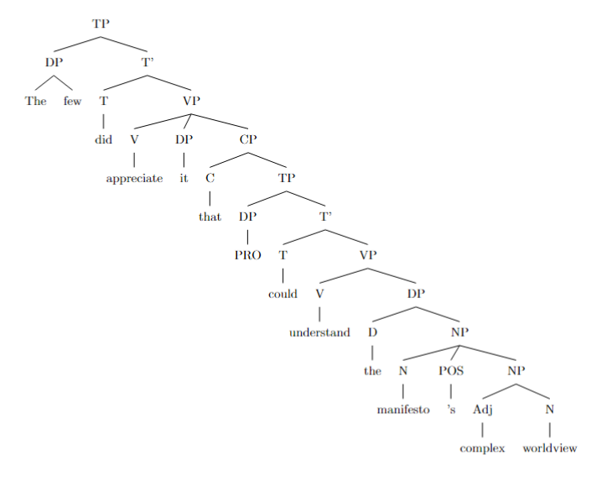
3. To expand the recursive structure, I will add another layer of clausal recursion to the existing structure. Here is the modified sentence:
"The few that could understand the manifesto's complex worldview that was influenced by various philosophical traditions appreciated it."

In this expanded sentence, I added another clause "that was influenced by various philosophical traditions" within the existing clause "that could understand the manifesto's complex worldview". This new clause is also a recursive structure of the same type (clausal recursion).

rec_21.txt arn:aws:bedrock:us-west-2::foundation-model/meta.llama3-1-405b-instruct-v1:0 temperature=0.5
PROMPT: Consider the sentence below and complete the following three tasks:
1. Does the sentence in question contain an instance of recursion? If so, identify the recursive part and say what kind of recursion it is. Note that there are different types of recursion, e.g. adjectival recursion (an adjective modifying an adjective-modified noun), Saxon Genitive a.k.a. possessive 's recursion (an 's-possessed 's-possessor), prepositional phrase recursion (a prepositional phrase with another prepositional phrase inside), clausal recursion (a clause within another clause), and so on.
2. Provide code for a syntactic tree representing the structure of the sentence that can be rendered with LaTeX's forest package. Assume X-bar theory.
3. If you identified that the sentence contains a recursive structure, expand it by adding another layer of recursion (of the same type) to the identified structure.
"Paul cherished his worn-out diary, whose pages were heavily marked by stains"
REPLY: 1. The sentence contains an instance of clausal recursion, specifically a relative clause ("whose pages were heavily marked by stains") modifying the noun "diary". The recursive part is the clause within the clause.

2. Here is the code for a syntactic tree representing the structure of the sentence using LaTeX's forest package, assuming X-bar theory:
```
\documentclass{article}
\usepackage[linguistics]{forest}

\begin{document}

\begin{forest}
[TP
[DP [Paul]]
[T' [T [cherished]]
[VP [V' [V [cherished]]
[DP [his [worn-out [diary]]]]
[CP [C [whose]]
[TP [T' [T [were]]
[VP [V' [V [heavily [marked]]]
[PP [P [by]]
[DP [stains]]]]]]]]]]]
\end{forest}

\end{document}
```

DOES NOT COMPILE; ADDED BRACKET (AM)
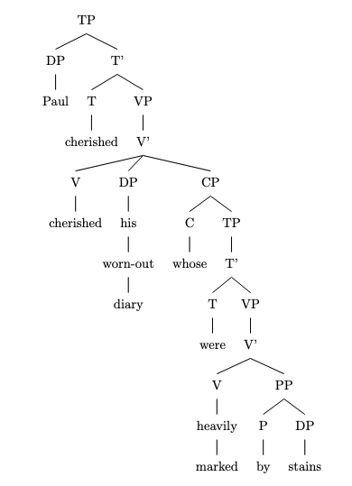
3. To expand the sentence by adding another layer of recursion (of the same type), we can add another relative clause modifying the noun "pages". Here is the revised sentence:
"Paul cherished his worn-out diary, whose pages, which were torn and crumpled, were heavily marked by stains"

This adds another layer of clausal recursion, with the relative clause "which were torn and crumpled" modifying the noun "pages".

rec_25.txt arn:aws:bedrock:us-west-2::foundation-model/meta.llama3-1-405b-instruct-v1:0 temperature=0.5
PROMPT: Consider the sentence below and complete the following three tasks:
1. Does the sentence in question contain an instance of recursion? If so, identify the recursive part and say what kind of recursion it is. Note that there are different types of recursion, e.g. adjectival recursion (an adjective modifying an adjective-modified noun), Saxon Genitive a.k.a. possessive 's recursion (an 's-possessed 's-possessor), prepositional phrase recursion (a prepositional phrase with another prepositional phrase inside), clausal recursion (a clause within another clause), and so on.
2. Provide code for a syntactic tree representing the structure of the sentence that can be rendered with LaTeX's forest package. Assume X-bar theory.
3. If you identified that the sentence contains a recursive structure, expand it by adding another layer of recursion (of the same type) to the identified structure.
"Pieces of a diary Paul tore to shreds lay on the ground."
REPLY: 1. The sentence contains an instance of recursion. The recursive part is "Pieces of a diary Paul tore to shreds", which is an example of clausal recursion (a clause within another clause). Specifically, it's a case of a reduced relative clause ("Paul tore to shreds") modifying the noun "diary", which is itself part of a larger noun phrase "Pieces of a diary".

2. Here's the LaTeX code for the syntactic tree:
```
\documentclass{article}
\usepackage[linguistics]{forest}

\begin{document}

\begin{forest}
[TP
[DP [D [Pieces]]
[PP [P [of]]
[DP [D [a]]
[NP [N [diary]]
[CP [C [\null]]
[TP [T [\null]]
[VP [V [tore]]
[DP [D [\null]]
[NP [N [Paul]]]]
[PP [P [to]]
[NP [N [shreds]]]]]]]]]]
[VP [V [lay]]
[PP [P [on]]
[DP [D [the]]
[NP [N [ground]]]]]]
\end{forest}

\end{document}
```

DOES NOT COMPILE; ADDED BRACKET (AM)
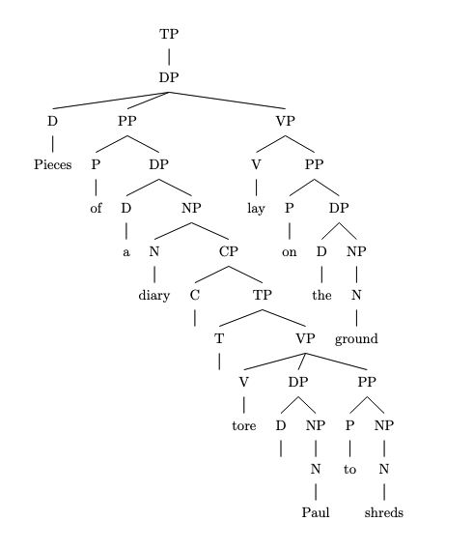
Note: In the code above, `TP` represents the Tense Phrase, `DP` represents the Determiner Phrase, `NP` represents the Noun Phrase, `VP` represents the Verb Phrase, `PP` represents the Prepositional Phrase, and `CP` represents the Complementizer Phrase.

3. To add another layer of recursion, we can modify the sentence to: "Pieces of a diary Paul, who had been struggling with his emotions, tore to shreds lay on the ground." Here, we've added another reduced relative clause ("who had been struggling with his emotions") modifying the noun "Paul", which is itself part of the larger reduced relative clause ("Paul tore to shreds") modifying the noun "diary".

The updated LaTeX code for the syntactic tree would be:
```
\documentclass{article}
\usepackage[linguistics]{forest}

\begin{document}

\begin{forest}
[TP
[DP [D [Pieces]]
[PP [P [of]]
[DP [D [a]]
[NP [N [diary]]
[CP [C [\null]]
[TP [T [\null]]
[VP [V [tore]]
[DP [D [\null]]
[NP [N [Paul]]
[CP [C [who]]
[TP [T [had]]
[VP [V [been]]
[VP [V [struggling]]
[PP [P [with]]
[DP [D [his]]
[NP [N [emotions]]]]]]]]]]
[PP [P [to]]
[NP [N [shreds]]]]]]]]]]
[VP [V [lay]]
[PP [P [on]]
[DP [D [the]]
[NP [N [ground]]]]]]
\end{forest}

\end{document}
```
Note that this updated tree is quite complex, and the LaTeX code may need to be adjusted to fit the page layout.

rec_23.txt arn:aws:bedrock:us-west-2::foundation-model/meta.llama3-1-405b-instruct-v1:0 temperature=0.5
PROMPT: Consider the sentence below and complete the following three tasks:
1. Does the sentence in question contain an instance of recursion? If so, identify the recursive part and say what kind of recursion it is. Note that there are different types of recursion, e.g. adjectival recursion (an adjective modifying an adjective-modified noun), Saxon Genitive a.k.a. possessive 's recursion (an 's-possessed 's-possessor), prepositional phrase recursion (a prepositional phrase with another prepositional phrase inside), clausal recursion (a clause within another clause), and so on.
2. Provide code for a syntactic tree representing the structure of the sentence that can be rendered with LaTeX's forest package. Assume X-bar theory.
3. If you identified that the sentence contains a recursive structure, expand it by adding another layer of recursion (of the same type) to the identified structure.
"The mirror the girl punched shattered into a million pieces."
REPLY: 1. The sentence contains an instance of recursion, specifically a type of clausal recursion known as a "center-embedded relative clause" or "center-embedding". The recursive part is "the girl punched", which is a clause embedded within the noun phrase "the mirror [the girl punched]".

2. Here is the LaTeX code for a syntactic tree representing the structure of the sentence using the forest package:
```
\documentclass{article}
\usepackage[linguistics]{forest}

\begin{document}

\begin{forest}
[S
[NP [Det [the]]
[N' [N [mirror]]
[CP [C [\emptyset]]
[S
[NP [Det [the]]
[N' [N [girl]]]]
[VP [V [punched]]]]]]
[VP [V [shattered]]
[PP [P [into]]
[NP [Det [a]]
[N' [N [million]]
[N [pieces]]]]]]
\end{forest}

\end{document}
```

DOES NOT COMPILE; ADDED BRACKETS (AM)
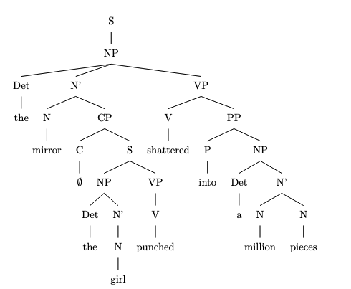
This code represents the sentence structure as follows:

* S: sentence
* NP: noun phrase
* N': intermediate projection of the noun
* N: noun
* CP: complementizer phrase (empty in this case)
* C: complementizer (empty in this case)
* VP: verb phrase
* V: verb
* PP: prepositional phrase
* P: preposition

3. To expand the recursive structure, we can add another layer of center-embedding by inserting another clause within the existing embedded clause:
"The mirror the girl the boy pushed punched shattered into a million pieces."

In this expanded sentence, the recursive structure is now "the girl [the boy pushed] punched", which contains another center-embedded relative clause "the boy pushed".

rec_24.txt arn:aws:bedrock:us-west-2::foundation-model/meta.llama3-1-405b-instruct-v1:0 temperature=0.5
PROMPT: Consider the sentence below and complete the following three tasks:
1. Does the sentence in question contain an instance of recursion? If so, identify the recursive part and say what kind of recursion it is. Note that there are different types of recursion, e.g. adjectival recursion (an adjective modifying an adjective-modified noun), Saxon Genitive a.k.a. possessive 's recursion (an 's-possessed 's-possessor), prepositional phrase recursion (a prepositional phrase with another prepositional phrase inside), clausal recursion (a clause within another clause), and so on.
2. Provide code for a syntactic tree representing the structure of the sentence that can be rendered with LaTeX's forest package. Assume X-bar theory.
3. If you identified that the sentence contains a recursive structure, expand it by adding another layer of recursion (of the same type) to the identified structure.
"Every desk I put a heavy lamp on eventually cracked."
REPLY: 1. The sentence contains an instance of clausal recursion, specifically a relative clause within a noun phrase. The recursive part is "I put a heavy lamp on", which is a clause embedded within the noun phrase "Every desk...".

2. Here is the LaTeX code for the syntactic tree using the forest package:
```
\begin{forest}
[DP [D [Every]]
[NP [N [desk]]
[CP [C [\emptyset]]
[IP [I [put]]
[VP [V [\emptyset]]
[DP [D [a]]
[NP [Adj [heavy]]
[N [lamp]]]]
[PP [P [on]]
[\emptyset]]]]
[C [\emptyset]]]]
[VP [V [cracked]]]]
\end{forest}
```
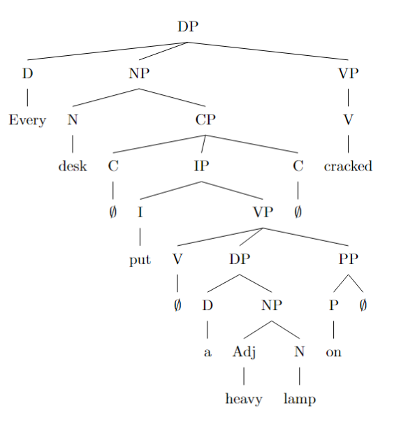

Note: In the code above, `DP` stands for Determiner Phrase, `NP` for Noun Phrase, `CP` for Complementizer Phrase, `IP` for Inflectional Phrase, `VP` for Verb Phrase, `PP` for Prepositional Phrase, `D` for Determiner, `N` for Noun, `Adj` for Adjective, `V` for Verb, `P` for Preposition, and `C` for Complementizer. The `\emptyset` symbol represents an empty category (a covert element).

3. To expand the recursive structure, we can add another layer of clausal recursion by embedding another clause within the existing relative clause. Here is an example:
"Every desk I put a heavy lamp on, which my friend had given me, eventually cracked."

In this expanded sentence, the new recursive structure is the clause "which my friend had given me", which is embedded within the existing relative clause "I put a heavy lamp on". The LaTeX code for the updated syntactic tree would be:
```
\begin{forest}
[DP [D [Every]]
[NP [N [desk]]
[CP [C [\emptyset]]
[IP [I [put]]
[VP [V [\emptyset]]
[DP [D [a]]
[NP [Adj [heavy]]
[N [lamp]]]]
[PP [P [on]]
[\emptyset]]]]
[CP [C [which]]
[IP [I [had]]
[VP [V [given]]
[DP [D [me]]]
[PP [P [by]]
[DP [D [my]]
[NP [N [friend]]]]]]]]
[C [\emptyset]]]]
[VP [V [cracked]]]]
\end{forest}
```
Note that this updated tree shows the new recursive structure, with the additional clause "which my friend had given me" embedded within the existing relative clause.

rec_27.txt arn:aws:bedrock:us-west-2::foundation-model/meta.llama3-1-405b-instruct-v1:0 temperature=0.5
PROMPT: Consider the sentence below and complete the following three tasks:
1. Does the sentence in question contain an instance of recursion? If so, identify the recursive part and say what kind of recursion it is. Note that there are different types of recursion, e.g. adjectival recursion (an adjective modifying an adjective-modified noun), Saxon Genitive a.k.a. possessive 's recursion (an 's-possessed 's-possessor), prepositional phrase recursion (a prepositional phrase with another prepositional phrase inside), clausal recursion (a clause within another clause), and so on.
2. Provide code for a syntactic tree representing the structure of the sentence that can be rendered with LaTeX's forest package. Assume X-bar theory.
3. If you identified that the sentence contains a recursive structure, expand it by adding another layer of recursion (of the same type) to the identified structure.
"The expert every investigator we dispatched questioned remained completely silent."
REPLY: 1. The sentence contains an instance of recursion, specifically a type of clausal recursion known as a "center-embedded clause" or "multiple center-embedding". The recursive part is "every investigator we dispatched questioned", where a clause ("we dispatched") is embedded within another clause ("every investigator... questioned").

2. Here is the LaTeX code for a syntactic tree representing the structure of the sentence using the forest package:
```
\documentclass{article}
\usepackage[linguistics]{forest}

\begin{document}

\begin{forest}
[TP
[DP [The] [expert]]
[T' [T [did]]
[VP [V [remained]]
[AP [completely] [silent]]
[CP [DP [every] [investigator]]
[C' [C [that]]
[TP [DP [we]]
[T' [T [dispatched]]
[VP [V [questioned]]]]]]]]]]
\end{forest}

\end{document}
```
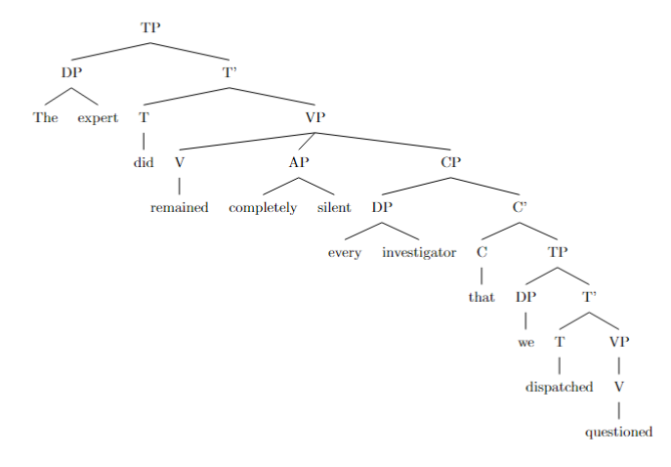
Note: This code represents the sentence structure using X-bar theory, with some simplifications for readability.

3. To expand the recursive structure, we can add another layer of center-embedding:
"The expert every investigator we dispatched and whom our team leader had previously interviewed questioned remained completely silent."

In this expanded sentence, we've added another clause ("whom our team leader had previously interviewed") embedded within the existing center-embedded clause ("every investigator... questioned"). This new clause is also a center-embedded clause, with the same type of recursion as the original sentence.

rec_26.txt arn:aws:bedrock:us-west-2::foundation-model/meta.llama3-1-405b-instruct-v1:0 temperature=0.5
PROMPT: Consider the sentence below and complete the following three tasks:
1. Does the sentence in question contain an instance of recursion? If so, identify the recursive part and say what kind of recursion it is. Note that there are different types of recursion, e.g. adjectival recursion (an adjective modifying an adjective-modified noun), Saxon Genitive a.k.a. possessive 's recursion (an 's-possessed 's-possessor), prepositional phrase recursion (a prepositional phrase with another prepositional phrase inside), clausal recursion (a clause within another clause), and so on.
2. Provide code for a syntactic tree representing the structure of the sentence that can be rendered with LaTeX's forest package. Assume X-bar theory.
3. If you identified that the sentence contains a recursive structure, expand it by adding another layer of recursion (of the same type) to the identified structure.
"The expert every journalist questioned remained completely silent."
REPLY: 1. The sentence contains an instance of recursion, specifically a type of clausal recursion known as a relative clause. The recursive part is "every journalist questioned", which is a clause embedded within the noun phrase "The expert [every journalist questioned]".

2. Here is the code for a syntactic tree representing the structure of the sentence using LaTeX's forest package, assuming X-bar theory:
```
\documentclass{article}
\usepackage[linguistics]{forest}

\begin{document}

\begin{forest}
[TP
[DP [The] [N' [expert]
[CP [every] [N' [journalist]
[VP [questioned]]]]]
[VP [remained] [AP [completely] [silent]]]]
\end{forest}

\end{document}
```

DOES NOT COMPILE; ADDED BRACKET (AM)
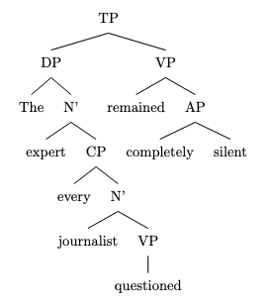
This code represents the sentence as a tree with the following structure:

* TP (Tense Phrase): the top node
* DP (Determiner Phrase): "The expert [every journalist questioned]"
+ N' (Noun Phrase): "expert"
+ CP (Clause Phrase): "every journalist questioned"
- N' (Noun Phrase): "journalist"
- VP (Verb Phrase): "questioned"
* VP (Verb Phrase): "remained completely silent"
+ AP (Adjective Phrase): "completely silent"

3. To expand the recursive structure, we can add another layer of recursion by embedding another clause within the existing relative clause. Here is the modified sentence:

"The expert every journalist the editor trusted questioned remained completely silent."

In this sentence, we've added another relative clause "the editor trusted" within the existing relative clause "every journalist questioned". This creates another layer of clausal recursion. The modified syntactic tree would be:
```
\documentclass{article}
\usepackage[linguistics]{forest}

\begin{document}

\begin{forest}
[TP
[DP [The] [N' [expert]
[CP [every] [N' [journalist]
[CP [the] [N' [editor]
[VP [trusted]]]
[VP [questioned]]]]]
[VP [remained] [AP [completely] [silent]]]]
\end{forest}

\end{document}
```

This code represents the modified sentence with an additional layer of clausal recursion.

rec_28.txt arn:aws:bedrock:us-west-2::foundation-model/meta.llama3-1-405b-instruct-v1:0 temperature=0.5
PROMPT: Consider the sentence below and complete the following three tasks:
1. Does the sentence in question contain an instance of recursion? If so, identify the recursive part and say what kind of recursion it is. Note that there are different types of recursion, e.g. adjectival recursion (an adjective modifying an adjective-modified noun), Saxon Genitive a.k.a. possessive 's recursion (an 's-possessed 's-possessor), prepositional phrase recursion (a prepositional phrase with another prepositional phrase inside), clausal recursion (a clause within another clause), and so on.
2. Provide code for a syntactic tree representing the structure of the sentence that can be rendered with LaTeX's forest package. Assume X-bar theory.
3. If you identified that the sentence contains a recursive structure, expand it by adding another layer of recursion (of the same type) to the identified structure.
"The astronomy the ancients we revere studied was not separate from astrology."
REPLY: 1. The sentence contains an instance of recursion, specifically a type of clausal recursion known as a "relative clause recursion" or "center-embedding recursion." The recursive part is "the astronomy the ancients we revere studied," where a clause ("the ancients we revere studied") is embedded within another clause.

2. Here is the code for a syntactic tree representing the structure of the sentence using LaTeX's forest package, assuming X-bar theory:
```
\documentclass{article}
\usepackage[linguistics]{forest}

\begin{document}

\begin{forest}
[S
[NP [Det [the]]
[N' [N [astronomy]]
[CP [NP [Det [the]]
[N' [N [ancients]]
[CP [NP [we]]
[VP [V [revere]]
[VP [V [studied]]]]]]]]
[VP [V [was]]
[AP [not]
[AP [separate]
[PP [from]
[NP [astrology]]]]]]
\end{forest}

\end{document}
```

DOES NOT COMPILE

3. To expand the recursive structure, I will add another layer of recursion to the relative clause:
"The astronomy the ancients we revere and our teachers admire studied was not separate from astrology."

In this expanded sentence, another clause ("and our teachers admire") is embedded within the existing recursive structure, creating an additional layer of center-embedding recursion.

rec_29.txt arn:aws:bedrock:us-west-2::foundation-model/meta.llama3-1-405b-instruct-v1:0 temperature=0.5
PROMPT: Consider the sentence below and complete the following three tasks:
1. Does the sentence in question contain an instance of recursion? If so, identify the recursive part and say what kind of recursion it is. Note that there are different types of recursion, e.g. adjectival recursion (an adjective modifying an adjective-modified noun), Saxon Genitive a.k.a. possessive 's recursion (an 's-possessed 's-possessor), prepositional phrase recursion (a prepositional phrase with another prepositional phrase inside), clausal recursion (a clause within another clause), and so on.
2. Provide code for a syntactic tree representing the structure of the sentence that can be rendered with LaTeX's forest package. Assume X-bar theory.
3. If you identified that the sentence contains a recursive structure, expand it by adding another layer of recursion (of the same type) to the identified structure.
"A candidate the committee we put together rejected developed the imposter syndrome."
REPLY: 1. The sentence contains an instance of recursion, specifically a type of clausal recursion known as a "center-embedded clause." The recursive part is "the committee we put together rejected," where a clause ("we put together") is embedded within another clause ("the committee... rejected").

2. Here is the LaTeX code for a syntactic tree representing the structure of the sentence using the forest package:
```
\documentclass{article}
\usepackage[linguistics]{forest}

\begin{document}

\begin{forest}
[CP
[NP [A [candidate]]]
[C'
[C [ø]]
[TP
[NP
[NP [the [committee]]]
[CP
[C [ø]]
[TP
[NP [we]]
[T'
[T [put]]
[VP
[V [together]]
[NP [ø]]
]
]
]
]
]
[T'
[T [rejected]]
[VP
[V [developed]]
[NP
[Det [the]]
[N'
[N [imposter]]
[N [syndrome]]
]
]
]
]
]
]
]
\end{forest}

\end{document}
```
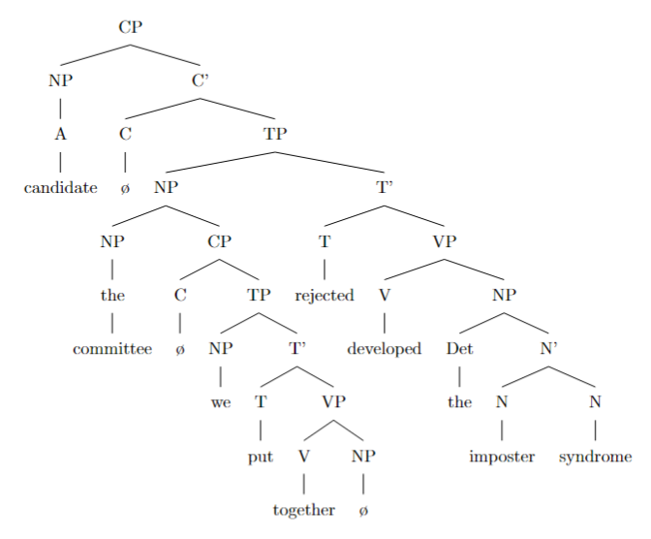

Note that this representation assumes a Chomskyan X-bar theory approach to phrase structure grammar.

3. To expand the recursive structure, we can add another layer of clausal recursion by embedding another clause within the existing center-embedded clause. Here is an example:
"A candidate the committee we put together because the funding was available rejected developed the imposter syndrome."

In this expanded sentence, the new recursive structure is "because the funding was available," which is a clause embedded within the existing center-embedded clause "the committee we put together rejected."

rec_30.txt arn:aws:bedrock:us-west-2::foundation-model/meta.llama3-1-405b-instruct-v1:0 temperature=0.5
PROMPT: Consider the sentence below and complete the following three tasks:
1. Does the sentence in question contain an instance of recursion? If so, identify the recursive part and say what kind of recursion it is. Note that there are different types of recursion, e.g. adjectival recursion (an adjective modifying an adjective-modified noun), Saxon Genitive a.k.a. possessive 's recursion (an 's-possessed 's-possessor), prepositional phrase recursion (a prepositional phrase with another prepositional phrase inside), clausal recursion (a clause within another clause), and so on.
2. Provide code for a syntactic tree representing the structure of the sentence that can be rendered with LaTeX's forest package. Assume X-bar theory.
3. If you identified that the sentence contains a recursive structure, expand it by adding another layer of recursion (of the same type) to the identified structure.
"The worldview that the prose Nietzsche wrote expressed was unprecedented."
REPLY: 1. The sentence contains an instance of clausal recursion, specifically a clause within a clause. The recursive part is "that the prose Nietzsche wrote expressed was unprecedented," which is a dependent clause within the main clause "The worldview...was unprecedented."

2. Here is the code for a syntactic tree representing the structure of the sentence using LaTeX's forest package, assuming X-bar theory:
```
\documentclass{article}
\usepackage[linguistics]{forest}

\begin{document}

\begin{forest}
[TP
[DP [The] [worldview]]
[T' [T [was]]
[VP [V [expressed]]
[CP [that]
[TP
[DP [the] [prose]]
[T' [T [wrote]]
[VP [V [Nietzsche]]
[VP [V [expressed]]]]]]]]]
\end{forest}

\end{document}
```

DOES NOT COMPILE; ADDED BRACKETS (AM)
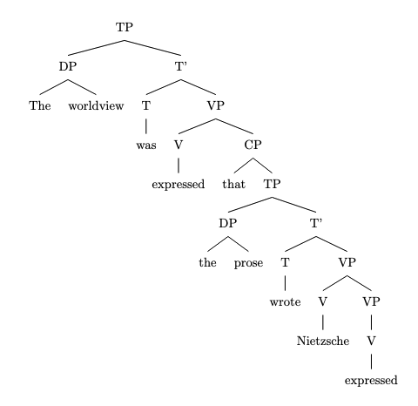
Note: This code represents the sentence structure using a simplified version of X-bar theory, with TP representing the Tense Phrase, DP representing the Determiner Phrase, T' representing the Tense head, VP representing the Verb Phrase, CP representing the Complementizer Phrase, and V representing the Verb head.

3. To expand the recursive structure, I will add another layer of clausal recursion to the identified structure. Here is the modified sentence:
"The worldview that the prose that Nietzsche's contemporaries admired wrote expressed was unprecedented."

In this expanded sentence, I added another dependent clause "that Nietzsche's contemporaries admired" within the existing dependent clause "that the prose Nietzsche wrote expressed was unprecedented." This new clause is also an instance of clausal recursion, with the same type of recursion as the original sentence.

Messages generated with 13255 tokens

o1-preview-2024-09-12

rec_01.txt o1-preview-2024-09-12 temperature=1.0
PROMPT: Consider the sentence below and complete the following three tasks:
1. Does the sentence in question contain an instance of recursion? If so, identify the recursive part and say what kind of recursion it is. Note that there are different types of recursion, e.g. adjectival recursion (an adjective modifying an adjective-modified noun), Saxon Genitive a.k.a. possessive 's recursion (an 's-possessed 's-possessor), prepositional phrase recursion (a prepositional phrase with another prepositional phrase inside), clausal recursion (a clause within another clause), and so on.
2. Provide code for a syntactic tree representing the structure of the sentence that can be rendered with LaTeX's forest package. Assume X-bar theory.
3. If you identified that the sentence contains a recursive structure, expand it by adding another layer of recursion (of the same type) to the identified structure.
"Jack van der Molen might be the sneaky old thief."
REPLY: **1. Identification of Recursion:**

Yes, the sentence contains an instance of recursion. The recursive structure occurs within the **noun phrase (NP)** "Jack van der Molen". Specifically, it involves **NP recursion via prepositional phrase (PP) complements**.

- **Recursive Part:** The NP "der Molen" is embedded within the PP "van der Molen", which itself is part of the larger NP "Jack van der Molen". This nesting of NPs within PPs and NPs is characteristic of recursive structures in syntax.

- **Type of Recursion:** This is an instance of **noun phrase recursion**. The recursion occurs because an NP contains a PP, which in turn contains another NP.

---

**2. Syntactic Tree Code with LaTeX's Forest Package (X-bar Theory):**

Below is the code for the syntactic tree representing the structure of the sentence using LaTeX's forest package, following X-bar theory conventions.

```latex
\begin{forest}
[TP
[NP
[N$'$
[N [\textit{Jack}]]
[PP
[P [\textit{van}]]
[NP
[Det [\textit{der}]]
[N [\textit{Molen}]]
]
]
]
]
[T$'$
[T [\textit{might}]]
[VP
[V$'$
[V [\textit{be}]]
[NP
[Det [\textit{the}]]
[N$'$
[AdjP [\textit{sneaky}]]
[N$'$
[AdjP [\textit{old}]]
[N [\textit{thief}]]
]
]
]
]
]
]
]
\end{forest}
```
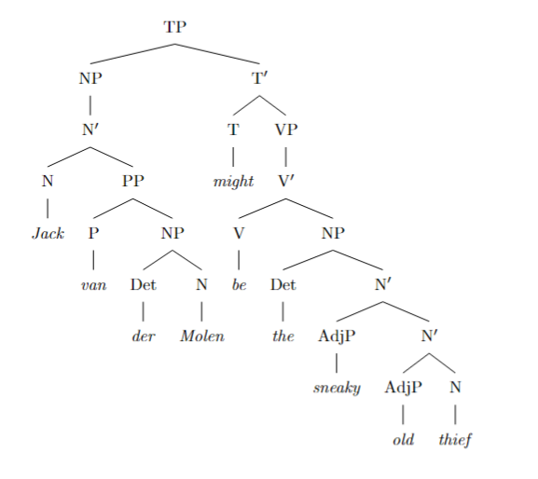
**Explanation of the Tree Structure:**

- **TP (Tense Phrase):** The root of the sentence.
- **NP (Subject):** "Jack van der Molen"
- **N$'$**
- **N:** "Jack"
- **PP:** "van der Molen"
- **P:** "van"
- **NP:**
- **Det:** "der"
- **N:** "Molen"
- **T$'$**
- **T:** "might"
- **VP:**
- **V$'$**
- **V:** "be"
- **NP (Complement):** "the sneaky old thief"
- **Det:** "the"
- **N$'$**
- **AdjP:** "sneaky"
- **N$'$**
- **AdjP:** "old"
- **N:** "thief"

---

**3. Expansion with Additional Layer of Recursion:**

To add another layer of recursion of the same type (NP recursion via PP complements), we expand the noun phrase by embedding another PP within the existing NP structure.

**Expanded Sentence:**

*"Jack van der Molen in the village might be the sneaky old thief."*

**Explanation:**

In this expanded sentence, we've added the prepositional phrase **"in the village"** to the noun phrase **"der Molen"**, creating an additional layer of NP recursion:

- The NP **"der Molen in the village"** is now embedded within the PP **"van der Molen in the village"**, which is part of the larger NP **"Jack van der Molen in the village"**.

**Updated Syntactic Tree Code:**

```latex
\begin{forest}
[TP
[NP
[N$'$
[N [\textit{Jack}]]
[PP
[P [\textit{van}]]
[NP
[Det [\textit{der}]]
[N$'$
[N [\textit{Molen}]]
[PP
[P [\textit{in}]]
[NP
[Det [\textit{the}]]
[N [\textit{village}]]
]
]
]
]
]
]
]
[T$'$
[T [\textit{might}]]
[VP
[V$'$
[V [\textit{be}]]
[NP
[Det [\textit{the}]]
[N$'$
[AdjP [\textit{sneaky}]]
[N$'$
[AdjP [\textit{old}]]
[N [\textit{thief}]]
]
]
]
]
]
]
]
\end{forest}
```

**Explanation of the Updated Tree Structure:**

- In the NP for **"Jack van der Molen in the village"**, the additional PP **"in the village"** is attached to the N$'$ node containing **"Molen"**.
- **PP:**
- **P:** "in"
- **NP:**
- **Det:** "the"
- **N:** "village"
- This creates a deeper recursive structure, adding another NP within a PP within an NP.

---

**Summary:**

- **Recursion Identified:** NP recursion via PP complements in the subject noun phrase.
- **Syntactic Tree Provided:** Represents the sentence structure in X-bar theory using the forest package.
- **Expanded Sentence:** Added another layer of recursion by embedding an additional PP within the NP.

rec_10.txt o1-preview-2024-09-12 temperature=1.0
PROMPT: Consider the sentence below and complete the following three tasks:
1. Does the sentence in question contain an instance of recursion? If so, identify the recursive part and say what kind of recursion it is. Note that there are different types of recursion, e.g. adjectival recursion (an adjective modifying an adjective-modified noun), Saxon Genitive a.k.a. possessive 's recursion (an 's-possessed 's-possessor), prepositional phrase recursion (a prepositional phrase with another prepositional phrase inside), clausal recursion (a clause within another clause), and so on.
2. Provide code for a syntactic tree representing the structure of the sentence that can be rendered with LaTeX's forest package. Assume X-bar theory.
3. If you identified that the sentence contains a recursive structure, expand it by adding another layer of recursion (of the same type) to the identified structure.
"The footprints clearly revealed Beth's young companion's escape route."
REPLY: **Answer to Task 1:**

Yes, the sentence contains an instance of recursion. The recursive part is **"Beth's young companion's"**, which exemplifies **possessive 's recursion** (also known as the Saxon Genitive). In this structure, a possessive construction is nested within another possessive construction. "Beth's" possesses "young companion," and "young companion's" possesses "escape route," forming a recursive possessive relationship.

---

**Answer to Task 2:**

Below is the code for a syntactic tree representing the structure of the sentence using LaTeX's `forest` package, assuming X-bar theory:

```latex
\documentclass{article}
\usepackage[linguistics]{forest}
\begin{document}

\begin{forest}
[, for tree={parent anchor=south, child anchor=north}
[CP
[NP
[Det [The]]
[N [footprints]]
]
[C$'$
[C [\phantom{X}]]
[TP
[T [\phantom{X}]]
[VP
[AdvP [clearly]]
[V$'$
[V [revealed]]
[DP
[Spec
[DP
[Spec [N [Beth]]]
[D$'$
[D ['s]]
[NP
[AP [young]]
[N [companion]]
]
]
]
]
[D$'$
[D ['s]]
[NP
[N [escape route]]
]
]
]
]
]
]
]
]
]
\end{forest}

\end{document}
```
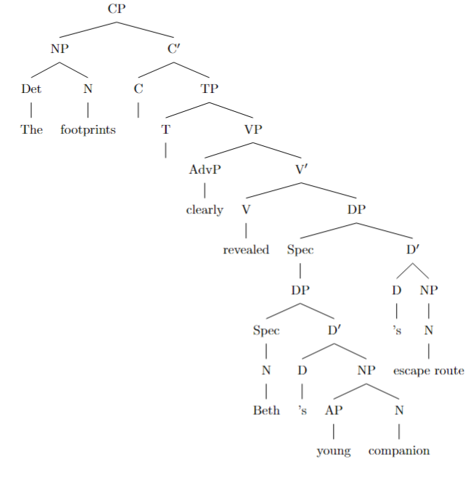

**Explanation:**

- **CP (Complementizer Phrase):** Represents the entire sentence.
- **NP (Noun Phrase):** Contains the subject "The footprints."
- **VP (Verb Phrase):** Contains the verb "revealed" and its complements.
- **AdvP (Adverb Phrase):** Contains the adverb "clearly."
- **DP (Determiner Phrase):** Represents the possessive constructions.
- **Possessive Recursion:**
- The first **DP** in the **Spec** position contains "Beth's young companion."
- Inside this **DP**, "Beth" is in the **Spec** position, and "'s" is in **D** with "young companion" as the **NP**.
- The outer **DP** attaches another "'s" in **D**, connecting to "escape route" as the **NP**.

---

**Answer to Task 3:**

Expanding the recursive structure by adding another layer of possessive recursion, we get:

**New Sentence:**

*"The footprints clearly revealed Beth's young companion's friend's escape route."*

**Updated Syntactic Tree Code:**

```latex
\documentclass{article}
\usepackage[linguistics]{forest}
\begin{document}

\begin{forest}
[, for tree={parent anchor=south, child anchor=north}
[CP
[NP
[Det [The]]
[N [footprints]]
]
[C$'$
[C [\phantom{X}]]
[TP
[T [\phantom{X}]]
[VP
[AdvP [clearly]]
[V$'$
[V [revealed]]
[DP
[Spec
[DP
[Spec
[DP
[Spec [N [Beth]]]
[D$'$
[D ['s]]
[NP
[AP [young]]
[N [companion]]
]
]
]
]
[D$'$
[D ['s]]
[NP
[N [friend]]
]
]
]
]
[D$'$
[D ['s]]
[NP
[N [escape route]]
]
]
]
]
]
]
]
]
]
\end{forest}

\end{document}
```

**Explanation of the Expansion:**

- Added another **DP** layer within the **Spec** of the existing **DP** to include "friend's."
- Now, the possessive recursion includes "Beth's young companion's friend's," adding another layer of possession.
- The structure shows the escape route belonging to the friend of Beth's young companion.

---

**Note:** To render the trees, compile the LaTeX code with the necessary packages (`forest` with the `linguistics` library). The trees illustrate the recursive possessive 's structures within the sentence, adhering to the principles of X-bar theory.

rec_04.txt o1-preview-2024-09-12 temperature=1.0
PROMPT: Consider the sentence below and complete the following three tasks:
1. Does the sentence in question contain an instance of recursion? If so, identify the recursive part and say what kind of recursion it is. Note that there are different types of recursion, e.g. adjectival recursion (an adjective modifying an adjective-modified noun), Saxon Genitive a.k.a. possessive 's recursion (an 's-possessed 's-possessor), prepositional phrase recursion (a prepositional phrase with another prepositional phrase inside), clausal recursion (a clause within another clause), and so on.
2. Provide code for a syntactic tree representing the structure of the sentence that can be rendered with LaTeX's forest package. Assume X-bar theory.
3. If you identified that the sentence contains a recursive structure, expand it by adding another layer of recursion (of the same type) to the identified structure.
"Unidentified flying objects may have conflicting characteristics."
REPLY: **Task 1: Identifying Recursion in the Sentence**

Yes, the sentence contains an instance of recursion. The recursive part is the noun phrase **"Unidentified flying objects"**, which exhibits **adjectival recursion**. In this structure:

- The adjective **"unidentified"** modifies the noun phrase **"flying objects"**.
- Within **"flying objects"**, the adjective **"flying"** modifies the noun **"objects"**.

This creates a recursive adjectival modification where an adjective modifies a noun that is already modified by another adjective.

---

**Task 2: Syntactic Tree in LaTeX with the Forest Package (Assuming X-bar Theory)**

Below is the code for a syntactic tree representing the structure of the sentence, using LaTeX's `forest` package and assuming X-bar theory:

```latex
\begin{forest}
[TP
[NP
[AdjP [Unidentified]]
[N$'$
[AdjP [flying]]
[N [objects]]
]
]
[T$'$
[T [may]]
[VP
[V [have]]
[NP
[AdjP [conflicting]]
[N [characteristics]]
]
]
]
]
\end{forest}
```
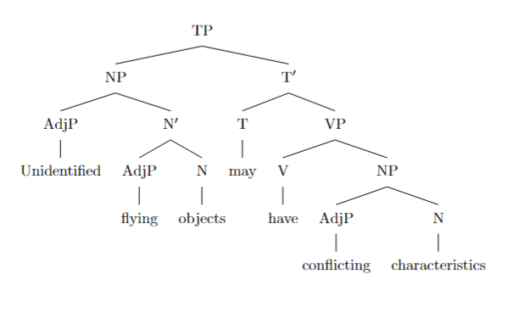
This tree can be visualized as:

- **TP (Tense Phrase)**
- **NP (Noun Phrase)**: Subject of the sentence
- **AdjP**: "Unidentified"
- **N′ (N-bar)**
- **AdjP**: "flying"
- **N**: "objects"
- **T′ (T-bar)**
- **T**: "may"
- **VP (Verb Phrase)**
- **V**: "have"
- **NP**
- **AdjP**: "conflicting"
- **N**: "characteristics"

---

**Task 3: Expanding the Sentence with Another Layer of Adjectival Recursion**

Adding another layer of adjectival recursion to the identified structure, we can expand the sentence as:

**"Unidentified recently sighted flying objects may have conflicting characteristics."**

In this expanded noun phrase:

- The adjective **"unidentified"** modifies **"recently sighted flying objects"**.
- The adjective **"recently sighted"** modifies **"flying objects"**.
- The adjective **"flying"** modifies **"objects"**.

This adds another layer of adjectival recursion, where adjectives recursively modify noun phrases that themselves contain adjectives.

rec_06.txt o1-preview-2024-09-12 temperature=1.0
PROMPT: Consider the sentence below and complete the following three tasks:
1. Does the sentence in question contain an instance of recursion? If so, identify the recursive part and say what kind of recursion it is. Note that there are different types of recursion, e.g. adjectival recursion (an adjective modifying an adjective-modified noun), Saxon Genitive a.k.a. possessive 's recursion (an 's-possessed 's-possessor), prepositional phrase recursion (a prepositional phrase with another prepositional phrase inside), clausal recursion (a clause within another clause), and so on.
2. Provide code for a syntactic tree representing the structure of the sentence that can be rendered with LaTeX's forest package. Assume X-bar theory.
3. If you identified that the sentence contains a recursive structure, expand it by adding another layer of recursion (of the same type) to the identified structure.
"A small child can easily get lost in a vast American mall."
REPLY: **Answer to Task 1:**

Yes, the sentence contains an instance of recursion, specifically adjectival recursion. In the noun phrase "a vast American mall," the noun "mall" is modified by the adjective "American," forming "American mall." This noun phrase is further modified by the adjective "vast," resulting in "vast American mall." Here, an adjective modifies a noun that has already been modified by another adjective, which is a recursive application of adjective modification in syntax.

---

**Answer to Task 2:**

Below is the code for the syntactic tree representing the structure of the sentence, using LaTeX's `forest` package and assuming X-bar theory:

```latex
\begin{forest}
[IP
[NP
[Det [A]]
[N'
[AdjP [small]]
[N [child]]
]
]
[I'
[I [can]]
[VP
[AdvP [easily]]
[V'
[V [get]]
[V'
[V [lost]]
[PP
[P [in]]
[NP
[Det [a]]
[N'
[N'
[AdjP [vast]]
[N'
[AdjP [American]]
[N [mall]]
]
]
]
]
]
]
]
]
]
]
\end{forest}
```
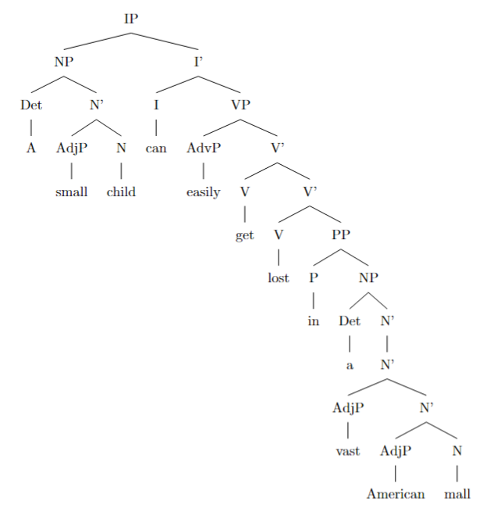
---

**Answer to Task 3:**

Expanding the recursive adjectival structure by adding another layer of recursion, we can add another adjective to the noun phrase. For example, we can modify "mall" with an additional adjective "new," resulting in the sentence:

*“A small child can easily get lost in a vast new American mall.”*

The updated recursive noun phrase is "a vast new American mall," where "mall" is modified by "American," which is modified by "new," which is in turn modified by "vast." Here is the revised syntactic tree code:

```latex
\begin{forest}
[IP
[NP
[Det [A]]
[N'
[AdjP [small]]
[N [child]]
]
]
[I'
[I [can]]
[VP
[AdvP [easily]]
[V'
[V [get]]
[V'
[V [lost]]
[PP
[P [in]]
[NP
[Det [a]]
[N'
[N'
[AdjP [vast]]
[N'
[AdjP [new]]
[N'
[AdjP [American]]
[N [mall]]
]
]
]
]
]
]
]
]
]
]
]
\end{forest}
```

This tree adds another layer of adjectival recursion by introducing the adjective "new" into the noun phrase.

rec_08.txt o1-preview-2024-09-12 temperature=1.0
PROMPT: Consider the sentence below and complete the following three tasks:
1. Does the sentence in question contain an instance of recursion? If so, identify the recursive part and say what kind of recursion it is. Note that there are different types of recursion, e.g. adjectival recursion (an adjective modifying an adjective-modified noun), Saxon Genitive a.k.a. possessive 's recursion (an 's-possessed 's-possessor), prepositional phrase recursion (a prepositional phrase with another prepositional phrase inside), clausal recursion (a clause within another clause), and so on.
2. Provide code for a syntactic tree representing the structure of the sentence that can be rendered with LaTeX's forest package. Assume X-bar theory.
3. If you identified that the sentence contains a recursive structure, expand it by adding another layer of recursion (of the same type) to the identified structure.
"The Old Continent's civilizations' advances have shaped history."
REPLY: **1. Analysis of Recursion in the Sentence**

Yes, the sentence contains an instance of recursion. Specifically, it features recursion of the **Saxon Genitive (possessive 's)** in the noun phrase **"The Old Continent's civilizations' advances"**. This recursive structure involves one possessive noun modifying another possessive noun, creating a nested possessive relationship:

- **First possessive**: "The Old Continent's civilizations"
- **Second possessive**: "civilizations' advances"

This stacking of possessive constructions is a type of **noun phrase recursion**, where one noun phrase contains another noun phrase within it, linked by the possessive 's.

---

**2. LaTeX Code Using the Forest Package Representing the Syntactic Tree**

Below is the LaTeX code for the syntactic tree of the sentence, using the forest package and assuming X-bar theory. This code represents the hierarchical structure of the sentence, highlighting the recursive possessive construction within the noun phrase.

```latex
\documentclass{article}
\usepackage{forest}
\begin{document}
\begin{forest}
[CP
[C$'$
[C]
[TP
[NP
[NP
[NP
[D [The]]
[AdjP [Old]]
[N$'$
[N [Continent]]
]
]
[D [\text{'s}]]
[N$'$
[N [civilizations]]
]
]
[D [\text{'s}]]
[N$'$
[N [advances]]
]
]
[T$'$
[T [have]]
[VP
[V$'$
[V [shaped]]
[NP [history]]
]
]
]
]
]
]
\end{forest}
\end{document}
```

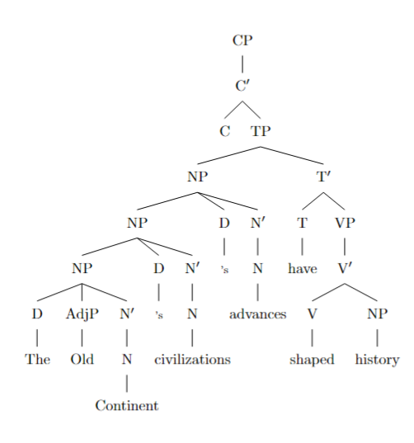

This code, when compiled with LaTeX, will produce a tree diagram illustrating the sentence's syntactic structure, including the recursive possession within the noun phrase.

---

**3. Expanding the Recursive Structure with Another Layer of Recursion**

Adding another layer of recursion of the same type (Saxon Genitive recursion), we expand the noun phrase by introducing an additional possessive noun:

**Expanded Sentence**:
"The Old Continent's civilizations' advances' impacts have shaped history."

Here, we've added **"advances' impacts"**, introducing a third possessive layer:

- **First possessive**: "The Old Continent's civilizations"
- **Second possessive**: "civilizations' advances"
- **Third possessive**: "advances' impacts"

This further nests the possessive structures, demonstrating an additional layer of recursion in the noun phrase.

---

**Expanded Syntactic Tree Code**

```latex
\documentclass{article}
\usepackage{forest}
\begin{document}
\begin{forest}
[CP
[C$'$
[C]
[TP
[NP
[NP
[NP
[NP
[D [The]]
[AdjP [Old]]
[N$'$
[N [Continent]]
]
]
[D [\text{'s}]]
[N$'$
[N [civilizations]]
]
]
[D [\text{'s}]]
[N$'$
[N [advances]]
]
]
[D [\text{'s}]]
[N$'$
[N [impacts]]
]
]
[T$'$
[T [have]]
[VP
[V$'$
[V [shaped]]
[NP [history]]
]
]
]
]
]
]
\end{forest}
\end{document}
```

This expanded code reflects the additional layer of recursion, showing the possessive relationship of "advances' impacts" nested within the already recursive noun phrase.

---

By identifying the recursion in the possessive constructions, providing a detailed syntactic tree representation, and expanding the recursive structure, we've completed the analysis of the sentence as requested.

rec_09.txt o1-preview-2024-09-12 temperature=1.0
PROMPT: Consider the sentence below and complete the following three tasks:
1. Does the sentence in question contain an instance of recursion? If so, identify the recursive part and say what kind of recursion it is. Note that there are different types of recursion, e.g. adjectival recursion (an adjective modifying an adjective-modified noun), Saxon Genitive a.k.a. possessive 's recursion (an 's-possessed 's-possessor), prepositional phrase recursion (a prepositional phrase with another prepositional phrase inside), clausal recursion (a clause within another clause), and so on.
2. Provide code for a syntactic tree representing the structure of the sentence that can be rendered with LaTeX's forest package. Assume X-bar theory.
3. If you identified that the sentence contains a recursive structure, expand it by adding another layer of recursion (of the same type) to the identified structure.
"This town's only road's potholes are driving me insane."
REPLY: **1. Identification of Recursion:**

Yes, the sentence contains an instance of recursion. The recursive structure is found in the possessive chain: **"This town's only road's potholes"**. This is an example of **possessive 's recursion** (also known as Saxon Genitive recursion). In this structure, possessive noun phrases are nested within each other, forming a recursive pattern where each noun possesses the next noun in the chain.

---

**2. Syntactic Tree Code using LaTeX's Forest Package (Assuming X-bar Theory):**

```latex
\begin{forest}
[TP
[DP
[DP
[DP
[D [\textit{This}]]
[NP [N [\textit{town}]]]
]
[D [\textit{'s}]]
[NP
[AP [A [\textit{only}]]]
[N [\textit{road}]]
]
]
[D [\textit{'s}]]
[NP [N [\textit{potholes}]]]
]
[T'
[T [\textit{are}]]
[VP
[V [\textit{driving}]]
[DP [D [\textit{me}]]]
[AdjP [A [\textit{insane}]]]
]
]
]
\end{forest}
```

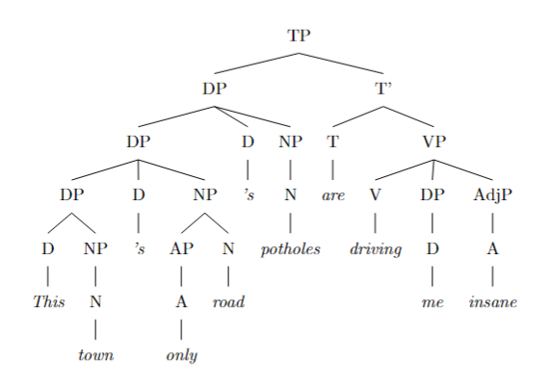

This code represents the syntactic structure of the sentence, highlighting the recursive possessive 's constructions within the Determiner Phrases (DPs). Each possessive 's attaches at the DP level, creating a nested, recursive pattern.

---

**3. Expansion with Another Layer of Recursion:**

By adding another layer of possessive 's recursion to the identified structure, the sentence becomes:

**"This town's only road's potholes' depths are driving me insane."**

In this expanded sentence, an additional possessive 's is added: **"potholes' depths"**, increasing the recursion within the possessive chain. The recursive structure now includes another noun phrase possessed by the previous one, extending the pattern of possessive nesting.

rec_02.txt o1-preview-2024-09-12 temperature=1.0
PROMPT: Consider the sentence below and complete the following three tasks:
1. Does the sentence in question contain an instance of recursion? If so, identify the recursive part and say what kind of recursion it is. Note that there are different types of recursion, e.g. adjectival recursion (an adjective modifying an adjective-modified noun), Saxon Genitive a.k.a. possessive 's recursion (an 's-possessed 's-possessor), prepositional phrase recursion (a prepositional phrase with another prepositional phrase inside), clausal recursion (a clause within another clause), and so on.
2. Provide code for a syntactic tree representing the structure of the sentence that can be rendered with LaTeX's forest package. Assume X-bar theory.
3. If you identified that the sentence contains a recursive structure, expand it by adding another layer of recursion (of the same type) to the identified structure.
"Now the six trainees construct a medium-sized sturdy lamp."
REPLY: **Task 1: Identifying Recursion**

Yes, the sentence contains an instance of recursion. The recursive part is within the noun phrase "a medium-sized sturdy lamp." Specifically, this is an example of **adjectival recursion**, where multiple adjective phrases (AP) are recursively adjoined to the noun phrase (NP). In X-bar theory, each adjective phrase combines with an N' (N-bar) to form a higher-level N', allowing for the stacking of adjectives. Here's the recursive structure within the NP:

- N'
- AP (medium-sized)
- N'
- AP (sturdy)
- N (lamp)

**Task 2: Syntactic Tree Code in LaTeX's Forest Package**

Below is the code for the syntactic tree representing the structure of the sentence using the forest package in LaTeX, adhering to X-bar theory:

```latex
\begin{forest}
[TP
[AdvP [Now]]
[T'
[NP
[Det [the]]
[N'
[Num [six]]
[N [trainees]]
]
]
[T'
[T [\textit{Ø}]]
[VP
[V [construct]]
[NP
[Det [a]]
[N'
[AP [medium-sized]]
[N'
[AP [sturdy]]
[N [lamp]]
]
]
]
]
]
]
]
\end{forest}
```

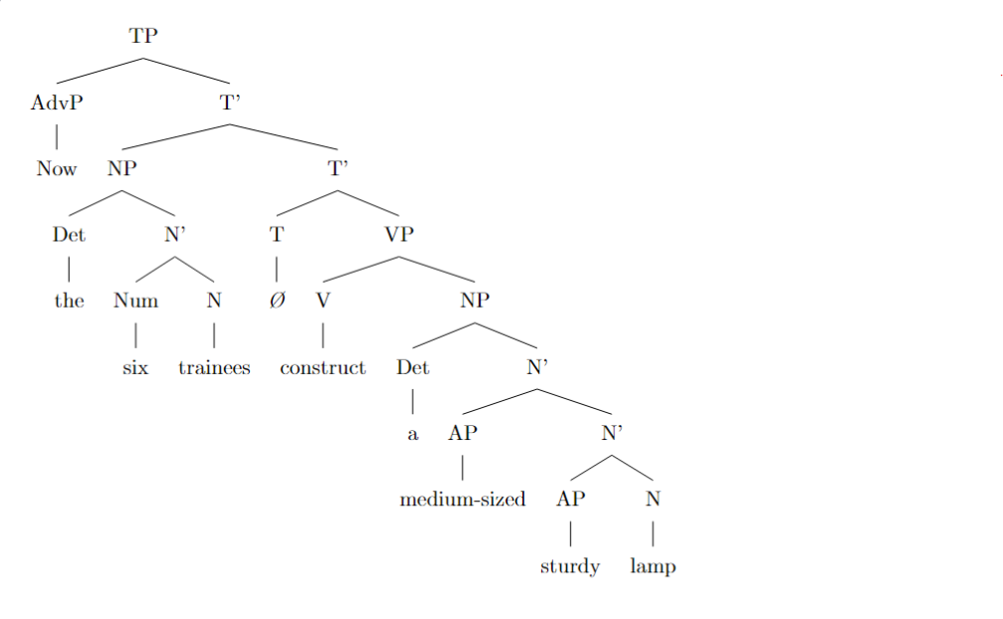

**Task 3: Expanding the Recursive Structure**

To add another layer of recursion of the same type (adjectival recursion), we can include an additional adjective in the noun phrase. The expanded sentence is:

"Now the six trainees construct a **beautiful** medium-sized sturdy lamp."

This adds another adjective "beautiful," resulting in a deeper recursive structure within the NP:

- N'
- AP (beautiful)
- N'
- AP (medium-sized)
- N'
- AP (sturdy)
- N (lamp)

The updated syntactic tree code reflecting this additional layer of recursion is:

```latex
\begin{forest}
[TP
[AdvP [Now]]
[T'
[NP
[Det [the]]
[N'
[Num [six]]
[N [trainees]]
]
]
[T'
[T [\textit{Ø}]]
[VP
[V [construct]]
[NP
[Det [a]]
[N'
[AP [beautiful]]
[N'
[AP [medium-sized]]
[N'
[AP [sturdy]]
[N [lamp]]
]
]
]
]
]
]
]
]
\end{forest}
```

rec_03.txt o1-preview-2024-09-12 temperature=1.0
PROMPT: Consider the sentence below and complete the following three tasks:
1. Does the sentence in question contain an instance of recursion? If so, identify the recursive part and say what kind of recursion it is. Note that there are different types of recursion, e.g. adjectival recursion (an adjective modifying an adjective-modified noun), Saxon Genitive a.k.a. possessive 's recursion (an 's-possessed 's-possessor), prepositional phrase recursion (a prepositional phrase with another prepositional phrase inside), clausal recursion (a clause within another clause), and so on.
2. Provide code for a syntactic tree representing the structure of the sentence that can be rendered with LaTeX's forest package. Assume X-bar theory.
3. If you identified that the sentence contains a recursive structure, expand it by adding another layer of recursion (of the same type) to the identified structure.
"Luna has been chasing the small white mouse all day long."
REPLY: **Answer to Question 1:**

Yes, the sentence *"Luna has been chasing the small white mouse all day long."* contains an instance of recursion. Specifically, it exhibits **verb phrase (VP) recursion** through the use of auxiliary verbs. In this sentence, auxiliary verbs "has" and "been" create nested verb phrases, where each VP contains another VP as its complement. This recursive structure is a hallmark of the VP via auxiliary verbs in English syntax.

---

**Answer to Question 2:**

Below is the code for a syntactic tree of the sentence, compatible with LaTeX's `forest` package and assuming X-bar theory:

```latex
\begin{forest}
[TP
[NP [N [Luna]]]
[T$'$
[T [has]]
[VP
[V$'$
[V [been]]
[VP
[V$'$
[V [chasing]]
[NP
[Det [the]]
[AP [A [small]]]
[AP [A [white]]]
[N [mouse]]
]
[AdvP [Adv [all day long]]]
]
]
]
]
]
]
\end{forest}
```

---

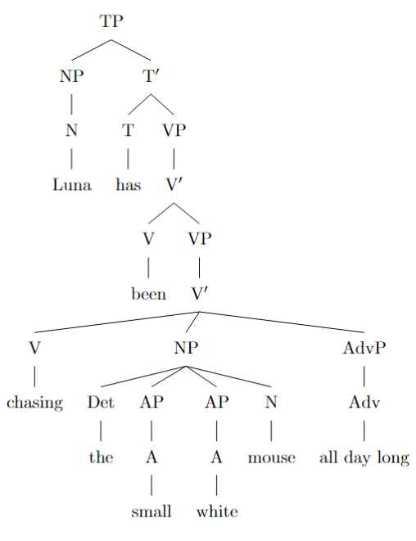
**Answer to Question 3:**

Expanding the recursive structure by adding another layer of recursion of the same type (VP recursion via auxiliary verbs), we can modify the sentence to:

*"Luna **will** have been chasing the small white mouse all day long."*

This adds the auxiliary verb "will," introducing an additional layer of VP recursion:

```latex
\begin{forest}
[TP
[NP [N [Luna]]]
[T$'$
[T [will]]
[VP
[V$'$
[V [have]]
[VP
[V$'$
[V [been]]
[VP
[V$'$
[V [chasing]]
[NP
[Det [the]]
[AP [A [small]]]
[AP [A [white]]]
[N [mouse]]
]
[AdvP [Adv [all day long]]]
]
]
]
]
]
]
]
]
\end{forest}
```

rec_11.txt o1-preview-2024-09-12 temperature=1.0
PROMPT: Consider the sentence below and complete the following three tasks:
1. Does the sentence in question contain an instance of recursion? If so, identify the recursive part and say what kind of recursion it is. Note that there are different types of recursion, e.g. adjectival recursion (an adjective modifying an adjective-modified noun), Saxon Genitive a.k.a. possessive 's recursion (an 's-possessed 's-possessor), prepositional phrase recursion (a prepositional phrase with another prepositional phrase inside), clausal recursion (a clause within another clause), and so on.
2. Provide code for a syntactic tree representing the structure of the sentence that can be rendered with LaTeX's forest package. Assume X-bar theory.
3. If you identified that the sentence contains a recursive structure, expand it by adding another layer of recursion (of the same type) to the identified structure.
"He spotted the infamous manuscript in the wizard's library's dark corner."
REPLY: 1. **Yes, the sentence contains an instance of recursion through possessive 's (Saxon Genitive) recursion.** The recursive part is _"the wizard's library's dark corner"_ where the possessive structures are nested: **"wizard's"** possesses **"library,"** which in turn possesses **"dark corner."** This creates a recursive chain of possessives within the noun phrase.

2. **Syntactic tree code using LaTeX's forest package (assuming X-bar theory):**

```latex
\begin{forest}
[S
[NP [N He]]
[VP
[V spotted]
[NP
[Det the]
[N'
[Adj infamous]
[N'
[N manuscript]
[PP
[P in]
[NP
[Det the]
[N'
[N corner]
[Adj dark]
[NP
[NP [N wizard][Poss 's]]
[NP [N library][Poss 's]]
]
]
]
]
]
]
]
]
]
\end{forest}
```
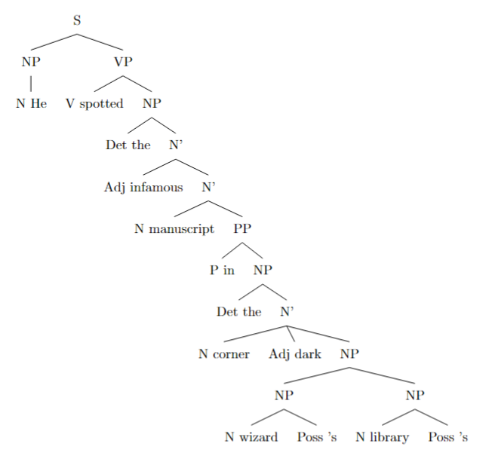
3. **Expanded sentence with an additional layer of possessive recursion:**

"He spotted the infamous manuscript in **the wizard's library's shelf's dark corner.**"

This adds another layer of recursion by including **"shelf's"** into the possessive chain, extending the recursive structure within the noun phrase.

rec_07.txt o1-preview-2024-09-12 temperature=1.0
PROMPT: Consider the sentence below and complete the following three tasks:
1. Does the sentence in question contain an instance of recursion? If so, identify the recursive part and say what kind of recursion it is. Note that there are different types of recursion, e.g. adjectival recursion (an adjective modifying an adjective-modified noun), Saxon Genitive a.k.a. possessive 's recursion (an 's-possessed 's-possessor), prepositional phrase recursion (a prepositional phrase with another prepositional phrase inside), clausal recursion (a clause within another clause), and so on.
2. Provide code for a syntactic tree representing the structure of the sentence that can be rendered with LaTeX's forest package. Assume X-bar theory.
3. If you identified that the sentence contains a recursive structure, expand it by adding another layer of recursion (of the same type) to the identified structure.
"A sudden shriek penetrated the cold winter's night's dead silence."
REPLY: **1. Identification of Recursion:**

Yes, the sentence contains an instance of recursion. Specifically, it exhibits **Saxon Genitive recursion** (possessive 's recursion). This occurs within the noun phrase:

- **"the cold winter's night's dead silence"**

Here, the possessive structure is recursive:

- **"winter's night's dead silence"**

This can be broken down as:

- **"winter's night"** (the night belonging to winter)
- **"night's dead silence"** (the dead silence belonging to the night)

Thus, the possessive 's is applied recursively to form a chain of possessions, where each possessive noun phrase contains another possessive noun phrase within it.

---

**2. Syntactic Tree with LaTeX's Forest Package (X-bar Theory):**

Below is the code for a syntactic tree representing the structure of the sentence using LaTeX's forest package. This code assumes familiarity with LaTeX and requires the `forest` package to compile.

```latex
\begin{forest}
for tree={
align=center,
grow'=south,
child anchor=north,
parent anchor=south,
anchor=center,
l=2cm,
edge path={
\noexpand\path [draw, ->, >=latex] (!u.parent anchor) -- +(0,-7pt) -| (.child anchor)\forestoption{edge label};
},
s sep=7pt
}
[TP
[NP
[D [A]]
[NP
[AdjP [Adj [sudden]]]
[N [shriek]]
]
]
[T$'$
[T]
[VP
[V [penetrated]]
[NP
[D [the]]
[NP
[NP
[NP
[AdjP [Adj [cold]]]
[N [winter]]
]
[D ['s]]
[N [night]]
]
[D ['s]]
[NP
[AdjP [Adj [dead]]]
[N [silence]]
]
]
]
]
]
]
\end{forest}
```
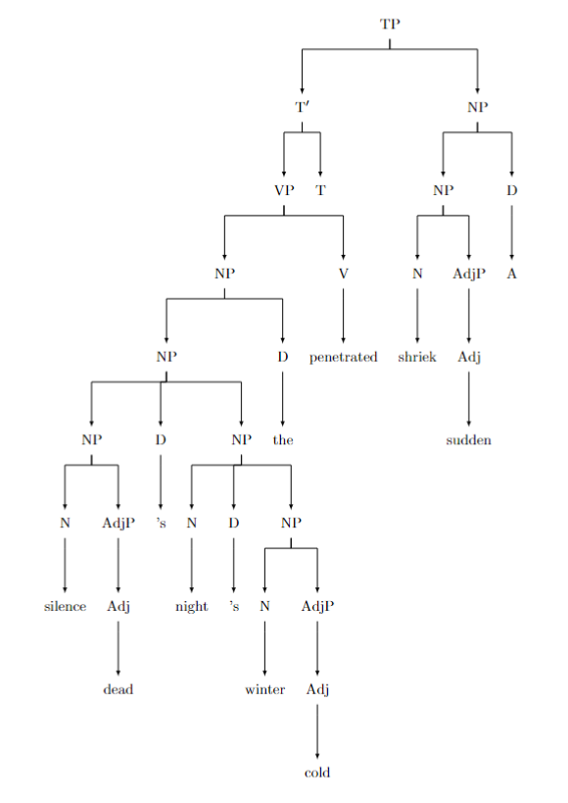
**Explanation:**

- **TP** (Tense Phrase) is the root of the sentence.
- The **subject NP** consists of:
- **D** (Determiner): *A*
- **NP**:
- **AdjP** (Adjective Phrase): *sudden*
- **N** (Noun): *shriek*
- The **VP** (Verb Phrase) includes:
- **V**: *penetrated*
- **NP** (Direct Object):
- **D**: *the*
- **NP**:
- **NP**:
- **NP**:
- **AdjP**: *cold*
- **N**: *winter*
- **D**: *'s*
- **N**: *night*
- **D**: *'s*
- **NP**:
- **AdjP**: *dead*
- **N**: *silence*

This tree illustrates the recursive possessive structures, where each possessive 's introduces a new layer within the NP.

---

**3. Expansion with Another Layer of Recursion:**

To add another layer of recursion of the same type (Saxon Genitive recursion), we can introduce an additional possessive 's phrase into the structure. Here's the expanded sentence:

- **"A sudden shriek penetrated the cold winter's night's wind's dead silence."**

**Explanation:**

We have added **"wind's"** into the possessive chain:

- **"winter's night's wind's dead silence"**

This adds another possessive layer:

1. **"winter's night"** (the night of winter)
2. **"night's wind"** (the wind of the night)
3. **"wind's dead silence"** (the dead silence of the wind)

**Updated Syntactic Tree Code:**

```latex
\begin{forest}
for tree={
align=center,
grow'=south,
child anchor=north,
parent anchor=south,
anchor=center,
l=2cm,
edge path={
\noexpand\path [draw, ->, >=latex] (!u.parent anchor) -- +(0,-7pt) -| (.child anchor)\forestoption{edge label};
},
s sep=7pt
}
[TP
[NP
[D [A]]
[NP
[AdjP [Adj [sudden]]]
[N [shriek]]
]
]
[T$'$
[T]
[VP
[V [penetrated]]
[NP
[D [the]]
[NP
[NP
[NP
[NP
[AdjP [Adj [cold]]]
[N [winter]]
]
[D ['s]]
[N [night]]
]
[D ['s]]
[N [wind]]
]
[D ['s]]
[NP
[AdjP [Adj [dead]]]
[N [silence]]
]
]
]
]
]
]
\end{forest}
```

**Explanation of the Expanded Tree:**

- An additional **NP** for *wind* has been inserted into the possessive chain.
- Each possessive 's (**D ['s]**) introduces a new level of recursion in the NP.
- The recursion now follows:
- **[cold winter]**'s
- **[night]**'s
- **[wind]**'s
- **[dead silence]**

---

**Summary:**

- The sentence demonstrates **Saxon Genitive recursion** through multiple possessive 's structures within the noun phrase.
- The syntactic tree illustrates the recursive possessive NPs and adheres to X-bar theory principles.
- Adding another possessive 's layer expands the recursion, further embedding NPs within NPs in the structure.

rec_05.txt o1-preview-2024-09-12 temperature=1.0
PROMPT: Consider the sentence below and complete the following three tasks:
1. Does the sentence in question contain an instance of recursion? If so, identify the recursive part and say what kind of recursion it is. Note that there are different types of recursion, e.g. adjectival recursion (an adjective modifying an adjective-modified noun), Saxon Genitive a.k.a. possessive 's recursion (an 's-possessed 's-possessor), prepositional phrase recursion (a prepositional phrase with another prepositional phrase inside), clausal recursion (a clause within another clause), and so on.
2. Provide code for a syntactic tree representing the structure of the sentence that can be rendered with LaTeX's forest package. Assume X-bar theory.
3. If you identified that the sentence contains a recursive structure, expand it by adding another layer of recursion (of the same type) to the identified structure.
"My cranky geriatric manager is beyond incompetent."
REPLY: **Answer to Task 1:**

Yes, the sentence contains an instance of recursion. Specifically, it features **adjectival recursion**, where multiple adjectives recursively modify a noun that is already modified by one or more adjectives. In the noun phrase "My cranky geriatric manager," the noun "manager" is first modified by the adjective "geriatric," forming "geriatric manager." This adjective-modified noun is then further modified by the adjective "cranky," resulting in "cranky geriatric manager." This layering of adjectives exemplifies adjectival recursion.

---

**Answer to Task 2:**

Below is the code for a syntactic tree representing the structure of the sentence, suitable for rendering with LaTeX's forest package and assuming X-bar theory:

```latex
\begin{forest}
[S
[NP
[D [My]]
[N$'$
[AP [cranky]]
[N$'$
[AP [geriatric]]
[N [manager]]
]
]
]
[VP
[V [is]]
[PP
[P [beyond]]
[AP [incompetent]]
]
]
]
\end{forest}
```
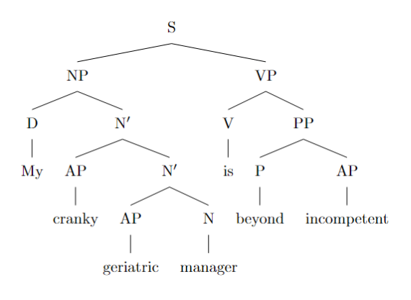
---

**Answer to Task 3:**

By adding another layer of adjectival recursion, the sentence expands to:

"My **unhelpful** cranky geriatric manager is beyond incompetent."

The updated syntactic tree code incorporating the additional adjective "unhelpful" is:

```latex
\begin{forest}
[S
[NP
[D [My]]
[N$'$
[AP [unhelpful]]
[N$'$
[AP [cranky]]
[N$'$
[AP [geriatric]]
[N [manager]]
]
]
]
]
[VP
[V [is]]
[PP
[P [beyond]]
[AP [incompetent]]
]
]
]
\end{forest}
```

This tree illustrates the additional layer of recursion, as "unhelpful" modifies the already adjective-modified noun phrase "cranky geriatric manager," further deepening the recursive adjectival structure.

rec_12.txt o1-preview-2024-09-12 temperature=1.0
PROMPT: Consider the sentence below and complete the following three tasks:
1. Does the sentence in question contain an instance of recursion? If so, identify the recursive part and say what kind of recursion it is. Note that there are different types of recursion, e.g. adjectival recursion (an adjective modifying an adjective-modified noun), Saxon Genitive a.k.a. possessive 's recursion (an 's-possessed 's-possessor), prepositional phrase recursion (a prepositional phrase with another prepositional phrase inside), clausal recursion (a clause within another clause), and so on.
2. Provide code for a syntactic tree representing the structure of the sentence that can be rendered with LaTeX's forest package. Assume X-bar theory.
3. If you identified that the sentence contains a recursive structure, expand it by adding another layer of recursion (of the same type) to the identified structure.
"Do I dare challenge my advisor's thesis' central argument?"
REPLY: **Task 1:**

Yes, the sentence contains an instance of recursion, specifically **Saxon Genitive recursion** (possessive 's recursion). The recursive part is:

- *my advisor's thesis' central argument*

This phrase involves nested possessive constructions:

- *[my advisor's] thesis' central argument*
- Within this, *advisor's thesis'* is a possessive within a possessive.

**Task 2:**

Here is the code for a syntactic tree representing the structure of the sentence using LaTeX's forest package, assuming X-bar theory:

```latex
\begin{forest}
[CP
[C$'$
[C [Do]]
[TP
[NP [I]]
[T$'$
[T [\emph{t}]]
[VP
[V [dare]]
[VP
[V [challenge]]
[NP
[NP
[NP
[D [my]]
[N$'$
[N [advisor]]
[Poss ['s]]
]
]
[N$'$
[N [thesis]]
[Poss ['s]]
]
]
[N$'$
[AdjP [central]]
[N [argument]]
]
]
]
]
]
]
]
]
\end{forest}
```
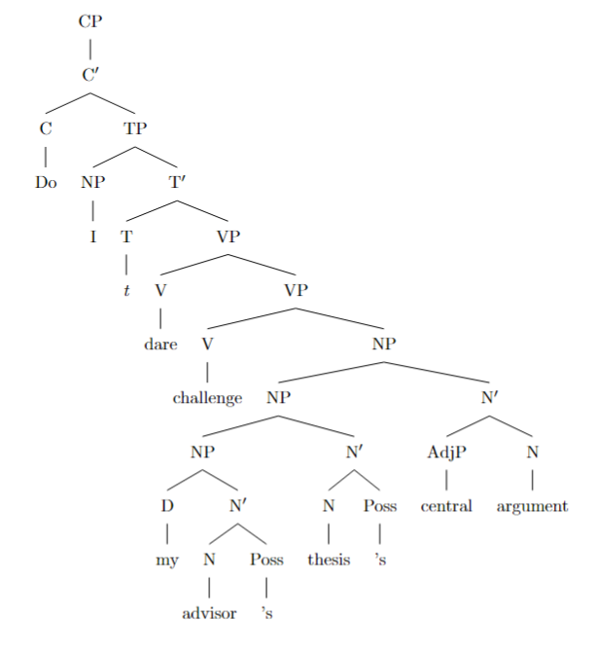
**Explanation:**

- **CP**: Complementizer Phrase, representing the entire sentence as a question.
- **C'**: Contains the Complementizer (C) and the Tense Phrase (TP).
- **C**: Holds the fronted auxiliary verb "Do" due to question formation.
- **TP**: Tense Phrase, with the subject **NP** "I" and the predicate.
- **T'**: Contains the Tense (T) and the Verb Phrase (VP). **T** has a trace (\emph{t}) of the moved auxiliary.
- **VP**: Verb Phrase, with the main verbs "dare" and "challenge," and the object **NP**.
- **NP**: Noun Phrase, representing the recursive possessive structure.
- The recursive **NP** is nested to represent each possessive 's:
- **my advisor's thesis' central argument**
- Each possessive 's is represented by a **Poss** node attached to the preceding **N**.

**Task 3:**

Expanding the recursive structure by adding another layer of possessive 's recursion:

**Expanded Sentence:**

"Do I dare challenge my advisor's advisor's thesis' central argument?"

**Explanation:**

- Added another layer of possessive recursion by including "advisor's advisor's."
- The recursive structure now includes:

- *my advisor's advisor's thesis' central argument*

This adds an additional possessive 's, increasing the depth of the recursive possessive construction within the noun phrase.

rec_15.txt o1-preview-2024-09-12 temperature=1.0
PROMPT: Consider the sentence below and complete the following three tasks:
1. Does the sentence in question contain an instance of recursion? If so, identify the recursive part and say what kind of recursion it is. Note that there are different types of recursion, e.g. adjectival recursion (an adjective modifying an adjective-modified noun), Saxon Genitive a.k.a. possessive 's recursion (an 's-possessed 's-possessor), prepositional phrase recursion (a prepositional phrase with another prepositional phrase inside), clausal recursion (a clause within another clause), and so on.
2. Provide code for a syntactic tree representing the structure of the sentence that can be rendered with LaTeX's forest package. Assume X-bar theory.
3. If you identified that the sentence contains a recursive structure, expand it by adding another layer of recursion (of the same type) to the identified structure.
"He had been warned about the dangers of tobacco."
REPLY: **Answer to Task 1:**

Yes, the sentence contains an instance of recursion. The recursive part is in the noun phrase (NP) "the dangers of tobacco." Specifically, it involves **nominal recursion** through prepositional phrases (PPs) attached to noun phrases. In X-bar theory, this is represented by the rule \( \text{N}' \rightarrow \text{N}' \ \text{PP} \), where an N' node dominates another N' node followed by a PP. Here, the noun "dangers" is expanded by the PP "of tobacco," forming a recursive structure within the NP.

---

**Answer to Task 2:**

Here is the code for the syntactic tree using LaTeX's forest package, following X-bar theory:

```latex
\begin{forest}
[IP
[NP [He]]
[I$'$
[I [had been]]
[VP
[V [warned]]
[PP
[P [about]]
[NP
[Det [the]]
[N$'$
[N$'$
[N [dangers]]
]
[PP
[P [of]]
[NP [tobacco]]
]
]
]
]
]
]
]
\end{forest}
```
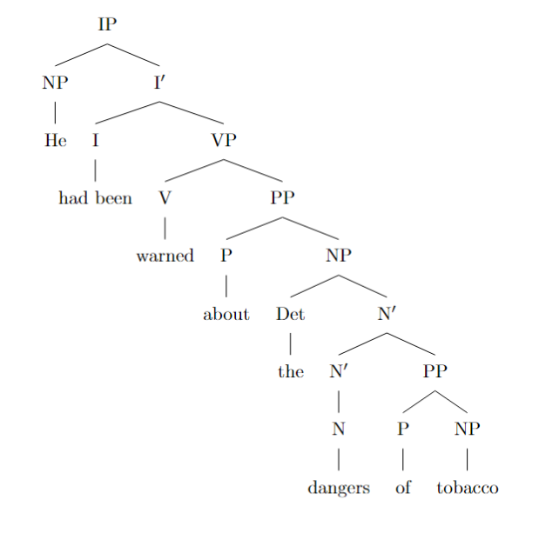
This tree represents the sentence structure, showing that the noun "dangers" combines with the PP "of tobacco" to form a recursive N' node within the NP "the dangers of tobacco." The VP "warned about the dangers of tobacco" shows the verb "warned" with its PP complement "about the dangers of tobacco."

---

**Answer to Task 3:**

Expanding the recursive structure by adding another layer of the same type, we can modify the sentence to:

"He had been warned about the dangers of tobacco of the highest toxicity."

In this expanded NP "the dangers of tobacco of the highest toxicity," we have added another PP "of the highest toxicity" to the N' node, creating an additional layer of nominal recursion:

- \( \text{N}' \rightarrow \text{N}' \ \text{PP} \)
- \( \text{N}' \rightarrow \text{N}' \ \text{PP} \)
- \( \text{N}' \rightarrow \text{N} \)
- PP: "of tobacco"
- PP: "of the highest toxicity"

The syntactic tree code for the expanded NP is:

```latex
\begin{forest}
[NP
[Det [the]]
[N$'$
[N$'$
[N$'$
[N [dangers]]
]
[PP
[P [of]]
[NP [tobacco]]
]
]
[PP
[P [of]]
[NP
[Det [the]]
[AdjP [highest]]
[N [toxicity]]
]
]
]
]
\end{forest}
```

This demonstrates an additional layer of recursion in the NP, maintaining the same recursive structure as identified in Task 1.

rec_13.txt o1-preview-2024-09-12 temperature=1.0
PROMPT: Consider the sentence below and complete the following three tasks:
1. Does the sentence in question contain an instance of recursion? If so, identify the recursive part and say what kind of recursion it is. Note that there are different types of recursion, e.g. adjectival recursion (an adjective modifying an adjective-modified noun), Saxon Genitive a.k.a. possessive 's recursion (an 's-possessed 's-possessor), prepositional phrase recursion (a prepositional phrase with another prepositional phrase inside), clausal recursion (a clause within another clause), and so on.
2. Provide code for a syntactic tree representing the structure of the sentence that can be rendered with LaTeX's forest package. Assume X-bar theory.
3. If you identified that the sentence contains a recursive structure, expand it by adding another layer of recursion (of the same type) to the identified structure.
"She saw someone loitering by the entrance to the library."
REPLY: **Answer:**

1. **Recursion Identification:**

Yes, the sentence contains an instance of recursion, specifically **prepositional phrase (PP) recursion**. The recursive part is within the phrase *"by the entrance **to the library**"*. Here, the prepositional phrase *"to the library"* is embedded within another prepositional phrase *"by the entrance ..."*. This nesting of a PP inside another PP is an example of PP recursion.

---

2. **Syntactic Tree Code in LaTeX's Forest Package (Assuming X-bar Theory):**

Here is the code for the syntactic tree representing the structure of the sentence using the forest package:

```latex
\begin{forest}
[CP
[NP [\textit{She}]]
[C'
[C [\textit{Ø}]]
[TP
[T'
[T [\textit{past}]]
[VP
[V'
[V [\textit{saw}]]
[NP
[N'
[N [\textit{someone}]]
[CP
[C' [C [\textit{Ø}]]
[TP
[T' [T [\textit{Ø}]]
[VP
[V'
[V [\textit{loitering}]]
[PP
[P' [P [\textit{by}]]
[NP
[D [\textit{the}]]
[N'
[N [\textit{entrance}]]
[PP
[P' [P [\textit{to}]]
[NP
[D [\textit{the}]]
[N [\textit{library}]]
]
]
]
]
]
]
]
]
]
]
]
]
]
]
]
]
]
]
]
]
]
\end{forest}
```
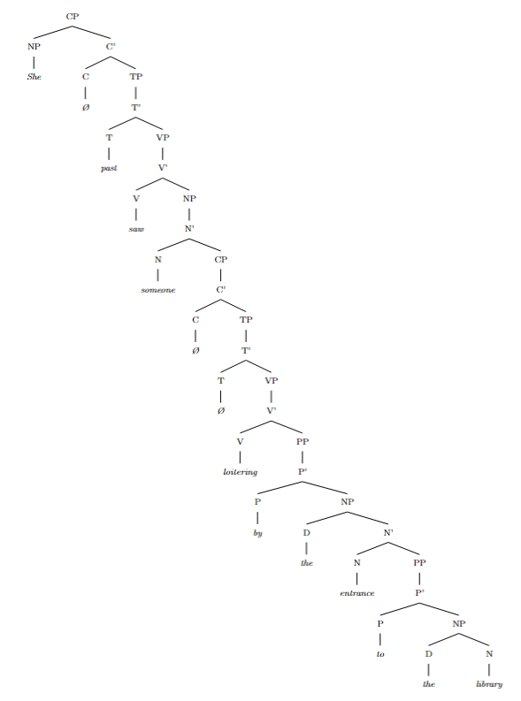
---

3. **Expanded Sentence with Additional Layer of Recursion:**

Expanded sentence with another layer of **prepositional phrase recursion**:

*"She saw someone loitering by the entrance down the path to the library."*

In this sentence, the PP recursion is extended by adding the prepositional phrase *"down the path"* inside the PP *"by the entrance ..."*, and within *"down the path"*, there is another PP *"to the library"* embedded, creating an additional layer of recursive PP structures.

rec_14.txt o1-preview-2024-09-12 temperature=1.0
PROMPT: Consider the sentence below and complete the following three tasks:
1. Does the sentence in question contain an instance of recursion? If so, identify the recursive part and say what kind of recursion it is. Note that there are different types of recursion, e.g. adjectival recursion (an adjective modifying an adjective-modified noun), Saxon Genitive a.k.a. possessive 's recursion (an 's-possessed 's-possessor), prepositional phrase recursion (a prepositional phrase with another prepositional phrase inside), clausal recursion (a clause within another clause), and so on.
2. Provide code for a syntactic tree representing the structure of the sentence that can be rendered with LaTeX's forest package. Assume X-bar theory.
3. If you identified that the sentence contains a recursive structure, expand it by adding another layer of recursion (of the same type) to the identified structure.
"We sow fear in the hearts of our enemies."
REPLY: **Task 1:**

Yes, the sentence contains an instance of recursion. Specifically, it exhibits **prepositional phrase recursion**. In the phrase **"in the hearts of our enemies,"** the prepositional phrase **"of our enemies"** is embedded within another prepositional phrase **"in the hearts [of our enemies]."** This nesting of prepositional phrases is a recursive structure where a prepositional phrase contains another prepositional phrase.

---

**Task 2:**

Below is the code for the syntactic tree of the sentence using LaTeX's **forest** package, following **X-bar theory**. This code can be compiled in a LaTeX editor to visualize the syntactic structure of the sentence.

```latex
\documentclass[margin=10pt]{standalone}
\usepackage[linguistics]{forest}

\begin{document}

\begin{forest}
for tree={
align=center,
parent anchor=south,
child anchor=north,
font=\small,
edge={->},
l=2cm
}
[TP
[NP [\textbf{We}]]
[T$'$
[T [{\phantom{T}}]]
[VP
[V$'$
[V [\textbf{sow}]]
[VP
[V$'$
[NP [\textbf{fear}]]
[PP
[P [\textbf{in}]]
[NP
[Det [\textbf{the}]]
[N$'$
[N [\textbf{hearts}]]
[PP
[P [\textbf{of}]]
[NP
[Det [\textbf{our}]]
[N [\textbf{enemies}]]]]]]]]]]]]
\end{forest}

\end{document}
```

DOES NOT COMPILE; ADDED BRACKET (AM)
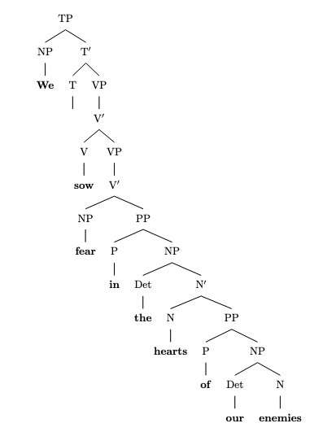
**Explanation:**

- **TP (Tense Phrase):** Represents the entire sentence.
- **NP (Noun Phrase):** The subject **"We"**.
- **T$'$ (T-bar):** Projects to the VP.
- **T:** Tense (left empty here as the verb **"sow"** is in the base form).
- **VP (Verb Phrase):** Contains the verb and its complements.
- **V$'$ (V-bar):** Projects from the verb.
- **V:** The main verb **"sow"**.
- **VP:** Contains another V-bar for recursion.
- **V$'$:**
- **NP:** The direct object **"fear"**.
- **PP:** Prepositional phrase **"in the hearts of our enemies"**.
- **P:** Preposition **"in"**.
- **NP:**
- **Det:** Determiner **"the"**.
- **N$'$:**
- **N:** Noun **"hearts"**.
- **PP:** Embedded prepositional phrase **"of our enemies"** (**prepositional phrase recursion**).
- **P:** Preposition **"of"**.
- **NP:**
- **Det:** Determiner **"our"**.
- **N:** Noun **"enemies"**.

---

**Task 3:**

Expanding the sentence by adding another layer of **prepositional phrase recursion**:

**"We sow fear in the hearts of the allies of our enemies."**

In this expanded sentence, an additional prepositional phrase **"of the allies"** is added within the prepositional phrase **"of our enemies,"** increasing the depth of recursion in the prepositional phrases.

The recursive structure now includes:

- **PP:** **"of our enemies"** containing
- **PP:** **"of the allies"** within
- **N$'$:** **"hearts"**

**Updated Tree Code:**

```latex
\documentclass[margin=10pt]{standalone}
\usepackage[linguistics]{forest}

\begin{document}

\begin{forest}
for tree={
align=center,
parent anchor=south,
child anchor=north,
font=\small,
edge={->},
l=2cm
}
[TP
[NP [\textbf{We}]]
[T$'$
[T [{\phantom{T}}]]
[VP
[V$'$
[V [\textbf{sow}]]
[VP
[V$'$
[NP [\textbf{fear}]]
[PP
[P [\textbf{in}]]
[NP
[Det [\textbf{the}]]
[N$'$
[N [\textbf{hearts}]]
[PP
[P [\textbf{of}]]
[NP
[Det [\textbf{the}]]
[N$'$
[N [\textbf{allies}]]
[PP
[P [\textbf{of}]]
[NP
[Det [\textbf{our}]]
[N [\textbf{enemies}]]]]]]]]]]]]]]]
\end{forest}

\end{document}
```

**Explanation of Expansion:**

- A new prepositional phrase **"of the allies"** is added within **"of our enemies,"** creating an additional layer of recursion.
- The structure now includes nested prepositional phrases:
- **PP:** **"of our enemies"**
- **PP:** **"of the allies"**
- This demonstrates deeper **prepositional phrase recursion** in the sentence structure.

---

**Note:** To view the tree diagrams, compile the LaTeX code in a LaTeX editor that supports the **forest** package. The diagrams will illustrate the hierarchical structure of the sentence according to X-bar theory, highlighting the recursive prepositional phrases.

rec_17.txt o1-preview-2024-09-12 temperature=1.0
PROMPT: Consider the sentence below and complete the following three tasks:
1. Does the sentence in question contain an instance of recursion? If so, identify the recursive part and say what kind of recursion it is. Note that there are different types of recursion, e.g. adjectival recursion (an adjective modifying an adjective-modified noun), Saxon Genitive a.k.a. possessive 's recursion (an 's-possessed 's-possessor), prepositional phrase recursion (a prepositional phrase with another prepositional phrase inside), clausal recursion (a clause within another clause), and so on.
2. Provide code for a syntactic tree representing the structure of the sentence that can be rendered with LaTeX's forest package. Assume X-bar theory.
3. If you identified that the sentence contains a recursive structure, expand it by adding another layer of recursion (of the same type) to the identified structure.
"Even their recipe for the basic dough of the pie crust is heavily guarded."
REPLY: **Answer:**

1. **Recursion Identification:**

Yes, the sentence contains an instance of recursion. The recursive structure is found within the **prepositional phrases (PPs)** embedded inside noun phrases (NPs). Specifically, we have a **recursive NP structure** where an NP contains a PP, which in turn contains an NP that itself contains a PP. This is an example of **prepositional phrase recursion** within noun phrases.

In the sentence:

*"Even their recipe [for the basic dough [of the pie crust]] is heavily guarded."*

- The NP "their recipe" is modified by the PP "for the basic dough of the pie crust."
- Within this PP, the object NP "the basic dough of the pie crust" contains another PP "of the pie crust."
- This demonstrates recursion as PPs are nested within NPs repeatedly.

---

2. **Syntactic Tree in LaTeX's Forest Package (Assuming X-bar Theory):**

Here is the code for the syntactic tree representing the structure of the sentence using the **forest** package in LaTeX:

```latex
\begin{forest}
[TP
[DP
[D [their]]
[NP
[N$'$
[N [recipe]]
[PP
[P [for]]
[NP
[D [the]]
[N$'$
[AdjP [Adj [basic]]]
[N$'$
[N [dough]]
[PP
[P [of]]
[NP
[D [the]]
[N$'$
[N$'$ [N [pie]]]
[N [crust]]
]
]
]
]
]
]
]
]
]
]
[T$'$
[T [is]]
[VP
[V [is]]
[AdjP
[AdvP [Adv [heavily]]]
[AdjP [Adj [guarded]]]
]
]
]
]
\end{forest}
```
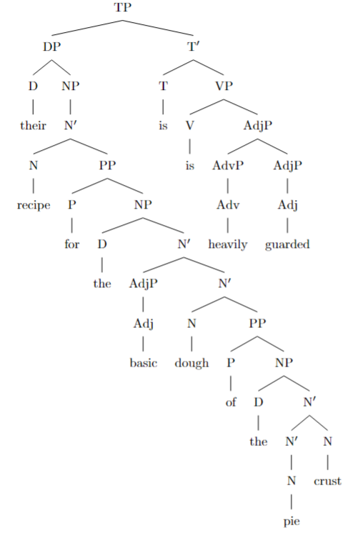
**Explanation of the Tree Structure:**

- **TP (Tense Phrase):** The root of the sentence.
- **DP (Determiner Phrase):** Subject of the sentence.
- **D (Determiner):** "their"
- **NP (Noun Phrase):** Contains the noun and its modifiers.
- **N' (N-bar):** Intermediate projection of N.
- **N (Noun):** "recipe"
- **PP (Prepositional Phrase):** Modifies "recipe."
- **P (Preposition):** "for"
- **NP:**
- **D:** "the"
- **N':**
- **AdjP:** "basic"
- **N':**
- **N:** "dough"
- **PP:**
- **P:** "of"
- **NP:**
- **D:** "the"
- **N':**
- **N':** "pie"
- **N:** "crust"
- **T' (T-bar):** Contains the tense and predicate.
- **T (Tense):** "is"
- **VP (Verb Phrase):**
- **V:** "is"
- **AdjP (Adjective Phrase):**
- **AdvP (Adverb Phrase):** "heavily"
- **AdjP:** "guarded"

---

3. **Expanded Sentence with Additional Recursion:**

To add another layer of recursion of the same type, we can include an additional **prepositional phrase** within the existing PP. For example:

*"Even their recipe for the basic dough of the pie crust **of the famous chef** is heavily guarded."*

In this expanded sentence, we've added the PP "of the famous chef" within the NP "the pie crust," introducing another layer of recursive PP within the NP structure.

**Updated Tree Structure Code:**

```latex
\begin{forest}
[TP
[DP
[D [their]]
[NP
[N$'$
[N [recipe]]
[PP
[P [for]]
[NP
[D [the]]
[N$'$
[AdjP [Adj [basic]]]
[N$'$
[N [dough]]
[PP
[P [of]]
[NP
[D [the]]
[N$'$
[N$'$
[N [pie]]
]
[N$'$
[N [crust]]
[PP
[P [of]]
[NP
[D [the]]
[N$'$
[AdjP [Adj [famous]]]
[N [chef]]
]
]
]
]
]
]
]
]
]
]
]
]
]
]
[T$'$
[T [is]]
[VP
[V [is]]
[AdjP
[AdvP [Adv [heavily]]]
[AdjP [Adj [guarded]]]
]
]
]
]
\end{forest}
```

In this updated tree:

- The NP "the pie crust" now includes an additional PP "of the famous chef."
- This PP is attached to the N' level of "crust," reflecting the added layer of recursion.
- The overall sentence structure remains the same, but with the expanded recursive element.

---

**Note:** The syntactic trees provided in the LaTeX code represent the hierarchical structure of the sentence according to X-bar theory. The recursive nature of PPs within NPs is visually depicted through the nested branches in the tree.

rec_16.txt o1-preview-2024-09-12 temperature=1.0
PROMPT: Consider the sentence below and complete the following three tasks:
1. Does the sentence in question contain an instance of recursion? If so, identify the recursive part and say what kind of recursion it is. Note that there are different types of recursion, e.g. adjectival recursion (an adjective modifying an adjective-modified noun), Saxon Genitive a.k.a. possessive 's recursion (an 's-possessed 's-possessor), prepositional phrase recursion (a prepositional phrase with another prepositional phrase inside), clausal recursion (a clause within another clause), and so on.
2. Provide code for a syntactic tree representing the structure of the sentence that can be rendered with LaTeX's forest package. Assume X-bar theory.
3. If you identified that the sentence contains a recursive structure, expand it by adding another layer of recursion (of the same type) to the identified structure.
"There is a little treat for you in the cupboard between the lamps."
REPLY: **Task 1: Identifying Recursion in the Sentence**

Yes, the sentence contains an instance of recursion. Specifically, it exhibits **prepositional phrase recursion**. In the sentence:

*"There is a little treat for you in the cupboard between the lamps."*

the recursive structure occurs within the noun phrase (NP) "the cupboard between the lamps," which is part of the prepositional phrase (PP) "in the cupboard between the lamps." Here's how the recursion unfolds:

1. **First Prepositional Phrase (PP1):** "in the cupboard between the lamps"
- **Head Preposition:** "in"
- **Complement NP:** "the cupboard between the lamps"

2. **Within the NP "the cupboard between the lamps":**
- **Head Noun:** "cupboard"
- **Modifier:** A prepositional phrase (PP2) "between the lamps"

3. **Second Prepositional Phrase (PP2):** "between the lamps"
- **Head Preposition:** "between"
- **Complement NP:** "the lamps"

This structure demonstrates recursion because PP2 ("between the lamps") is embedded within the NP that is itself part of PP1 ("in the cupboard between the lamps"). The recursion occurs as a PP contains an NP that includes another PP.

---

**Task 2: Syntactic Tree Using LaTeX's Forest Package**

Below is the code for a syntactic tree representing the structure of the sentence, using the forest package and assuming X-bar theory:

```latex
\begin{forest}
[IP
[NP [There]]
[I$'$
[I [is]]
[NP
[Det [a]]
[N$'$
[AdjP [Adj [little]]]
[N$'$
[N [treat]]
[PP
[P [for]]
[NP [you]]
]
[PP
[P [in]]
[NP
[Det [the]]
[N$'$
[N [cupboard]]
[PP
[P [between]]
[NP
[Det [the]]
[N [lamps]]
]
]
]
]
]
]
]
]
]
]
\end{forest}
```
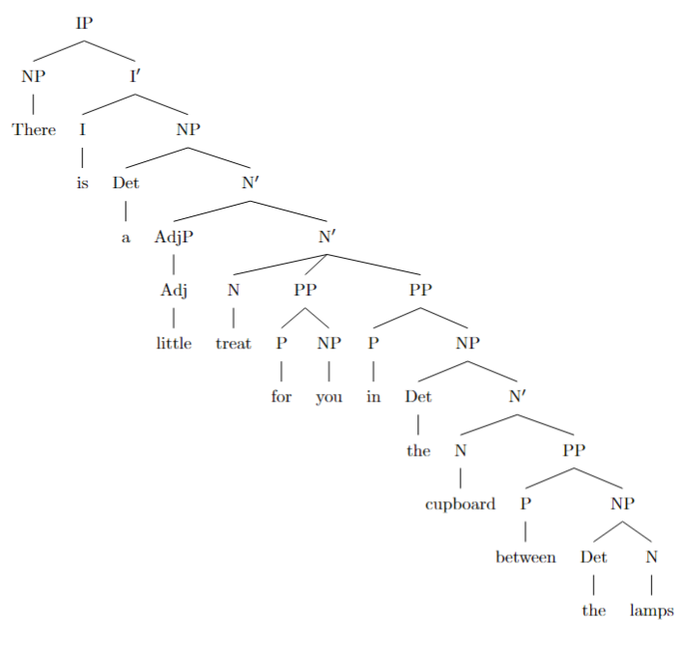
**Explanation of the Tree Structure:**

- **IP (Inflectional Phrase):** The root of the sentence.
- **NP (There):** Expletive subject.
- **I' (I prime):** Contains the inflection and VP.
- **I (is):** The verb "is."
- **NP (a little treat for you in the cupboard between the lamps):** The predicate nominative.
- **Det (a):** Determiner.
- **N' (N prime):**
- **AdjP (little):** Adjective phrase modifying "treat."
- **N' (treat):** Noun "treat," which is the head noun.
- **PP (for you):** First prepositional phrase modifying "treat."
- **P (for):** Preposition.
- **NP (you):** Object of the preposition "for."
- **PP (in the cupboard between the lamps):** Second prepositional phrase modifying "treat."
- **P (in):** Preposition.
- **NP (the cupboard between the lamps):** Object of the preposition "in."
- **Det (the):** Determiner.
- **N' (cupboard):** Head noun "cupboard."
- **PP (between the lamps):** Prepositional phrase modifying "cupboard."
- **P (between):** Preposition.
- **NP (the lamps):** Object of the preposition "between."
- **Det (the):** Determiner.
- **N (lamps):** Noun "lamps."

---

**Task 3: Expanding the Recursive Structure**

To add another layer of recursion of the same type (prepositional phrase recursion), we'll expand the original sentence by adding an additional PP within the NP. The expanded sentence is:

*"There is a little treat for you in the cupboard between the lamps beside the window."*

Here, we've added the PP "beside the window," which modifies "lamps" within the PP "between the lamps." This adds an extra layer of PP recursion.

**Updated Syntactic Tree Code:**

```latex
\begin{forest}
[IP
[NP [There]]
[I$'$
[I [is]]
[NP
[Det [a]]
[N$'$
[AdjP [Adj [little]]]
[N$'$
[N [treat]]
[PP
[P [for]]
[NP [you]]
]
[PP
[P [in]]
[NP
[Det [the]]
[N$'$
[N [cupboard]]
[PP
[P [between]]
[NP
[Det [the]]
[N$'$
[N [lamps]]
[PP
[P [beside]]
[NP
[Det [the]]
[N [window]]
]
]
]
]
]
]
]
]
]
]
]
]
]
\end{forest}
```

**Explanation of the Added Recursion:**

- **Within the NP "lamps,"** we've added a new PP "beside the window."
- **PP (beside the window):** Modifies "lamps."
- **P (beside):** Preposition.
- **NP (the window):** Object of the preposition "beside."
- **Det (the):** Determiner.
- **N (window):** Noun "window."

**The recursive structure now includes:**

- **First PP:** "in the cupboard between the lamps beside the window"
- **Second PP (within NP "cupboard"):** "between the lamps beside the window"
- **Third PP (within NP "lamps"):** "beside the window"

By adding "beside the window," we have introduced another PP within an NP that is already part of a PP, thus creating an additional layer of prepositional phrase recursion in the sentence.

---

**Note:** The syntactic trees provided should be compiled using LaTeX with the forest package. Ensure that you include the necessary packages and that your LaTeX editor supports compiling complex trees.

Here's how you might include the necessary packages:

```latex
\documentclass{article}
\usepackage{forest}
\begin{document}
% Include the tree code here
\end{document}
```

This completes the tasks by identifying the recursion, providing the syntactic tree code, and expanding the recursive structure with an additional layer of prepositional phrase recursion.

rec_19.txt o1-preview-2024-09-12 temperature=1.0
PROMPT: Consider the sentence below and complete the following three tasks:
1. Does the sentence in question contain an instance of recursion? If so, identify the recursive part and say what kind of recursion it is. Note that there are different types of recursion, e.g. adjectival recursion (an adjective modifying an adjective-modified noun), Saxon Genitive a.k.a. possessive 's recursion (an 's-possessed 's-possessor), prepositional phrase recursion (a prepositional phrase with another prepositional phrase inside), clausal recursion (a clause within another clause), and so on.
2. Provide code for a syntactic tree representing the structure of the sentence that can be rendered with LaTeX's forest package. Assume X-bar theory.
3. If you identified that the sentence contains a recursive structure, expand it by adding another layer of recursion (of the same type) to the identified structure.
"You must remember that you should always run all the basic diagnostics first."
REPLY: **Answer:**

1. **Identification of recursion and its type:**

Yes, the sentence contains an instance of recursion. The recursive part is the embedding of a clause within another clause, which is known as **clausal recursion**. Specifically, the main clause "You must remember" contains a subordinate clause "that you should always run all the basic diagnostics first," and within this subordinate clause, there could be further clauses embedded (as in the expanded sentence in task 3).

2. **LaTeX code for the syntactic tree using the forest package (assuming X-bar theory):**

```latex
\begin{forest}
[IP
[NP [You]]
[I$'$
[I [must]]
[VP
[V [remember]]
[CP
[C [that]]
[IP
[NP [you]]
[I$'$
[I [should]]
[VP
[AdvP [always]]
[V$'$
[V [run]]
[NP [all the basic diagnostics]]
[AdvP [first]]
]
]
]
]
]
]
]
]
\end{forest}
```

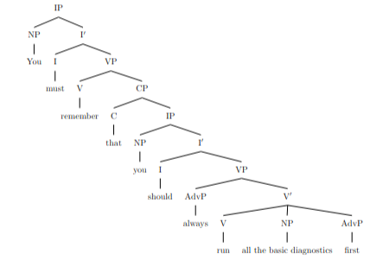

3. **Expanded sentence with an additional layer of clausal recursion:**

"You must remember that you should always **ensure that all the basic diagnostics are run first**."

In this expanded sentence, another subordinate clause "that all the basic diagnostics are run first" is embedded within the previous subordinate clause, adding another layer of **clausal recursion**.

rec_20.txt o1-preview-2024-09-12 temperature=1.0
PROMPT: Consider the sentence below and complete the following three tasks:
1. Does the sentence in question contain an instance of recursion? If so, identify the recursive part and say what kind of recursion it is. Note that there are different types of recursion, e.g. adjectival recursion (an adjective modifying an adjective-modified noun), Saxon Genitive a.k.a. possessive 's recursion (an 's-possessed 's-possessor), prepositional phrase recursion (a prepositional phrase with another prepositional phrase inside), clausal recursion (a clause within another clause), and so on.
2. Provide code for a syntactic tree representing the structure of the sentence that can be rendered with LaTeX's forest package. Assume X-bar theory.
3. If you identified that the sentence contains a recursive structure, expand it by adding another layer of recursion (of the same type) to the identified structure.
"She announced her victory to irritate her detractors."
REPLY: **Answer to Task 1:**

Yes, the sentence contains an instance of **clausal recursion**. The recursive part is the infinitival clause "**to irritate her detractors**," which is embedded within the verb phrase (VP) of the main clause. This clause functions as an adjunct purpose clause modifying the main verb "**announced**." In clausal recursion, a clause is embedded within another clause or phrase of the same type, creating a nested structure. Here, the infinitival clause is nested within the VP of the main clause, showcasing recursion in the syntactic structure.

---

**Answer to Task 2:**

Below is the LaTeX code using the `forest` package to represent the syntactic structure of the sentence, assuming X-bar theory:

```latex
\documentclass[border=5pt]{standalone}
\usepackage{forest}
\begin{document}
\begin{forest}
[TP
[NP [She]]
[T$'$
[T [\textit{past}]]
[VP
[V$'$
[V$'$
[V [announced]]
[NP [her \\ victory]]
]
[CP
[C$'$
[C [to]]
[TP
[T$'$
[T [\textit{Ø}]]
[VP
[V$'$
[V [irritate]]
[NP [her \\ detractors]]
]
]
]
]
]
]
]
]
]
]
\end{forest}
\end{document}
```
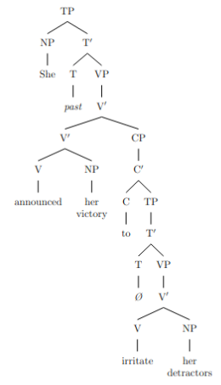
This code produces a syntactic tree where:

- The main clause is a **TP** (Tense Phrase) with "She" as the subject **NP**.
- The **VP** contains the verb "announced" and its object "her victory."
- The infinitival clause "to irritate her detractors" is represented as a **CP** (Complementizer Phrase) embedded within the VP, showing clausal recursion.
- Within the embedded clause, "to" is the complementizer **C**, introducing the non-finite **TP**.
- The verb "irritate" and its object "her detractors" form the embedded **VP**.

---

**Answer to Task 3:**

Adding another layer of clausal recursion of the same type involves embedding an additional infinitival clause within the existing one. Here's the expanded sentence with an extra layer of clausal recursion:

**"She announced her victory to irritate her detractors to prove her abilities."**

In this expanded sentence:

- The original infinitival clause "**to irritate her detractors**" now contains another infinitival clause "**to prove her abilities**."
- This adds a new layer of clausal recursion, as the second infinitival clause is embedded within the first, further nesting the syntactic structure.
- The recursive pattern continues with clauses embedded within clauses, all functioning as adjuncts expressing purpose.

This expanded structure maintains the same type of recursion (clausal recursion) by adding another infinitival purpose clause, demonstrating deeper levels of syntactic embedding.

rec_18.txt o1-preview-2024-09-12 temperature=1.0
PROMPT: Consider the sentence below and complete the following three tasks:
1. Does the sentence in question contain an instance of recursion? If so, identify the recursive part and say what kind of recursion it is. Note that there are different types of recursion, e.g. adjectival recursion (an adjective modifying an adjective-modified noun), Saxon Genitive a.k.a. possessive 's recursion (an 's-possessed 's-possessor), prepositional phrase recursion (a prepositional phrase with another prepositional phrase inside), clausal recursion (a clause within another clause), and so on.
2. Provide code for a syntactic tree representing the structure of the sentence that can be rendered with LaTeX's forest package. Assume X-bar theory.
3. If you identified that the sentence contains a recursive structure, expand it by adding another layer of recursion (of the same type) to the identified structure.
"Drowning your sorrows in a glass of whiskey is at best a temporary solution."
REPLY: **Task 1: Identifying Recursion**

Yes, the sentence contains an instance of recursion. The recursive part is within the prepositional phrases embedded inside each other. Specifically, the prepositional phrase (PP) "of whiskey" is embedded within the noun phrase (NP) "a glass of whiskey", which is itself the complement of the prepositional phrase "in a glass of whiskey". This is an example of **prepositional phrase recursion**, where a PP contains an NP that includes another PP.

**Explanation:**

- **Main PP:** "in a glass of whiskey"
- **Preposition (P):** in
- **NP Complement:** "a glass of whiskey"
- **Determiner (D):** a
- **Noun (N):** glass
- **Embedded PP:** "of whiskey"
- **P:** of
- **NP Complement:** "whiskey"

This structure shows that within the PP "in a glass of whiskey", the NP "a glass of whiskey" contains another PP "of whiskey". The embedding of one PP within another via the NP constitutes recursive structure in the sentence.

---

**Task 2: Syntactic Tree using LaTeX's Forest Package (X-bar Theory)**

Here is the LaTeX code for a syntactic tree representing the structure of the sentence, formatted using the forest package and following X-bar theory:

```latex
\begin{forest}
[TP
[NP
[N'
[V'
[V [Drowning]]
[NP [Det [your] ][N' [N [sorrows]]]]
[PP
[P [in]]
[NP
[Det [a]]
[N'
[N [glass]]
[PP
[P [of]]
[NP [N [whiskey]]]
]
]
]
]
]
]
]
[T'
[T [is]]
[VP
[AdvP [Adv [at best]]]
[NP
[Det [a]]
[N'
[AdjP [Adj [temporary]]]
[N [solution]]
]
]
]
]
]
\end{forest}
```
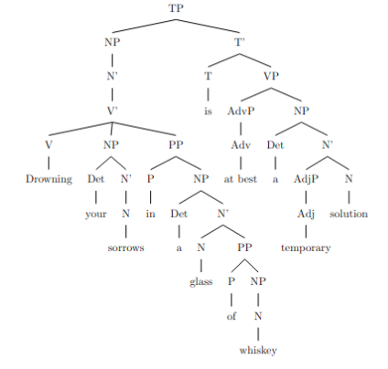
**Explanation:**

- **TP (Tense Phrase):** The root of the sentence.
- **NP (Subject):** "Drowning your sorrows in a glass of whiskey"
- **V':** Contains the verb and its complements.
- **V:** "Drowning"
- **NP:** "your sorrows"
- **Det:** "your"
- **N:** "sorrows"
- **PP:** "in a glass of whiskey"
- **P:** "in"
- **NP:** "a glass of whiskey"
- **Det:** "a"
- **N':**
- **N:** "glass"
- **PP:** "of whiskey"
- **P:** "of"
- **NP:** "whiskey"
- **T':** Contains the tense and the predicate.
- **T:** "is"
- **VP:** The predicate phrase.
- **AdvP:** "at best"
- **NP:** "a temporary solution"
- **Det:** "a"
- **N':**
- **AdjP:** "temporary"
- **N:** "solution"

This tree shows the hierarchical structure of the sentence, illustrating the recursive embedding of the PP "of whiskey" within the NP "a glass of whiskey" inside the PP "in a glass of whiskey".

---

**Task 3: Expanding the Recursive Structure**

To add another layer of recursion of the same type (prepositional phrase recursion), we can expand the PP within the NP by including an additional PP. Here's the modified sentence:

*"Drowning your sorrows in a glass of whiskey of the finest quality is at best a temporary solution."*

**Explanation:**

- **Original NP:** "a glass of whiskey"
- **Expanded NP:** "a glass of whiskey of the finest quality"
- **PP:** "of whiskey"
- **N:** "whiskey"
- **PP:** "of the finest quality"
- **P:** "of"
- **NP:** "the finest quality"

The recursive structure now includes another PP "of the finest quality" embedded within the NP "whiskey", which is itself part of the PP "of whiskey". This adds another layer of prepositional phrase recursion to the structure, demonstrating deeper recursive embedding.

---

**Summary:**

1. **Recursion Identified:** Prepositional phrase recursion within "in a glass of whiskey".
2. **Syntactic Tree Code:** Provided LaTeX code using X-bar theory and the forest package.
3. **Expanded Recursion:** Added another PP to create "a glass of whiskey of the finest quality", increasing the recursion level.

---

**Note:** To visualize the syntactic tree, compile the LaTeX code using a LaTeX editor that supports the forest package.

rec_22.txt o1-preview-2024-09-12 temperature=1.0
PROMPT: Consider the sentence below and complete the following three tasks:
1. Does the sentence in question contain an instance of recursion? If so, identify the recursive part and say what kind of recursion it is. Note that there are different types of recursion, e.g. adjectival recursion (an adjective modifying an adjective-modified noun), Saxon Genitive a.k.a. possessive 's recursion (an 's-possessed 's-possessor), prepositional phrase recursion (a prepositional phrase with another prepositional phrase inside), clausal recursion (a clause within another clause), and so on.
2. Provide code for a syntactic tree representing the structure of the sentence that can be rendered with LaTeX's forest package. Assume X-bar theory.
3. If you identified that the sentence contains a recursive structure, expand it by adding another layer of recursion (of the same type) to the identified structure.
"The few that could understand the manifesto's complex worldview appreciated it."
REPLY: **Answer to Task 1:**

Yes, the sentence contains an instance of **clausal recursion**. The recursive part is the relative clause "that could understand the manifesto's complex worldview," which is embedded within the main clause "The few appreciated it." This relative clause is itself a clause embedded within another clause, demonstrating clausal recursion.

---

**Answer to Task 2:**

Below is the code for a syntactic tree representing the structure of the sentence, using LaTeX's forest package and following X-bar theory conventions:

```latex
\documentclass{article}
\usepackage{forest}
\begin{document}
\begin{forest}
[CP
[C$'$
[C [\textit{[+DECL]}]]
[IP
[NP
[D [The]]
[N$'$
[N [few]]
[CP
[C$'$
[C [that]]
[IP
[NP [\textit{pro}]]
[I$'$
[I [could]]
[VP
[V$'$
[V [understand]]
[NP
[D [the]]
[N$'$
[NP
[N$'$
[N [manifesto]]
[\,['s]]% Possessive marker
]
]
[N$'$
[AdjP
[Adj [complex]]
]
[N [worldview]]
]
]
]
]
]
]
]
]
]
]
]
[I$'$
[I [\textit{[+PAST]}]]
[VP
[V$'$
[V [appreciated]]
[NP [it]]
]
]
]
]
]
]
\end{forest}
\end{document}
```
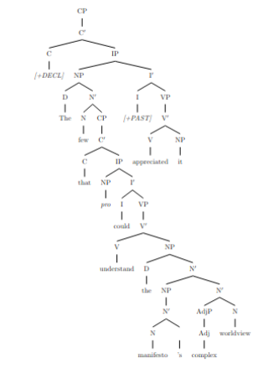
---

**Answer to Task 3:**

We can expand the recursive clausal structure by adding another layer of recursion within the relative clause. Here's the expanded sentence:

*"The few that could understand that the manifesto's complex worldview was revolutionary appreciated it."*

In this sentence, the relative clause "that could understand **that the manifesto's complex worldview was revolutionary**" contains another clause embedded within it, adding another layer of **clausal recursion**.

rec_21.txt o1-preview-2024-09-12 temperature=1.0
PROMPT: Consider the sentence below and complete the following three tasks:
1. Does the sentence in question contain an instance of recursion? If so, identify the recursive part and say what kind of recursion it is. Note that there are different types of recursion, e.g. adjectival recursion (an adjective modifying an adjective-modified noun), Saxon Genitive a.k.a. possessive 's recursion (an 's-possessed 's-possessor), prepositional phrase recursion (a prepositional phrase with another prepositional phrase inside), clausal recursion (a clause within another clause), and so on.
2. Provide code for a syntactic tree representing the structure of the sentence that can be rendered with LaTeX's forest package. Assume X-bar theory.
3. If you identified that the sentence contains a recursive structure, expand it by adding another layer of recursion (of the same type) to the identified structure.
"Paul cherished his worn-out diary, whose pages were heavily marked by stains"
REPLY: **Answer to Task 1:**

Yes, the sentence contains an instance of recursion in the form of **clausal recursion**. Specifically, there is a relative clause embedded within the main clause. The main clause is "Paul cherished his worn-out diary," and it contains the relative clause "whose pages were heavily marked by stains." This relative clause modifies the noun "diary" and functions as an embedded clause within the main clause.

---

**Answer to Task 2:**

Below is the code for a syntactic tree representing the structure of the sentence using LaTeX's forest package, assuming X-bar theory:

```latex
\documentclass{article}
\usepackage{forest}
\begin{document}
\begin{forest}
[IP
[NP [N Paul]]
[I'
[I \\ ]
[VP
[V cherished]
[NP
[DP [D his]]
[N'
[AdjP [Adj worn-out]]
[N diary]
[CP
[C' [C whose]
[IP
[NP [N pages]]
[I'
[I were]
[VP
[AdvP [Adv heavily]]
[V'
[V marked]
[PP
[P by]
[NP [N stains]]
]
]
]
]
]
]
]
]
]
]
]
]
\end{forest}
\end{document}
```
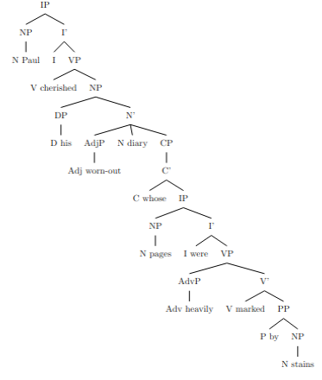
---

**Answer to Task 3:**

We can expand the recursive clausal structure by adding another relative clause within the existing relative clause. Here's the expanded sentence with an additional layer of clausal recursion:

**Expanded Sentence:**

"Paul cherished his worn-out diary, whose pages were heavily marked by stains **that had faded over time**."

In this expanded sentence, the original relative clause "whose pages were heavily marked by stains" now contains another relative clause "that had faded over time" modifying the noun "stains." This adds another layer of clausal recursion to the identified structure.

rec_25.txt o1-preview-2024-09-12 temperature=1.0
PROMPT: Consider the sentence below and complete the following three tasks:
1. Does the sentence in question contain an instance of recursion? If so, identify the recursive part and say what kind of recursion it is. Note that there are different types of recursion, e.g. adjectival recursion (an adjective modifying an adjective-modified noun), Saxon Genitive a.k.a. possessive 's recursion (an 's-possessed 's-possessor), prepositional phrase recursion (a prepositional phrase with another prepositional phrase inside), clausal recursion (a clause within another clause), and so on.
2. Provide code for a syntactic tree representing the structure of the sentence that can be rendered with LaTeX's forest package. Assume X-bar theory.
3. If you identified that the sentence contains a recursive structure, expand it by adding another layer of recursion (of the same type) to the identified structure.
"Pieces of a diary Paul tore to shreds lay on the ground."
REPLY: 1. **Yes**, the sentence contains an instance of **clausal recursion**. The recursive part is the **relative clause** "Paul tore to shreds," which is embedded within the noun phrase "a diary Paul tore to shreds." This relative clause modifies the noun "diary" and is itself a clause within the main clause "Pieces of a diary Paul tore to shreds lay on the ground." This embedding of a clause within a clause is an example of clausal recursion.

---

2. **Syntactic Tree in LaTeX's forest Package (Assuming X-bar Theory):**

```latex
\begin{forest}
[ S
[ NP
[ N'
[ N [Pieces] ]
[ PP
[ P'
[ P [of] ]
[ NP
[ D [a] ]
[ N'
[ N [diary] ]
[ CP
[ C'
[ C [\textit{Ø}] ]
[ IP
[ NP [Paul] ]
[ I'
[ I [\textit{Ø}] ]
[ VP
[ V'
[ V [tore] ]
[ PP
[ P'
[ P [to] ]
[ NP [shreds] ]
]
]
]
]
]
]
]
]
]
]
]
]
]
]
[ VP
[ V [lay] ]
[ PP
[ P'
[ P [on] ]
[ NP
[ D [the] ]
[ N [ground] ]
]
]
]
]
]
\end{forest}
```
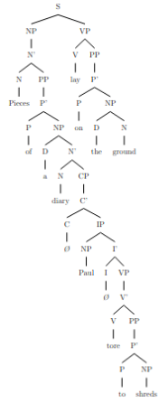
**Explanation:**

- **S (Sentence):** The top node representing the entire sentence.
- **NP (Noun Phrase):** The subject of the sentence "Pieces of a diary Paul tore to shreds."
- **N':** Intermediate projection of the noun.
- **N (Pieces):** The head noun.
- **PP (of a diary Paul tore to shreds):** Prepositional phrase modifying "Pieces."
- **P' (of):** Headed by the preposition "of."
- **NP (a diary Paul tore to shreds):** Noun phrase within the PP.
- **D (a):** Determiner.
- **N':** Intermediate projection of "diary."
- **N (diary):** The noun being modified.
- **CP (Paul tore to shreds):** Relative clause modifying "diary."
- **C' (Ø):** The complementizer is unpronounced (null).
- **IP:** Inflectional phrase representing the relative clause.
- **NP (Paul):** Subject of the relative clause.
- **I' (Ø):** Tense is unpronounced (assumed past tense).
- **VP:** Verb phrase "tore to shreds."
- **V'**
- **V (tore):** Verb of the relative clause.
- **PP (to shreds):** Prepositional phrase complement of "tore."
- **VP (lay on the ground):** The predicate of the sentence.
- **V (lay):** Main verb.
- **PP (on the ground):** Prepositional phrase indicating location.

---

3. **Expanded Sentence with Another Layer of Clausal Recursion:**

*"Pieces of a diary Paul, who had argued with his sister, tore to shreds lay on the ground."*

**Explanation:**

In this expanded sentence, an additional relative clause "who had argued with his sister" is embedded within the original relative clause "Paul tore to shreds." This adds another layer of clausal recursion, as a relative clause now modifies "Paul" within the existing relative clause, resulting in a clause within a clause within the main clause.

rec_23.txt o1-preview-2024-09-12 temperature=1.0
PROMPT: Consider the sentence below and complete the following three tasks:
1. Does the sentence in question contain an instance of recursion? If so, identify the recursive part and say what kind of recursion it is. Note that there are different types of recursion, e.g. adjectival recursion (an adjective modifying an adjective-modified noun), Saxon Genitive a.k.a. possessive 's recursion (an 's-possessed 's-possessor), prepositional phrase recursion (a prepositional phrase with another prepositional phrase inside), clausal recursion (a clause within another clause), and so on.
2. Provide code for a syntactic tree representing the structure of the sentence that can be rendered with LaTeX's forest package. Assume X-bar theory.
3. If you identified that the sentence contains a recursive structure, expand it by adding another layer of recursion (of the same type) to the identified structure.
"The mirror the girl punched shattered into a million pieces."
REPLY: **Answer to Task 1:**

Yes, the sentence contains recursion. The recursive part is the relative clause "the girl punched" embedded within the noun phrase "the mirror." This is an example of **clausal recursion**, where a clause ("the girl punched") is nested within another clause or phrase.

**Answer to Task 2:**

Here is the code for a syntactic tree representing the structure of the sentence using LaTeX's forest package, assuming X-bar theory:

```latex
\begin{forest}
[TP
[NP
[Det [The]]
[N\textsuperscript{$'$}
[N [mirror]]
[CP
[C\textsuperscript{$'$}
[C [\relax]]
[TP
[NP [the girl]]
[T\textsuperscript{$'$}
[T [\relax]]
[VP
[V [punched]]
[NP [\emph{t}\textsubscript{mirror}]]
]
]
]
]
]
]
]
[T\textsuperscript{$'$}
[T [\relax]]
[VP
[V [shattered]]
[PP
[P [into]]
[NP
[Det [a]]
[N\textsuperscript{$'$}
[N [million]]
[N\textsuperscript{$'$}
[N [pieces]]
]
]
]
]
]
]
]
\end{forest}
```
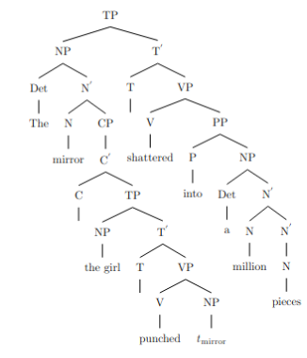
**Answer to Task 3:**

By adding another layer of clausal recursion to the identified structure, we expand the sentence to:

"The mirror the girl whom the boy loved punched shattered into a million pieces."

In this expanded version, the noun phrase "the girl" is modified by an additional relative clause "whom the boy loved," creating another layer of clausal recursion within the original relative clause.

rec_24.txt o1-preview-2024-09-12 temperature=1.0
PROMPT: Consider the sentence below and complete the following three tasks:
1. Does the sentence in question contain an instance of recursion? If so, identify the recursive part and say what kind of recursion it is. Note that there are different types of recursion, e.g. adjectival recursion (an adjective modifying an adjective-modified noun), Saxon Genitive a.k.a. possessive 's recursion (an 's-possessed 's-possessor), prepositional phrase recursion (a prepositional phrase with another prepositional phrase inside), clausal recursion (a clause within another clause), and so on.
2. Provide code for a syntactic tree representing the structure of the sentence that can be rendered with LaTeX's forest package. Assume X-bar theory.
3. If you identified that the sentence contains a recursive structure, expand it by adding another layer of recursion (of the same type) to the identified structure.
"Every desk I put a heavy lamp on eventually cracked."
REPLY: **Task 1: Identification of Recursion**

Yes, the sentence contains an instance of recursion. Specifically, it exhibits **clausal recursion**, where a clause is embedded within another clause. The recursive part is the relative clause modifying the noun "desk":

- **Relative Clause**: "I put a heavy lamp on"

This clause is embedded within the noun phrase headed by "desk" and functions to modify it. The recursion occurs because a clause ("I put a heavy lamp on") is nested within another phrase, creating a hierarchical structure typical of recursive constructs in syntax.

---

**Task 2: Syntactic Tree Representation using LaTeX's Forest Package**

Below is the LaTeX code using the `forest` package to represent the syntactic structure of the sentence under X-bar theory:

```latex
\documentclass{article}
\usepackage{forest}
\begin{document}
\begin{forest}
[IP
[NP
[Det [Every]]
[N'
[N [desk]]
[CP
[C'
[C [that]]
[IP
[NP [\textit{pro}]]
[I'
[I [\phantom{I}]]
[VP
[V'
[V [put]]
[NP
[Det [a]]
[N'
[AdjP [Adj [heavy]]]
[N [lamp]]
]
]
[PP
[P [on]]
[NP [\textit{t}]]
]
]
]
]
]
]
]
]
]
[I'
[I [\phantom{I}]]
[VP
[AdvP [Adv [eventually]]]
[V' [V [cracked]]]
]
]
]
\end{forest}
\end{document}
```

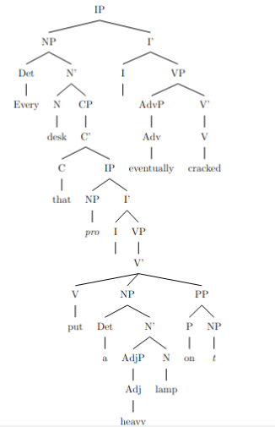
**Explanation:**

- **IP (Inflectional Phrase):** The top-level structure representing the sentence.
- **NP (Noun Phrase):** The subject of the sentence "Every desk I put a heavy lamp on".
- **Det (Determiner):** "Every"
- **N':** Intermediate projection of N.
- **N (Noun):** "desk"
- **CP (Complementizer Phrase):** The relative clause modifying "desk".
- **C (Complementizer):** "that" (often omitted in English but included here for completeness).
- **IP:**
- **NP:** Pronoun subject "I" (represented as the pro-drop **pro** since it's understood).
- **I':**
- **I:** Empty inflection since there's no auxiliary verb.
- **VP:**
- **V':**
- **V (Verb):** "put"
- **NP:** Direct object "a heavy lamp".
- **Det:** "a"
- **N':**
- **AdjP (Adjective Phrase):**
- **Adj (Adjective):** "heavy"
- **N (Noun):** "lamp"
- **PP (Prepositional Phrase):**
- **P (Preposition):** "on"
- **NP:** Trace **t** indicating the position of "desk" within the relative clause.
- **I':**
- **I:** Empty inflection.
- **VP:**
- **AdvP (Adverbial Phrase):**
- **Adv (Adverb):** "eventually"
- **V':**
- **V (Verb):** "cracked"

---

**Task 3: Expansion with an Additional Layer of Recursion**

To add another layer of clausal recursion, we can embed an additional relative clause within the existing relative clause. Here's the expanded sentence:

"**Every desk I put a heavy lamp that I bought last week on eventually cracked.**"

In this version, the noun "lamp" within the first relative clause ("I put a heavy lamp on") is further modified by another relative clause "that I bought last week". This adds a new clausal recursion layer, as we now have a relative clause within a relative clause.

---

**Note:** In the syntactic tree provided in Task 2, the pronoun "I" in the relative clause is represented as an understood subject, and traces or empty categories are used to indicate movement or omission in the relative clauses, consistent with X-bar theory conventions.

rec_27.txt o1-preview-2024-09-12 temperature=1.0
PROMPT: Consider the sentence below and complete the following three tasks:
1. Does the sentence in question contain an instance of recursion? If so, identify the recursive part and say what kind of recursion it is. Note that there are different types of recursion, e.g. adjectival recursion (an adjective modifying an adjective-modified noun), Saxon Genitive a.k.a. possessive 's recursion (an 's-possessed 's-possessor), prepositional phrase recursion (a prepositional phrase with another prepositional phrase inside), clausal recursion (a clause within another clause), and so on.
2. Provide code for a syntactic tree representing the structure of the sentence that can be rendered with LaTeX's forest package. Assume X-bar theory.
3. If you identified that the sentence contains a recursive structure, expand it by adding another layer of recursion (of the same type) to the identified structure.
"The expert every investigator we dispatched questioned remained completely silent."
REPLY: **Answer to Task 1:**

Yes, the sentence contains recursion. Specifically, it exhibits **clausal recursion** through nested relative clauses. The recursive part involves the embedding of relative clauses within noun phrases. Here's how the recursion unfolds:

- The noun **"expert"** is modified by a relative clause: **"every investigator we dispatched questioned"**.
- Within that relative clause, the noun **"investigator"** is further modified by another relative clause: **"we dispatched"**.
- This results in a recursive structure where a clause is embedded within another clause, both serving as modifiers within noun phrases.

This type of recursion is common in complex sentences and demonstrates the capacity of language to extend indefinitely by embedding similar structures within each other.

---

**Answer to Task 2:**

Below is the code for a syntactic tree representing the structure of the sentence, rendered using LaTeX's forest package and adhering to X-bar theory:

```latex
\documentclass{article}
\usepackage{forest}

\begin{document}
\begin{forest}
[IP
[NP
[Det [The]]
[N'
[N [expert]]
[CP
[C [\textsuperscript{$^\emptyset$}]]
[IP
[NP
[Det [every]]
[N'
[N [investigator]]
[CP
[C [\textsuperscript{$^\emptyset$}]]
[IP
[NP [we]]
[I'
[I [\textsuperscript{$^\emptyset$}]]
[VP
[V [dispatched]]
[NP [t\textsubscript{1}]]
]
]
]
]
]
]
[I'
[I [\textsuperscript{$^\emptyset$}]]
[VP
[V [questioned]]
[NP [t\textsubscript{2}]]
]
]
]
]
]
]
[I'
[I [\textsuperscript{$^\emptyset$}]]
[VP
[V [remained]]
[AdjP
[Adv [completely]]
[Adj [silent]]
]
]
]
]
\end{forest}
\end{document}
```
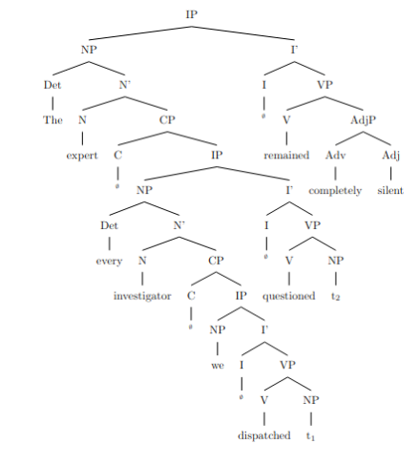
This tree represents the hierarchical structure of the sentence, illustrating the recursive embedding of relative clauses within noun phrases according to X-bar theory.

---

**Answer to Task 3:**

Expanding the sentence by adding another layer of recursion of the same type (clausal recursion), we can introduce an additional relative clause within the existing structure. The expanded sentence is:

*"The expert every investigator we dispatched who we trained questioned remained completely silent."*

In this version, the noun **"investigator"** is now modified by a relative clause **"we dispatched who we trained"**, adding another layer of recursion. The structure continues to nest relative clauses within noun phrases, demonstrating the same type of clausal recursion identified in the original sentence.

rec_26.txt o1-preview-2024-09-12 temperature=1.0
PROMPT: Consider the sentence below and complete the following three tasks:
1. Does the sentence in question contain an instance of recursion? If so, identify the recursive part and say what kind of recursion it is. Note that there are different types of recursion, e.g. adjectival recursion (an adjective modifying an adjective-modified noun), Saxon Genitive a.k.a. possessive 's recursion (an 's-possessed 's-possessor), prepositional phrase recursion (a prepositional phrase with another prepositional phrase inside), clausal recursion (a clause within another clause), and so on.
2. Provide code for a syntactic tree representing the structure of the sentence that can be rendered with LaTeX's forest package. Assume X-bar theory.
3. If you identified that the sentence contains a recursive structure, expand it by adding another layer of recursion (of the same type) to the identified structure.
"The expert every journalist questioned remained completely silent."
REPLY: **Answer to Task 1:**

Yes, the sentence contains an instance of recursion. The recursive part is the **clausal recursion** found within the noun phrase (NP) "The expert every journalist questioned". Here, the relative clause "every journalist questioned" modifies the noun "expert". This relative clause is a clause embedded within another clause, constituting clausal recursion.

---

**Answer to Task 2:**

Below is the code for a syntactic tree representing the structure of the sentence, using LaTeX's forest package and assuming X-bar theory:

```latex
\documentclass{article}
\usepackage{forest}
\begin{document}
\begin{forest}
[TP
[NP\textsubscript{i}
[Det [the]]
[N'
[N [expert]\textsubscript{i}]
[CP
[C'
[C [\emph{Ø}]]
[IP
[NP
[Det [every]]
[N [journalist]]
]
[I'
[I [\emph{Ø}]]
[VP
[V'
[V [questioned]]
[NP [\emph{t}\textsubscript{i}]]
]
]
]
]
]
]
]
]
[T'
[T [\emph{Ø}]]
[VP
[V'
[V [remained]]
[AdjP
[AdvP [Adv [completely]]]
[Adj' [Adj [silent]]]
]
]
]
]
]
\end{forest}
\end{document}
```
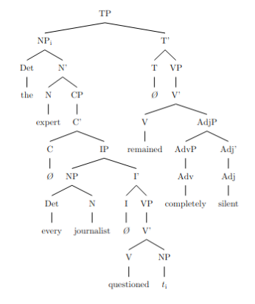
**Explanation:**

- **TP (Tense Phrase):** The root of the sentence, representing the entire sentence.
- **NP\textsubscript{i}:** The subject noun phrase, indexed with \textsubscript{i}.
- **Det:** The determiner "the".
- **N':** The noun phrase bar level.
- **N [expert]\textsubscript{i}:** The head noun "expert", coindexed with the trace in the embedded clause.
- **CP:** The embedded relative clause modifying "expert".
- **C':** The complementizer phrase.
- **C [\emph{Ø}]:** An empty complementizer (since "that" is omitted in reduced relative clauses).
- **IP:** The inflectional phrase of the embedded clause.
- **NP:** The subject of the embedded clause.
- **Det [every]:** The determiner "every".
- **N [journalist]:** The noun "journalist".
- **I':** The inflection phrase bar level.
- **I [\emph{Ø}]:** An empty inflection (since tense is not overtly marked).
- **VP:** The verb phrase of the embedded clause.
- **V':**
- **V [questioned]:** The verb "questioned".
- **NP [\emph{t}\textsubscript{i}]:** The trace of the moved NP "expert", indicating movement and coindexation.
- **T':** The tense phrase bar level of the main clause.
- **T [\emph{Ø}]:** An empty tense node (assuming present tense not marked).
- **VP:** The verb phrase of the main clause.
- **V':**
- **V [remained]:** The verb "remained".
- **AdjP:** The adjective phrase modifying the verb.
- **AdvP [Adv [completely]]:** The adverb phrase "completely".
- **Adj' [Adj [silent]]:** The adjective "silent".

---

**Answer to Task 3:**

By adding another layer of clausal recursion to the identified structure, we expand the sentence as follows:

**Expanded Sentence:**

*“The expert every journalist the editor hired questioned remained completely silent.”*

**Explanation:**

In this expanded sentence, an additional relative clause "the editor hired" is embedded within the original relative clause "every journalist questioned". This adds another layer of **clausal recursion**. Now, "the editor hired" modifies "journalist", which is part of the relative clause modifying "expert".

---

**Visualization of the Expanded Structure:**

Below is the modified syntactic tree code including the additional layer of recursion:

```latex
\documentclass{article}
\usepackage{forest}
\begin{document}
\begin{forest}
[TP
[NP\textsubscript{i}
[Det [the]]
[N'
[N [expert]\textsubscript{i}]
[CP
[C'
[C [\emph{Ø}]]
[IP
[NP\textsubscript{j}
[NP
[Det [every]]
[N [journalist]\textsubscript{j}]
]
[CP
[C'
[C [\emph{Ø}]]
[IP
[NP
[Det [the]]
[N [editor]]
]
[I'
[I [\emph{Ø}]]
[VP
[V'
[V [hired]]
[NP [\emph{t}\textsubscript{j}]]
]
]
]
]
]
]
]
[I'
[I [\emph{Ø}]]
[VP
[V'
[V [questioned]]
[NP [\emph{t}\textsubscript{i}]]
]
]
]
]
]
]
]
]
[T'
[T [\emph{Ø}]]
[VP
[V'
[V [remained]]
[AdjP
[AdvP [Adv [completely]]]
[Adj' [Adj [silent]]]
]
]
]
]
]
\end{forest}
\end{document}
```

**Explanation of the Expanded Tree:**

- **Second Layer of CP within NP\textsubscript{j}:** The noun "journalist"\textsubscript{j} is now modified by a relative clause introduced by another CP.
- **CP:** Relative clause modifying "journalist".
- **C [\emph{Ø}]:** Empty complementizer.
- **IP:** Contains the embedded clause.
- **NP:** Subject "the editor".
- **VP:**
- **V [hired]:** Verb "hired".
- **NP [\emph{t}\textsubscript{j}]:** Trace of "journalist", indicating movement and coindexation.

This recursive embedding demonstrates another level of clausal recursion, with a clause embedded within a clause that is itself embedded within another clause.

---

**Note for Interpretation:**

- **Indices (\textsubscript{i}, \textsubscript{j}):** Used to indicate which elements are coindexed (i.e., related through movement).
- **Empty Categories (\emph{Ø}):** Represent elements that are not phonetically realized but are present in the syntactic structure (e.g., null complementizers, traces).
- **Traces (\emph{t}\textsubscript{i}):** Indicate where a moved constituent originated from.

This detailed analysis captures the complexity of the sentence's structure and the recursive nature of its clauses, aligning with the principles of X-bar theory and syntactic representation in linguistics.

rec_28.txt o1-preview-2024-09-12 temperature=1.0
PROMPT: Consider the sentence below and complete the following three tasks:
1. Does the sentence in question contain an instance of recursion? If so, identify the recursive part and say what kind of recursion it is. Note that there are different types of recursion, e.g. adjectival recursion (an adjective modifying an adjective-modified noun), Saxon Genitive a.k.a. possessive 's recursion (an 's-possessed 's-possessor), prepositional phrase recursion (a prepositional phrase with another prepositional phrase inside), clausal recursion (a clause within another clause), and so on.
2. Provide code for a syntactic tree representing the structure of the sentence that can be rendered with LaTeX's forest package. Assume X-bar theory.
3. If you identified that the sentence contains a recursive structure, expand it by adding another layer of recursion (of the same type) to the identified structure.
"The astronomy the ancients we revere studied was not separate from astrology."
REPLY: **Answer to Task 1:**

Yes, the sentence contains recursion. Specifically, it features **clausal recursion**: a relative clause embedded within another relative clause. The noun "astronomy" is modified by a relative clause "the ancients we revere studied," and within that clause, "the ancients" is further modified by another relative clause "we revere." This nesting of relative clauses exemplifies clausal recursion.

**Answer to Task 2:**

Here is the LaTeX code for a syntactic tree representing the structure of the sentence using the forest package and assuming X-bar theory:

```latex
\begin{forest}
[TP
[NP
[D [The]]
[N$'$
[N [astronomy]]
[CP
[C [\textit{Ø}]]
[TP
[NP
[D [the]]
[N$'$
[N [ancients]]
[CP
[C [\textit{Ø}]]
[TP
[NP [we]]
[T$'$
[T [\textit{Ø}]]
[VP
[V [revere]]
]]]]]]
[T$'$
[T [\textit{Ø}]]
[VP
[V [studied]]
]]]]]]
[T$'$
[T [was]]
[VP
[AdvP [not]]
[AdjP [separate]]
[PP
[P [from]]
[NP [astrology]]]]]]
\end{forest}
```
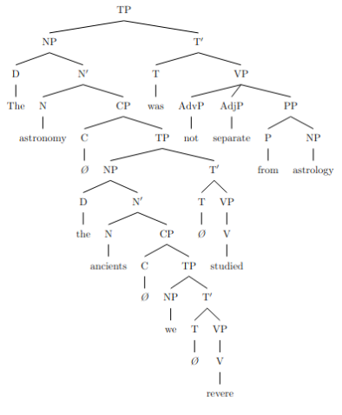
**Answer to Task 3:**

Expanding the recursive structure by adding another layer of clausal recursion, the sentence becomes:

*"The astronomy the ancients we revere who lived in lands we cherish studied was not separate from astrology."*

In this expanded sentence, an additional relative clause "who lived in lands we cherish" is embedded within the existing relative clause "we revere," increasing the depth of the clausal recursion.

rec_29.txt o1-preview-2024-09-12 temperature=1.0
PROMPT: Consider the sentence below and complete the following three tasks:
1. Does the sentence in question contain an instance of recursion? If so, identify the recursive part and say what kind of recursion it is. Note that there are different types of recursion, e.g. adjectival recursion (an adjective modifying an adjective-modified noun), Saxon Genitive a.k.a. possessive 's recursion (an 's-possessed 's-possessor), prepositional phrase recursion (a prepositional phrase with another prepositional phrase inside), clausal recursion (a clause within another clause), and so on.
2. Provide code for a syntactic tree representing the structure of the sentence that can be rendered with LaTeX's forest package. Assume X-bar theory.
3. If you identified that the sentence contains a recursive structure, expand it by adding another layer of recursion (of the same type) to the identified structure.
"A candidate the committee we put together rejected developed the imposter syndrome."
REPLY: 1. **Identification of Recursion:**

Yes, the sentence contains an instance of recursion. Specifically, it exhibits **clausal recursion**, where a clause is embedded within another clause. In this sentence, the recursive structure is the embedding of the relative clause "we put together" within another relative clause "the committee we put together rejected," which modifies the noun "candidate."

- The relative clause "the committee we put together rejected" modifies "candidate."
- Within this clause, "the committee we put together" is the subject.
- "We put together" is a relative clause modifying "committee."
- Thus, a clause ("we put together") is embedded within another clause ("the committee ... rejected"), demonstrating clausal recursion.

2. **Syntactic Tree in LaTeX's Forest Package (X-bar Theory):**

Below is the code for the syntactic tree representing the structure of the sentence, rendered using LaTeX's forest package and assuming X-bar theory:

```latex
\begin{forest}
[TP
[NP
[Det [A]]
[N$'$
[N [candidate]]
[CP
[C$'$ [C [\textit{Ø}]]
[TP
[NP
[Det [the]]
[N$'$
[N [committee]]
[CP
[C$'$ [C [\textit{Ø}]]
[TP
[NP [we]]
[T$'$ [T [\textit{Ø}]] [VP [V [put together]]]]
]
]
]
]
]
[T$'$ [T [\textit{Ø}]] [VP [V [rejected]] [NP [\textit{t} (trace)]]]]
]
]
]
]
]
[T$'$ [T [\textit{Ø} (past)]] [VP [V [developed]] [NP [Det [the]] [N$'$ [N [imposter syndrome]]]]]]
]
\end{forest}
```
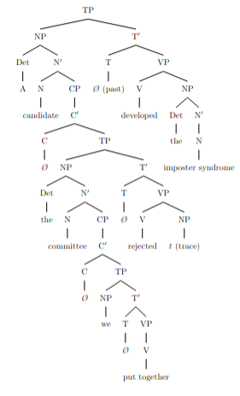
**Explanation:**

- **TP (Tense Phrase):** The root of the tree, representing the entire sentence.
- **NP (Subject):** Contains the determiner "A" and the noun "candidate," modified by a relative clause (CP).
- **CP (Complementizer Phrase):** Represents the embedded relative clauses.
- The first CP modifies "candidate" and contains the clause "the committee we put together rejected."
- Within this CP, there's another CP that modifies "committee," containing the clause "we put together."
- **VP (Verb Phrase):** Contains the verb "developed" and its complement "the imposter syndrome."
- **Trace (\textit{t}):** Represents the position from which the relative pronoun has moved in wh-movement, typical in relative clauses.

3. **Expanding the Recursive Structure with Another Layer of Recursion:**

To add another layer of recursion of the same type (clausal recursion), we can introduce an additional relative clause within the existing structure. Here's the expanded sentence:

**Original Sentence:**
> "A candidate the committee we put together rejected developed the imposter syndrome."

**Expanded Sentence:**
> "A candidate the committee we put together that the dean appointed rejected developed the imposter syndrome."

**Explanation of Expansion:**

- We've added another relative clause "that the dean appointed" modifying "committee."
- This introduces an additional layer of clausal recursion, as "that the dean appointed" is a clause within the clause "the committee we put together rejected," which itself modifies "candidate."
- The recursive structure now includes three layers of clauses embedded within each other.

**Syntactic Tree Illustration of the Expanded Sentence:**

```latex
\begin{forest}
[TP
[NP
[Det [A]]
[N$'$
[N [candidate]]
[CP
[C$'$ [C [\textit{Ø}]]
[TP
[NP
[Det [the]]
[N$'$
[N [committee]]
[CP
[C$'$ [C [\textit{Ø}]]
[TP
[NP
[NP [we]]
[T$'$ [T [\textit{Ø}]] [VP [V [put together]]]]
]
[CP
[C$'$ [C [that]]
[TP
[NP [the dean]]
[T$'$ [T [\textit{Ø}]] [VP [V [appointed]] [NP [\textit{t}]]]]
]
]
]
]
]
]
]
]
[T$'$ [T [\textit{Ø}]] [VP [V [rejected]] [NP [\textit{t}]]]]
]
]
]
]
]
[T$'$ [T [\textit{Ø} (past)]] [VP [V [developed]] [NP [Det [the]] [N$'$ [N [imposter syndrome]]]]]]
]
\end{forest}
```

**Note:** We've added the relative clause "that the dean appointed" modifying "committee," introducing another CP layer within the existing structure, thereby deepening the recursion.

---

This expanded sentence and corresponding syntactic tree demonstrate an additional layer of clausal recursion, maintaining the same recursive structure identified in the original sentence.

rec_30.txt o1-preview-2024-09-12 temperature=1.0
PROMPT: Consider the sentence below and complete the following three tasks:
1. Does the sentence in question contain an instance of recursion? If so, identify the recursive part and say what kind of recursion it is. Note that there are different types of recursion, e.g. adjectival recursion (an adjective modifying an adjective-modified noun), Saxon Genitive a.k.a. possessive 's recursion (an 's-possessed 's-possessor), prepositional phrase recursion (a prepositional phrase with another prepositional phrase inside), clausal recursion (a clause within another clause), and so on.
2. Provide code for a syntactic tree representing the structure of the sentence that can be rendered with LaTeX's forest package. Assume X-bar theory.
3. If you identified that the sentence contains a recursive structure, expand it by adding another layer of recursion (of the same type) to the identified structure.
"The worldview that the prose Nietzsche wrote expressed was unprecedented."
REPLY: **Answer to Task 1:**

Yes, the sentence contains an instance of recursion. Specifically, it involves **clausal recursion**, where a relative clause contains another relative clause. The recursive part is within the noun phrase "the worldview that the prose Nietzsche wrote expressed." Here, the noun "worldview" is modified by the relative clause "that the prose Nietzsche wrote expressed," which itself contains the embedded relative clause "Nietzsche wrote" modifying "prose." The structure can be illustrated as:

- **Main Clause:** The worldview *...* was unprecedented.
- **First Relative Clause:** that the prose **[Second Relative Clause]** expressed
- **Second Relative Clause:** [that] Nietzsche wrote

**Answer to Task 2:**

Below is the code for a syntactic tree representing the structure of the sentence, using LaTeX's **forest** package and assuming X-bar theory. This tree illustrates the recursive embedding of relative clauses within the noun phrases.

```latex
\begin{forest}
for tree={
align=center,
grow'=south,
parent anchor=south,
child anchor=north,
l sep+=1em,
s sep=1.5em,
edge={->}
}
[IP
[NP
[Det [The]]
[N'
[N [worldview]]
[CP
[C' [C [that]]
[IP
[NP
[Det [the]]
[N'
[N [prose]]
[CP
[C' [C [\textit{ø}]]
[IP
[NP [Nietzsche]]
[I' [I [\textit{ø}]]
[VP
[V [wrote]]
[NP [$t_1$]]
]
]
]
]
]
]
]
[I' [I [\textit{ø}]]
[VP
[V [expressed]]
[NP [$t_2$]]
]
]
]
]
]
]
]
[I' [I [was]]
[AdjP [Adj [unprecedented]]]
]
]
\end{forest}
```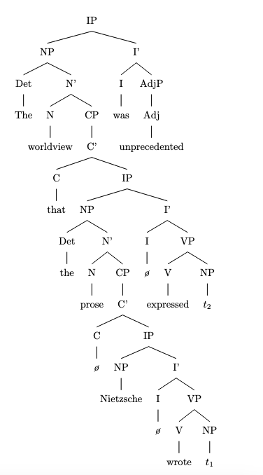
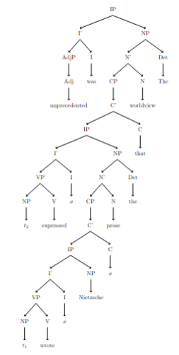
**Explanation of the Tree Structure:**

- The **main clause (IP)** consists of the NP subject and the predicate "was unprecedented."
- The NP subject includes:
- Determiner **"The"**
- Noun **"worldview"**
- A relative clause **(CP)** that modifies "worldview."
- The first **relative clause (CP)** contains:
- Complementizer **"that"**
- An embedded **IP**, where:
- The NP **"the prose"** is further modified by a second relative clause.
- The **second relative clause (CP)** contains:
- An omitted complementizer (notated as **\textit{ø}**, since "that" is optional and omitted here).
- An IP where **"Nietzsche"** is the subject, and **"wrote"** is the verb.
- The object of "wrote" is a trace **$t_1$**, indicating movement of "prose."
- The verb **"expressed"** in the outer IP takes a trace **$t_2$** as its object, referring back to "worldview."

**Answer to Task 3:**

Expanding the sentence by adding another layer of clausal recursion results in:

**"The worldview that the prose that the philosopher Nietzsche admired wrote expressed was unprecedented."**

In this revised sentence, we've added another relative clause "that the philosopher Nietzsche admired" modifying "prose." The recursive structure now includes a third layer of relative clauses:

1. **First Relative Clause:** that the prose **[Second Relative Clause]** wrote expressed
2. **Second Relative Clause:** that the philosopher **[Third Relative Clause]** admired
3. **Third Relative Clause:** [that] Nietzsche admired

**Updated Syntactic Tree Code:**

```latex
\begin{forest}
for tree={
align=center,
grow'=south,
parent anchor=south,
child anchor=north,
l sep+=1em,
s sep=1.5em,
edge={->}
}
[IP
[NP
[Det [The]]
[N'
[N [worldview]]
[CP
[C' [C [that]]
[IP
[NP
[Det [the]]
[N'
[N [prose]]
[CP
[C' [C [that]]
[IP
[NP
[Det [the]]
[N'
[N [philosopher]]
[CP
[C' [C [that]]
[IP
[NP [Nietzsche]]
[I' [I [\textit{ø}]]
[VP
[V [admired]]
[NP [$t_3$]]
]
]
]
]
]
]
]
[I' [I [\textit{ø}]]
[VP
[V [wrote]]
[NP [$t_2$]]
]
]
]
]
]
]
]
[I' [I [\textit{ø}]]
[VP
[V [expressed]]
[NP [$t_1$]]
]
]
]
]
]
]
]
[I' [I [was]]
[AdjP [Adj [unprecedented]]]
]
]
\end{forest}
```

**Explanation of the Updated Tree:**

- **Third Relative Clause (CP):** "that Nietzsche admired" modifies "philosopher."
- Introduces a new complementizer **"that"** and an IP where "Nietzsche" is the subject and "admired" is the verb.
- **Second Relative Clause (CP):** "that the philosopher Nietzsche admired wrote" modifies "prose."
- The NP includes "the philosopher Nietzsche admired," which is itself modified by the third relative clause.
- The verb "wrote" takes a trace **$t_2$** as its object, indicating movement of "prose."
- **First Relative Clause (CP):** "that the prose that the philosopher Nietzsche admired wrote expressed" modifies "worldview."
- The verb "expressed" takes a trace **$t_1$** as its object, referring back to "worldview."
- The additional layer demonstrates further **clausal recursion** by embedding another relative clause within the existing structure, maintaining the same type of recursion (relative clauses within relative clauses).

This expanded sentence and accompanying tree illustrate how the recursive structure can infinitely embed clauses of the same type, showcasing the recursive nature of human language syntax.

Messages generated with 133864 tokens

